**Chapter 1 - INTRODUCTION**

“Drmedizone" was developed to overcome the problems prevalent in practical manual systems. This software program is supported to remove and possibly mitigate the problems met by this present system. In addition, the system is designed with the specific needs of the people in mind, allowing operations to run smoothly and effectively.

If you enter invalid data, an error message is displayed. No formal knowledge is required for users to use this system. That alone proves its usability. Drmedizone above can be a bug-free, secure, reliable and fast system. It helps users focus on other activities instead of focusing on record keeping.

Drmedizone is an online doctor appointment system this is a web application which allows the people of a particular area to book appointments and order medicines. This system provides a login and registration for doctor and patient. Doctor is register by giving their required details like timings, fees, category, etc. After successful registration, the doctor and patient can login by giving a username and password. The doctor views the patient booking request, and if he receives the requests, the status will be shown as reservation confirmed to the patient. The patients must be registered and logged in to book a doctor based on the category and the type of problem the patient is facing. The search results will show the list of doctors similar the patient’s required norms and he can select one and send a request, the request will be forwarded to the doctor and if he is available, he will send the approval back to the patient. The patient can view the status. After confirming appointment send confirmation email to patients.

**1.1 BACKGROUND:**

This digital world makes our lives easier and better. All kinds of industries are changing us technology. All things go from offline to online, saving time and using this time for other things Therefore, the medical industry is also moving from offline to online. So Drmedizone is a Python (Django) based online appointment web application. Your partner is on a journey to improve the health of you and your family. At Drmedizone, all doctors are affordable to all patients and our doctors a well trained and experienced. Our projects are adaptable to our needs.

**1.2 OBJECTIVES:**

The motive of this web application is to deliver peace of thoughts to both doctors and sufferers. sufferers commonly visit the health centre for appointments and other reasons, wasting money and time. these issues are conquered via this challenge. Globally available physicians seek based totally on the patient. We can also a set to up and lab take a look at dates for you. Drmedizone the great web application for commonplace diseases and ugly condition.

The main cause of Drmedizone undertaking is to control doctors, medical doctor schedules, clinical news and health practitioner details. projects are constructed exclusively on the administration facet, so simplest directors are assured get entry to. The cause of this undertaking is to create a software to reduce the guide paintings associated with handling medical doctors, appointments, medical expenses and sufferers. saw all affected person, appointment and doctor time table info.

**1.3 System Overview: -**

**Description of the existing system. :-**

This platform was created to save you money, and time make and your life easy; Through this project, I am going to meet you with the best and most educated doctors. Sometimes patients are in very trouble finding experts doctors; So, through this project, patients can find and meet a doctor very easily. Using this project, patients make doctor appointments, Lab appointments and order medicines.

**1.4 PURPOSE:**

The purpose of the project is Doctor appointment system that provides Doctors and also Patients. A doctor gives the appointment time and days (how much time/day appointment taking is open) and also in this project I include medicine e-commerce system. This project is two types of appointment-based project; one is video calling meeting appointments and the other is a face-to-face meeting appointment. This project overcome issues managing and booking an appointment through doctor and patien. Patients taking appointments as per schedule after opening appointment time to before closing time.

Patients are buying online medicines. Any appointment-taking messages are also given to the patient's registered mobile number or email. This project also provide options for the appointment is video meeting and personal meeting; the patient also cancelling appointment option is present. In this project some additional features are available; doctors give health reports to a patient through the application and also downloading facility is available for patients. Doctors decide how future appointments are taken by patients. Patients also chose doctors as per the required criteria. This project saves doctors’ as well as patients’ time.

**1.5 SCOPE:**

This project aims to save you time and give you satisfaction. The doctor also checks patients if the clinic is not available because the doctor is decided which types of appointments (online or offline) are taken. The doctor/doctor’s assistant are managing appointments. Doctors upload patient health care reports on patients’ accounts. A patient quickly locates a nearby doctor or clinic/hospital in his/her locality and books an appointment. Search doctors by doctor’s speciality wise /city wise/ fesswise. Get updated appointment notifications are send by mobile number and email address. A Patient can buy online medicines also on this web application. Patients are meat overall world’s specialist doctors without living in our homes.

**Who will be using this software?**

This software are patients and doctors will be used. Through this project doctor are given the treatment for any patients from any state and countries’ patients also meat world’s best expert doctors and taking the treatments. Patients takes advanced appointments also and save over time and Patients can buy medicines on this web application; Using this project a patient and doctor also meat in online mode means video calling through

**Reports of Drmedizone: -**

* It generates the file on doctor, appointment, physician fees, medicine invoice.
* Provide reports on patient, booking, doctor schedule.
* You can easily download health report PDF from doctor, appointment booking recipt, buying medicines.

**1.6 Applicability:**

Life is too busy to make an in-person doctor's appointment and get proper health care. The main knowledge of this paintings is to provide patients with ease and comfort when making an appointment with a doctor, and at the same time, it solves the problems that patients have to deal with when making an appointment. The Dremdizone web application as a client, while a database containing doctor, patient ,appointment, medicines etc. details is maintained by a Web application that acts as a server.

**Chapter 2 - SURVEY OF TECHNOLOGY**

* 1. **DESCRIPTION OF PROJECT:**

Drmedizone is an appointment-based and ecommerce meducine system; this project is suitable for buying medicines; doctors and patient interaction with each other. Through this project both are save over time to giving and taking appointments. Most of the time this project is so useful for patient more than doctors; because the patient can make an appointment with any doctors from anywhere and also buying medicines. Patients can usually find the kind of speciality's doctor they want. This project is useful for doctors also. In this project doctors are giving a time and days when doctors are available; use given time and days by doctor’s patient are taking appointment for personal meeting or video calling.

* 1. **AVAILABLE TECHNOLOGIES:** 
     1. **FRONT END TECHNOLOGIES:** 
        1. Html5:

It is a markup language used to create the structure of a web page. It is an only body of web pages. It is a foundational technology and is very popular for making modern Web application s. It is a very easy and useful language for any creating Web application s.

* + - 1. CSS:

CSS stand for Cascading Style Sheet; CSS is used for make html page is beautiful and user friendly. CSS thoroughly html page is customized. CSS defined of html attributes are displayed.

* + - 1. Java Script:

It is a most popular language. It is also interpreted compiled language; JavaScript is a type scripting language; It is a brain of Web application s. If we are making working Web application so JavaScript are use in this Web application . It is use to make Web application dynamically.

* + - 1. Bootstrap:

It is an open-source Cascading Style Sheet CSS framework which is used to make responsive frontend Web application . It provides CSS and JavaScript templates for different attribute of HTML. Bootstrap are combination of html CSS and JavaScript.

* + 1. **BACKEND TECHNOLOGIES:**
       1. **PROCESSING TECHNOLOGY:**
          - **Python/Django:**

Python is easy language comparatively other languages; for writing a syntax and also easy to learn. Python is also ideal backend language because of its many libraries and frameworks. Django and Flask are web development frameworks.

* + - 1. **DATABASE TECHNOLOGY:** 
         * **MySQL:**

MySQL is an open-source database structure query language; It is use for relational databases. Using MySQL manage over data into database. This is a very popular language for relational database. Most of the biggest companies used MySQL for store over data.

* 1. **JUSTIFICATION OF PLATFORM:**
     1. **THE FOLLOWING TECHNOLOGIES WILL BE USED IN THE FRONTEND:**
        1. **HTML:**

Html is language very easy and it's free; html is used for developing Web application page. it is very easy to developing Web application page. Html syntax is very easy and understandable. Html language is also used for making responsive web pages; If we are using HTML for developing web pages so this web page is very well responsive to any type of device. Html language has supported all types of browsers. This is user-friendly language.

* + - 1. **Bootstrap:**

Bootstrap is also free open-source framework. It is used for designing purpose. Bootstrap is help to over normal web page is making attractive and beautiful with responsive web page. It is also easy to used. We are customized the web page.

* + - 1. **CSS:**

CSS is also used designing over html page is beautiful. If we are use CSS in over creating web page so this page is loaded faster than without used CSS page. It’s also user friendly. CSS is also easy to learn and design web pages.

* + - 1. **JavaScript:**

JavaScript is a type script language. It is brain over Web application page; Without JavaScript over web page is static. If we are making working webpage so used JavaScript. JavaScript is also used backend. If we are making over page animated so also used JavaScript.

* + 1. **THE FOLLOWING TECHNOLOGIES WILL BE USED FOR BACKEND BUSINESS LOGIC:**
       1. **Python/Django: -**

Python is easy to used and learn; we are writing a programme faster than other types of languages. In python many frameworks and libraries are available. From python we are make any types of projects. A Django, flask are frameworks of python; both are used developing a webpage. In python easy to write a project related logic. I learned python from one year. Python is also very popular and demanding language this time.

* + 1. **THE FOLLOWING TECHNOLOGIES WILL BE USED IN THE DATABASE:**
       1. **MySQL: -**

It is storing a many data into database. I know that about MySQL language. If we are used relational database in over project so used MySQL. MySQL is a totally free and it is an open source. In databases MySQL are most demanding technology; most of the companies are used.

* 1. **Feasibility study:**

The main thing of the probability study is to test the practical, Working and Inexpensive feasibility of adding new things and debugging or manipulating the old running system. There are features in the feasibility study helping of the initial examination. A probability study is an estimation and investigation of a project or system proposed by someone. This study attempts to control whether the development is theoretically and economically. Financially viable in this situation means whether the development is possible within the predictable costs. The feasibility study also controls whether the project makes commercial sense, i.e., whether it is profitable. Simply put, this study analyses how simply or positively you can complete something. We also try to determine if it is profitable or not. Corporations and administrations typically conduct proof-of-concept studies when it is costly. probability study evaluates the probability of a proposed plan or project. In a portion of a probability study, the feasibility of development or plan is checked to control whether it will be positive. As the name proposes, feasibility studies are used to control the feasibility of an idea. me. Ensuring the legal and technical feasibility and economic feasibility of the development. Indicates whether the project is worth investing in. In some cases, the project may not start. Different types possible reasons for this. For example, if you need too many resources, not only can those resources get in the way of doing other things, but it can cost a company more money than it takes to recoup and pay for the lossy project.

**There are four types of a Feasibility studies:**

* **Economic feasibility:**

This is a very important aspect to be considered while developing a project. We decided the technology based on minimum possible cost factor. All hardware & software cost has to be biome by the organization. Overall, we have estimated that the benefits the organization is going to receive from the proposed system will surely overcome the initial costs & the later on running cost for system.

* **Operational feasibility:**

No doubt the proposed system is fully GUI based that is very user friendly & all inputs to be taken all self-explanatory even to a layman. Besides, a proper training has been conducted to let know the essence of the system to the users so that they feel comfortable with new system. As far our study is connected the clients are comfortable & happy as the system has cut down their loads & doing.

* **Technical feasibility :**

This is included the study of function, performance 7 limitations that may affect the ability to achieve an acceptable system. For this feasibility study, we studied complete functionality to be provided in the system checked if everything was possible using different type of frontend & backend platforms.

* **Schedules feasibility** :

A project will flop if it takes too long to be finished previously itis useful. This means guessing how long the system will take to progress, and if it can be finished in a given time period using some methods like profit dated. Schedule feasibility is a measure of how realistic the development timetable is. Based on given information the system will perform given tasks. Planning a project strategy and building a project schedule to

* + Complete project within time and budget.
  + Resource management system.
  + Increase project success rate.
  + Realize significant time and resource savings.

I tried to complete the software within time limit. And almost I can do it. The proposed system will easily be accessible and it will be well organized and delivered the right information in the right place.

**Chapter 3 - Requirements and Analysis**

1. **Problem Definition:**

Astechnologyadvances, many new things have been developed and are helping us in a big manner. One of them is Doctor Appointment Application through which we can get doctor’s appointment easily sitting at our home.

Drmedizone wants to expand this through a web application so that people will be able to get appointments easily without going to Doctor’s clinic. This Application will make taking appointments more compatible.

1. **Hardware and Software Requirements:**
   1. **Hardware requirements for development:**
      * Ram: - minimum 2GB,
      * Processor: - minimum 1GHz
      * Storage: - 2GB or more
   2. **Software requirement for development: -**

Operating system: - Windows

Frontend: - HTML, CSS, JavaScript, Bootstrap

Backend: -

Business logic language: - Python(Django)

Database: - MySQL

* 1. **Software requirement for user:**
     + User devices: Smartphone or computer
     + Windows :7/8/10/11
     + Android 4.1 or higher
     + iOS 6 or higher
     + Mac OS 10.5 or higher
     + User software: Latest version of browsers

1. **Software requirement for user:**

The function of this platform is to cater to all the needs of doctors and patients. In order to make it easier for the patient to get all the information from mobile, laptop or desktop, it is easy for the patient to get all the information from mobile, laptop or desktop, giving complete information about the educated and many types of doctors shown on your platform. And accordingly, patients choose the doctor and makes an appointment.

There are the requirements that the end users demand from the system:

* Search and visit the Web application easily:

Patients and doctor also must be able to search the application easily

* Have a secured account:

Patients and doctor can register and login with their self-information without any fear of data privacy and have a secured account

* Retrieve Account:

Patients and doctor should be able to retrieve their account with their phone number, email, security question or previous password if they forget the password

* Option to search:

There must be option for patients to search for their requirements related doctors Filter Options available on doctor’s speciality, fees and user rating of doctors. Patient also search Lab tests and medicines.

* Contact for help:

`If there is any regarding application there must be option to contact the customer service via email or phone number of customer service.

* Give and view feedback:

Patients can give and view feedback after their visit to the Doctor or related Web application and give feedback about medicines.

* Payment:

Patients can pay the bill of appointment and buying medicines.

* Give and Take appointment:

After registration doctor give time and days for taking appointment; doctor also give advanced appointment days.

* Buy medicines:

After registration patients buy medicines on this web application.

1. **Functional Requirement:**

Astechnologyadvances, many new things have been developed and are helping us in a big manner. One of them is Doctor Appointment Application through which we can get doctor’s appointment easily sitting at our home.

Drmedizone wants to expand this through a web application so that people will be able to get appointments easily without going to Doctor’s clinic. This web Application will make taking appointments more compatible.

**Functionalities provide by Drmedizone are as follows: -**

* Provides the searching services based on various features. Such as Doctor’s names, medicines names and etc.
* Drmedizone also accomplish the doctors fee detail, appointment booking details, doctor schedule detail, medicine details, showing doctors, showing lab tests, showing medicines etc.
* It tracks all the information of booking appointment, fees, doctors.
* Show all information about doctors ,patients, lab test, medicines.
* Manage the information of all doctors, patients, lab tests and medicines.
* Admin can Edit, add, update, and delete of patients’, doctors’, lab tests’ and medicines’ records.
* Manage the appointment booking information and buying medicine information .
* Choose doctors. Lab tests and medicines from Filtering by patients.
* Two types of appointment booking; 1) Personal meeting and 2) Video calling meeting.
* Send and download health report and other reports.
* Feedback for doctors from patients.
* Feedback for medicines from patients.
* Feedback for web applications from users.
* Send appointment-related messages from patients’ mobile numbers.
* 2 to 3 types of forgetting passwords.
* Find nearby doctors.

**What users can do?**

* Admin: -

Access all web applications and CRUD-related operations. Manages all web applications. Solve queries from doctors and patients, and also solve some technical issues, manage doctors and patients send alerts, login, register, forget username and password, fix bugs. Manage all over web application.

* Doctor: -

Self-Register and clinic register, login, give health related report for patients; Doctor schedules appointment, forget password; show some patient details, received appointment, give fees, view alert message, give appointment, forget password, update profile, give feedback.

* Patient: -

Register, update profile, Take and cancel appointments; Buy medicines; Pay bills; Download health report from doctors; video chatting appointment options are available; find nearby specialist and forget password, search and filter doctors, received messages, view and download appointment, buy medicones and payment confirmation receipt, give and view feedback, login, update profile.

* Unregister users:

View Drmedizone web application, Register, search and filter doctors and Medicines, view doctor’s and medicine’s details, view feedbacks

1. **Project Constraints:** 
   * 1. **Compatibility:**

This Web application is a python (Django), HTML and CSS-based Web application . It doesn’t have so much of a gleam. This appointment scheduling Web application is available on any smartphone or desktops or laptop. The Web application is designed for the especially doctors and patients to give and take appointments. This Web application runs smoothly anywhere on mobiles or desktops.

* + 1. **Reliability and availability:**

You can easily find this Web application of our platform through the link. Patients can easily find doctors and take an appointment with particular doctors. This Web application provides the best educated and trained doctors. Using this Web application , you save your time as well as money.

* + 1. **Performance:**

The performance of the Web application is very smooth and the students can use it very comfortably. It will be no difficult to give and take appointments, and find doctors. You can also download your medical reports from doctor.

1. **Gantt Chart:**

A Gantt chart is a sequential, horizontal bar chart, an easy and complete timeline that converts your project details into a clear graphical representation. Gantt chart is strongly related with waterfall type project management. In other words, each project phase must complete before the next step can begin, and phases are never repeated.

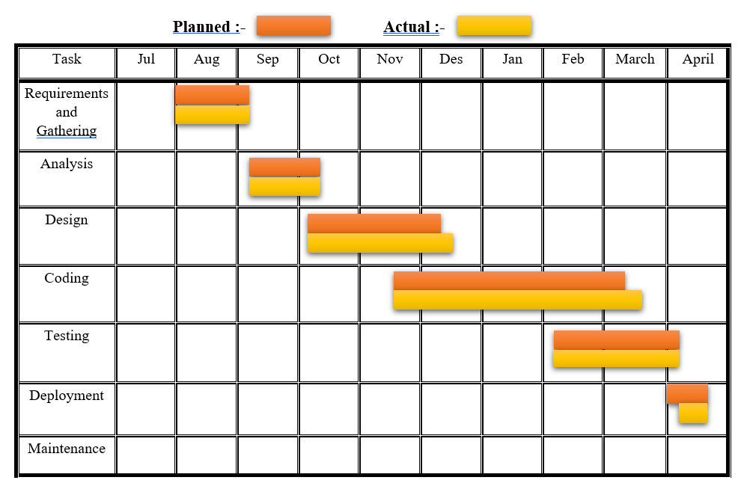

**Figure: - Gantt Chart**

**Chapter 4 - System Design**

1. **Basic Modules:**

Drmedizone is appointment-based project. Any user can take appointment from doctors and take lab appointments and buy medicines. This is a web application. There are some modules present in this web application.

* Doctor appointment management module
* Registration module
* Login module
* Search module
* Doctor management module
* Patient management module
* Appointment scheduled management module
* Payment module
* Filter module
* Medicine shop module
* Lab appointment module
* Admin module

1. **Creation of Diagram:**
2. **ER diagram:**

An entity Relationship diagram is a type of flow chart. ER diagram is used to developing relationship between data-base and show relationship between user and project. In this diagram are used many symbols rectangle, diamond shape, ovals, and connecting lines to show the interconnection of entities, relationships and their attributes. it is a focus on the relationship of basics within entities instead of relationship between entity.

**Entity:**

* + - Entity is real world object.
    - Entity is shown in rectangular structure.
    - In entity are two types of categories; one is a weak entity and second is an associative entity.
    - Weak entity is shown in rectangular figure.
    - Associative entity is shown in diamond shape figure.

**Attribute:**

* + - Attribute is a property of entity.
    - Attributes are shown in oval shape.
    - Two types of attributes categories, one single value attributes and second is Multivalued attributes.
    - In single value attribute are only one attribute value, e.g., birthday date, username etc.
    - In multivalued attributes are more than one attribute value is denoted, egg Multiple address, phone numbers etc.

**Cardinality:**

* + - Describes the numerical characteristics of the relationship between two entities.
    - The three main cardinal relationships are Unary(one-to-one), Binary(one-to-many), and Ternary(many-many).
    - Cardinality relationship diagram are shown in following: -

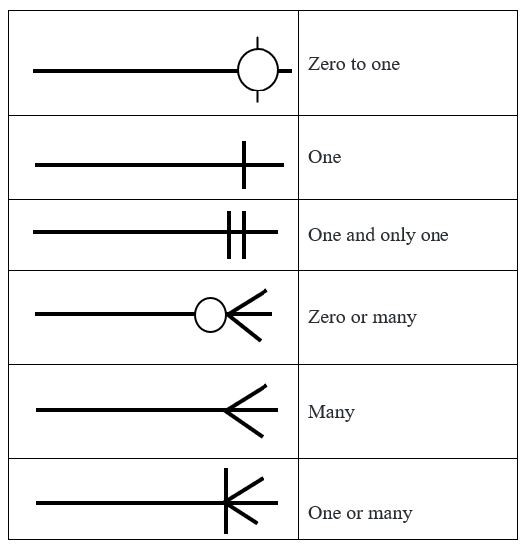

* + **description: Entity Relationship’s shapes and**

|  |  |  |
| --- | --- | --- |
| Shapes name | Shapes | Meaning |
| Rectangle |  | **Entity set** |
| Double outline rectangle |  | **Weak Entity** |
| Diamond | null | **Relationship set** |
| Double outline diamond | null | **Identifying relationship set** |
| Ellipse |  | **Attribute** |
| Ellipse with underline |  | **Primary key attribute** |
| Double line ellipse |  | **Multi-valued attribute** |
| Dashed ellipse |  | **Derived attribute** |
| Line |  | **Link between an entity and relationship** |
| Double line |  | **Total Participants** |

* + **ER diagram part of Drmedizone application:**

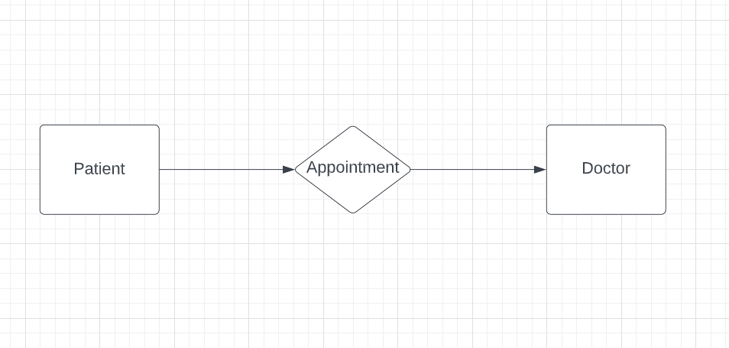

**ER Figure No.:- 1**

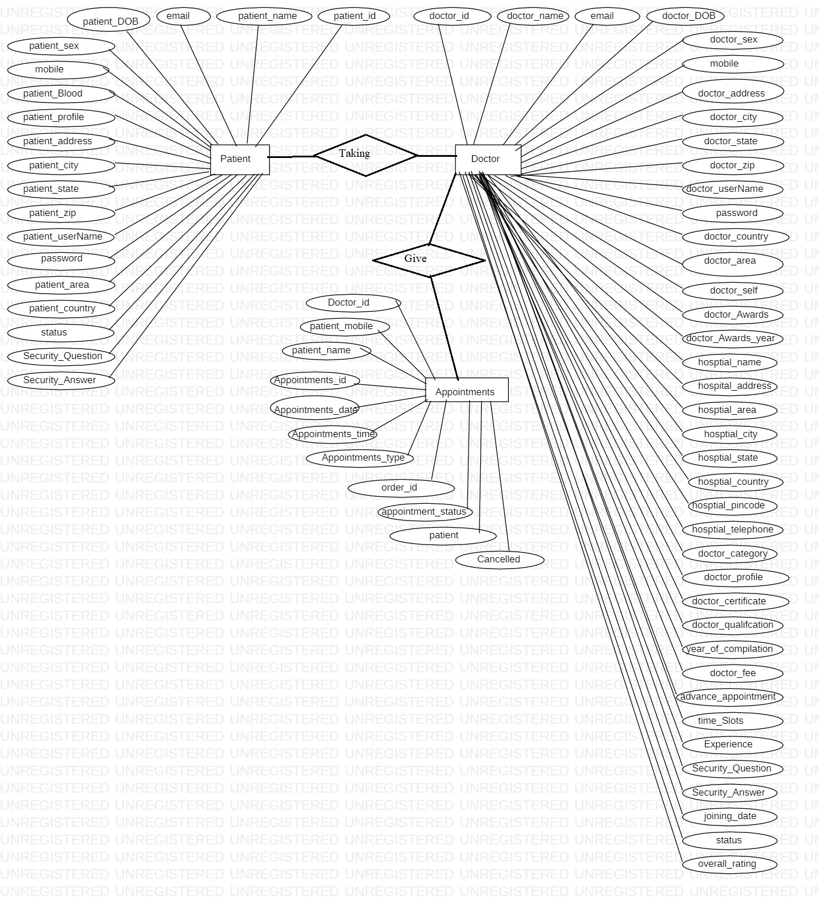

**ER Figure No.:- 2**

* + **ER diagram for Drmedizone database:**

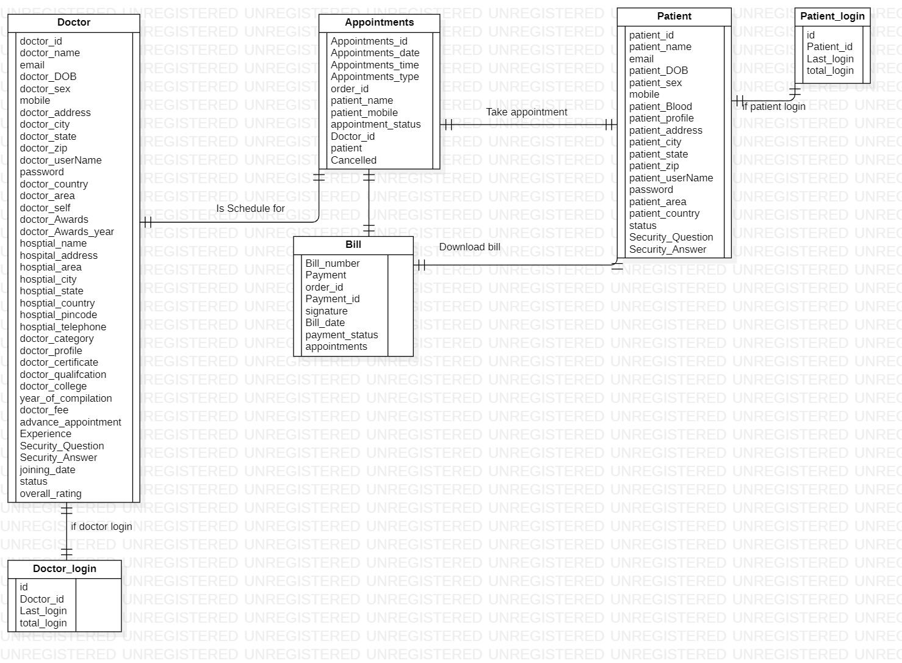

**ER Figure No.:- 3**

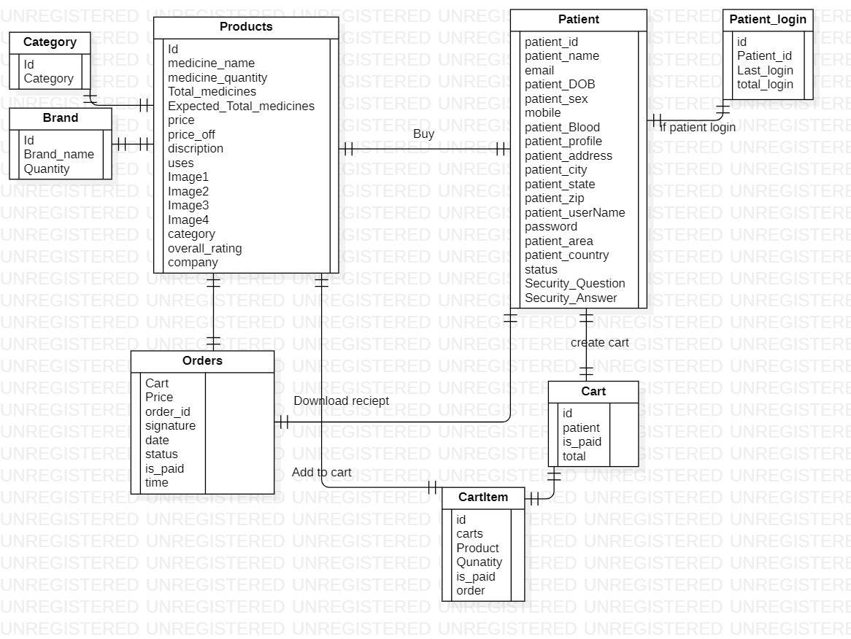

**ER Figure No.:- 4**

1. **Flow Chart:**

Flowcharts are nothing but a graphical representation of truths or a system for better graphical understanding of project. It represents step-by-step solutions to a problem, set of rules, or method. it's a far more figurative way of representing the steps that can be preferred with the help of maximum beginner programmers to understand computer technological know-how procedures, then causal to problem-solving inside the procedure. A flow chart is a picture of stacks that shows how the technology developments with the present. since a flowchart is a graphical design of a procedure, it is easy to understand the system.

* + **Flow chart’s shapes and description:**

|  |  |  |
| --- | --- | --- |
| Name | shapes | Meaning |
| Process |  | Process or action a] step |
| Flow line |  | The direction of process flow |
| Start / terminator |  | Start or end point of process flow |
| Decision |  | Represents a decision-making point |
| Connector |  | Inspection point |
| Inventory |  | Raw material storage |
| Inventory |  | Finished goods storage |
| Preparation |  | Initial setup and other preparation steps before the start of the process flow |
| Alternate process |  | Shows a flow which is an alternative to the normal flow |
| Flow line (dashed) |  | The alternate flow direction of the information flow |
|  |  |  |

* **Flow chart of the Drmedizone:**

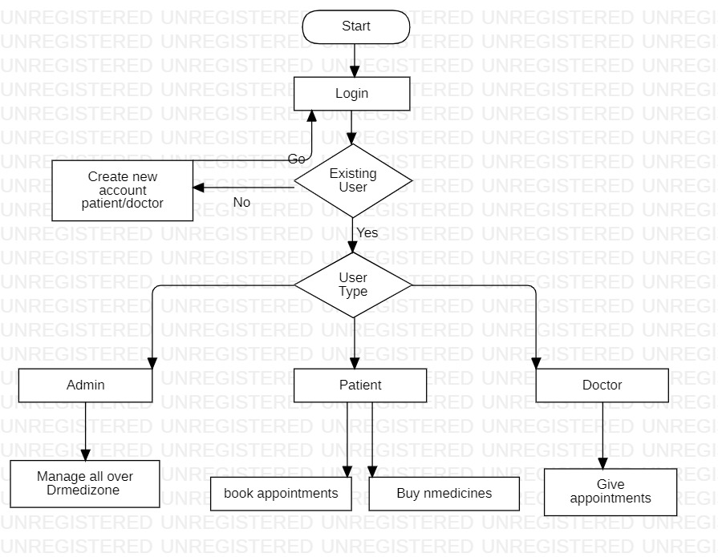

**Flow Chart Figure No.:- 1**

1. **Activity Diagram:**

Activity diagrams help you visualize the flow of work from one activity to the next. It put emphasis on the condition of flow and the order in which it occurs. The flow can be sequential or parallel, and to contract with such kinds of flows, the activity diagram has come up with a fork, join, etc.

**Activity diagram can be used for:**

* Displaying work flow by using activities.
* Displaying business requirements.
* High level understanding of the system's functionalities.
* Examining professional requirements at a future stage.
  + **Activity diagram’s shapes and description:**

|  |  |  |
| --- | --- | --- |
| Name | shape | Meaning |
| Start node |  | The initial state has not yet been used or modified by the activity. An activity diagram starts with this step. |
| Action state |  | A step in which a user or software performs a specific task. It represents the actions taken during this phase of the software system. |
| Control flow |  | Connectors between two states or two actions to show the flow. Shows the order of execution. Also known as roads. |
| Decision node |  | A conditional node or decision node is one where multiple options are available. Or there are two or more conditions that can be considered at a software system point |
| Fork |  | The point from which two concurrent or parallel processes start or start or process. It generally contains one input but may or may not have one output. |
| Join |  | A connection is where two results of concurrent activities add up to form one result. When concatenating, there is more than one input, but only one output is got. Two activities yield two results and one result is obtained. |
| End state |  | This is the last stage of the UML activity diagram. This is where the activity ends in a software system ends. |

* + **Activity diagram for doctor appointment Booking:**

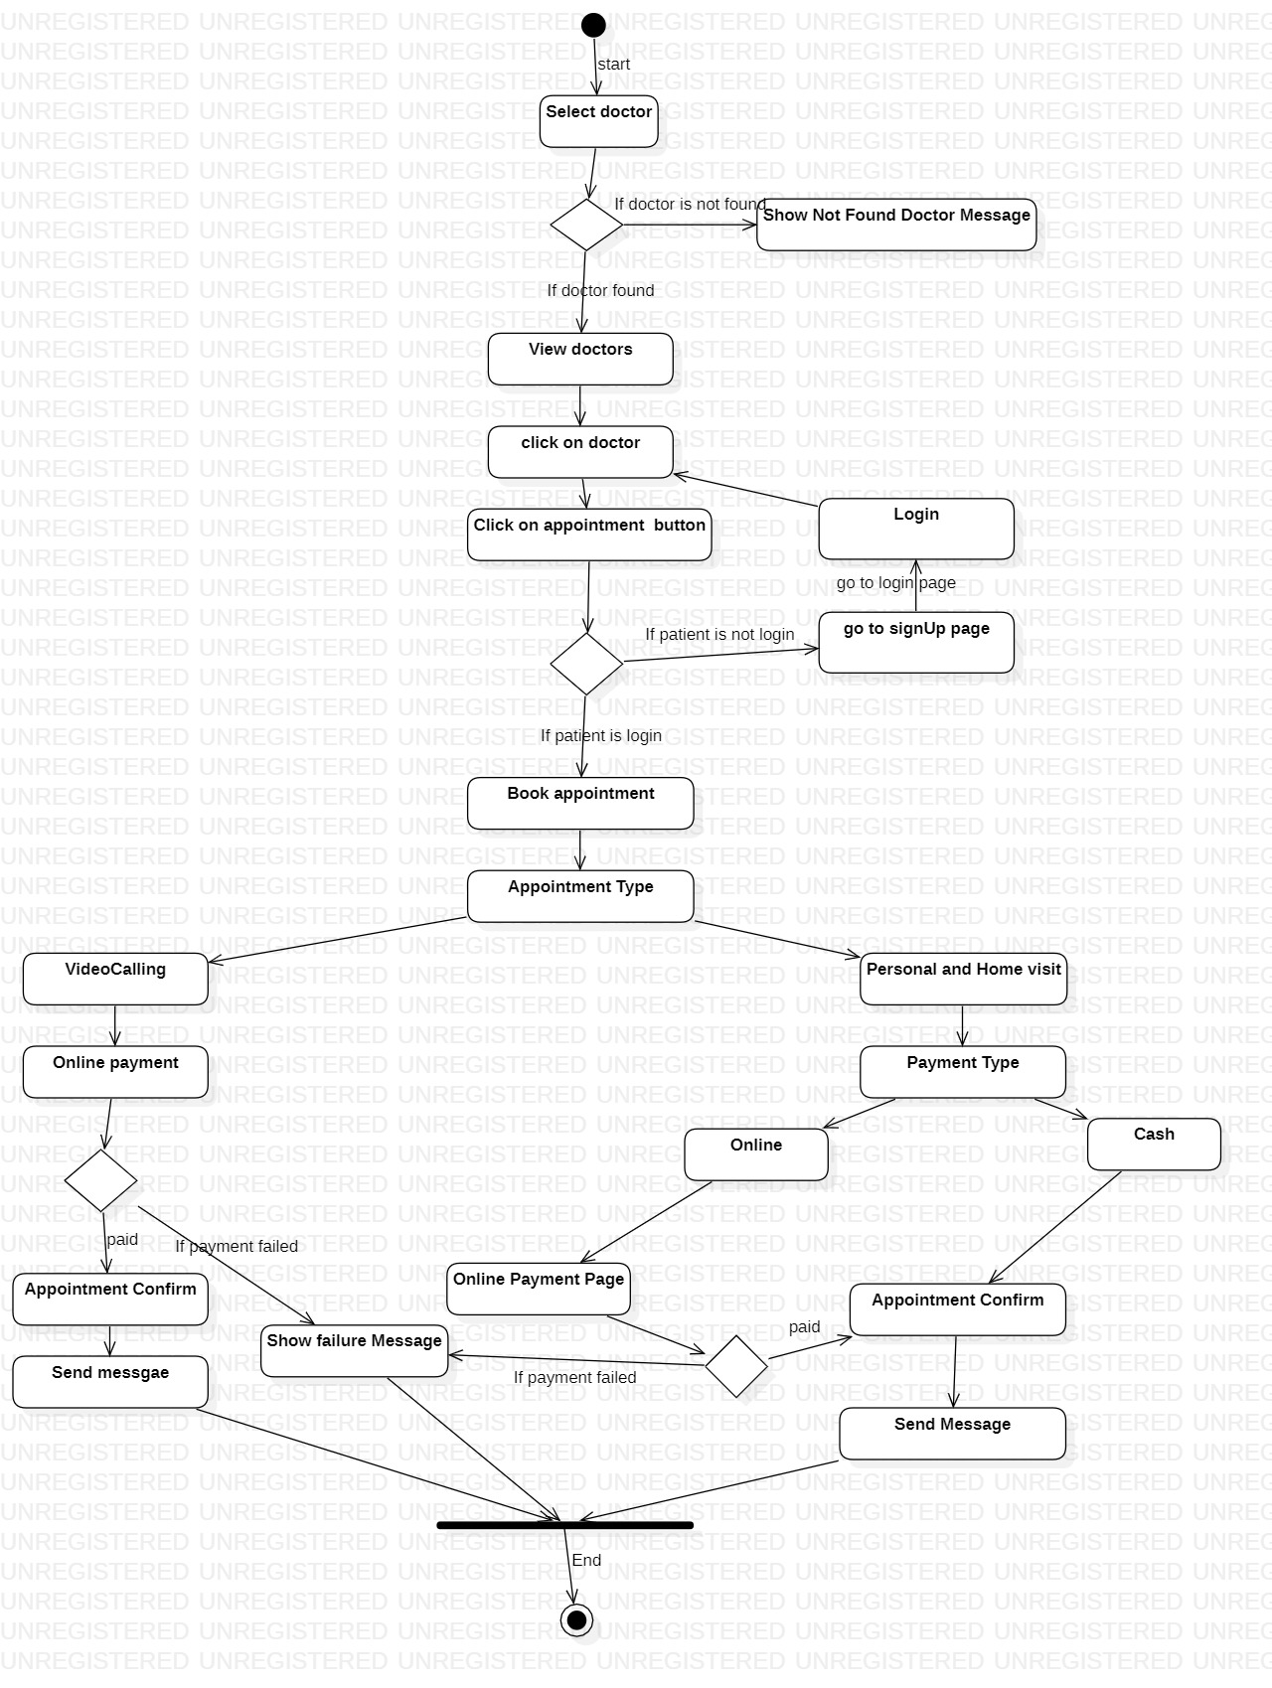

**Activity Figure No.:- 1**

* + **Activity diagram for Buy Medicines:**

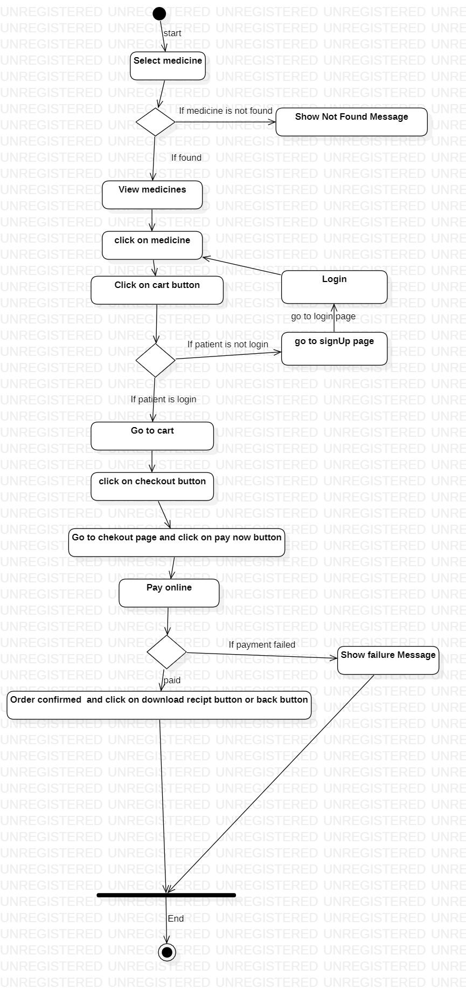

**Activity Figure No.:- 2**

* + **Activity diagram for book Lab Test:**

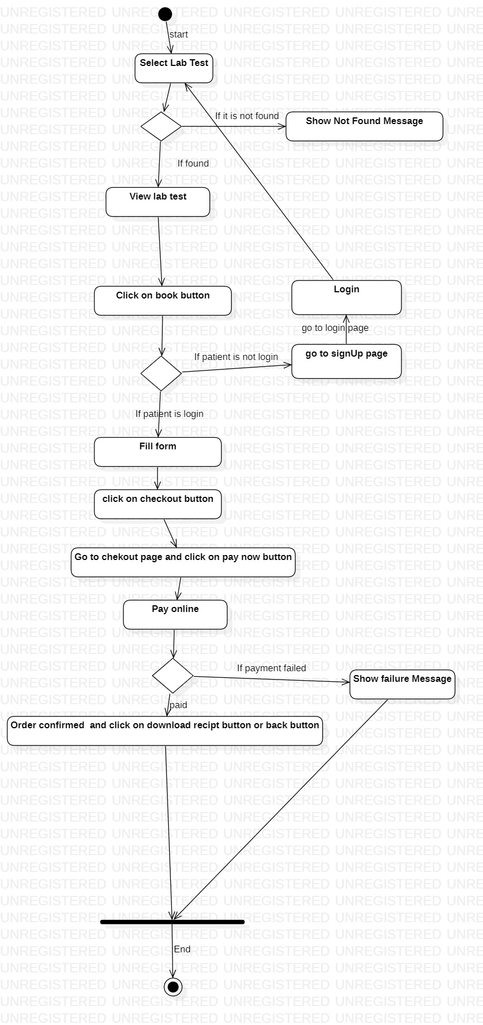

**Activity Figure No.:- 3**

* + **Activity diagram for login:**

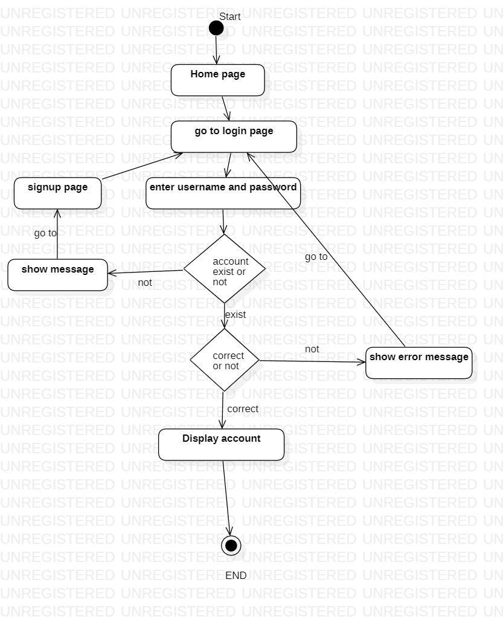

**Activity Figure No.:- 4**

* + **Activity diagram for registration:**

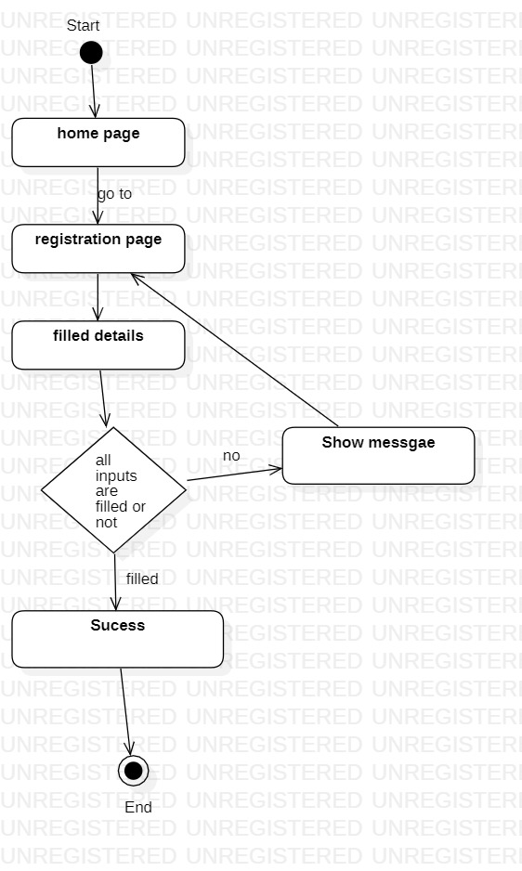

**Activity Figure No.:- 5**

1. **Data flow diagram (DFD):**

DFD is the contraction for data flow Diagram. The breath of records of a device or a development is represented by using DFD. It also gives awareness into the inputs and outputs of each object and the method itself. DFD does not have manage float and no loops or decision rules are gift. particular operations depending at the form of records can be defined with the help of a flowchart. data go with the flow Diagram can be represented in many tactics. The DFD goes to based-evaluation displaying tools. information float diagrams are very famous due to the fact they help us to visualise the primary steps and records concerned in software systems.

**Levels of DFD diagrams: -**

* + 0-Level (context) DFD
  + 1-Level DFD
  + 2-Level DFD
  + **Zero level (context) diagram:**

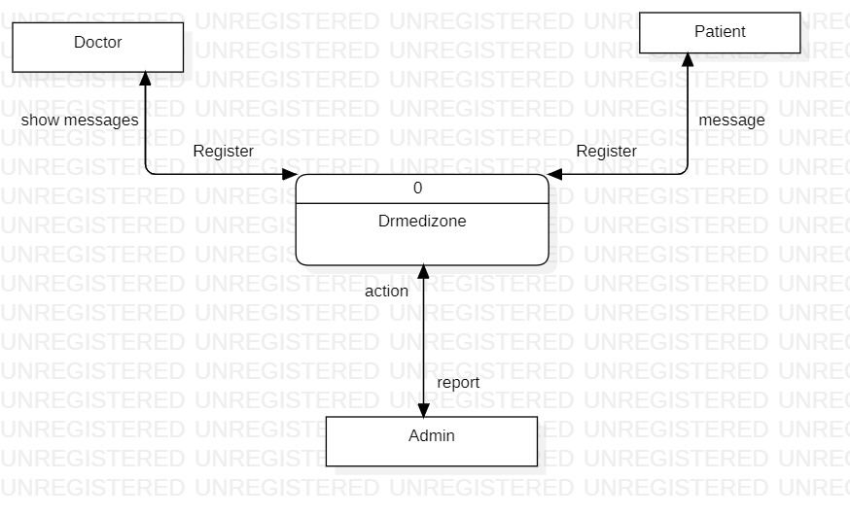

**DFD Figure No.:- 1**

* + - * **First Level Data Flow Diagram (DFD):**

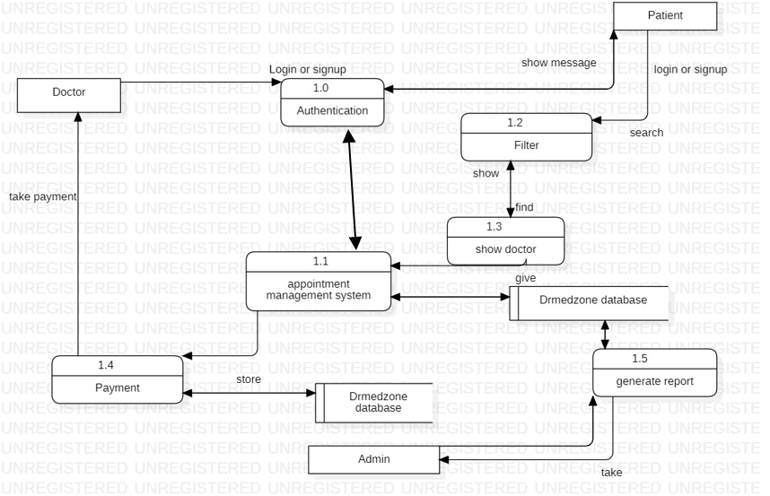

**DFD Figure No.:- 2**

* + **Second Level Data Flow Diagram (DFD):**

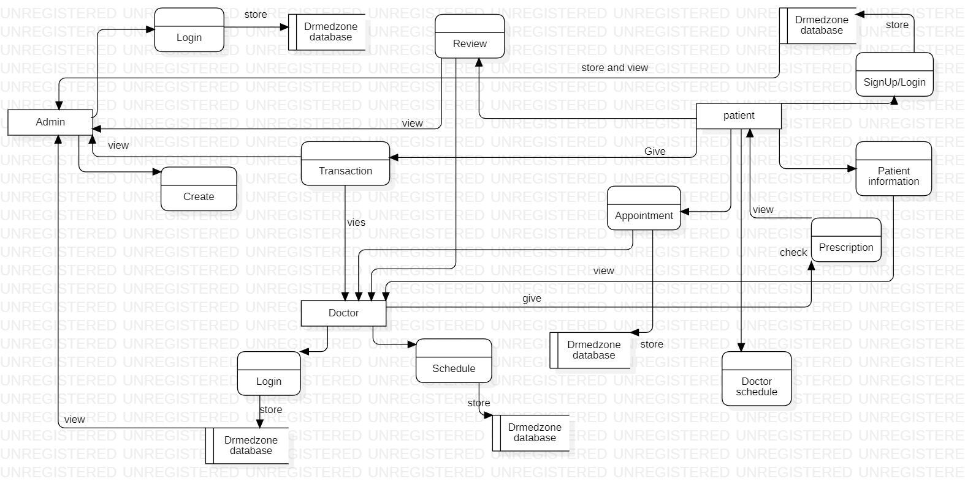

**DFD Figure No.:- 3**

1. **Use case Diagram:**

Use case diagram shows a fixed of use cases, or actors, for a gadget and the relationships among them. The encompass dating provides more capability not exact within the base use case. It does not display the order in which the stairs are achieved to reap the goal of each use case. Use case figure are used to reveal the active behaviour of the system. It summarizes the functionality of the machine with the aid of consisting of use instances, actors and their relationships. model the tasks, services, and features required by using your utility's structures/subsystems. It suggests the excessive-level functionality of the machine and additionally suggests how customers engage with it.

* + A simple and entire use case diagram must be clarified.
  + A use case diagram should constitute the maximum vital interplay among more than one interaction.
  + at the least one module of a machine has to be represented by means of the use case diagram.
  + If the use case diagram is huge and greater complex, then it has to be drawn greater generalized.
  + **Use case diagram for doctor:**

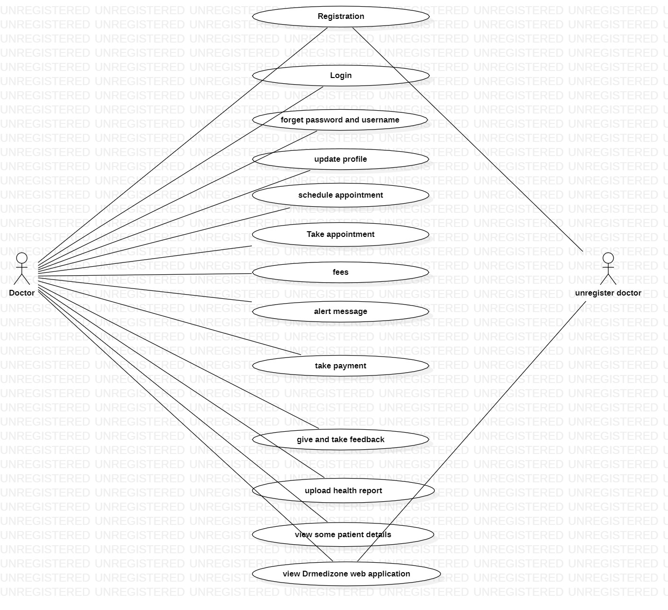

**Use Case Figure No.:- 1**

* + **Use case diagram for admin:**

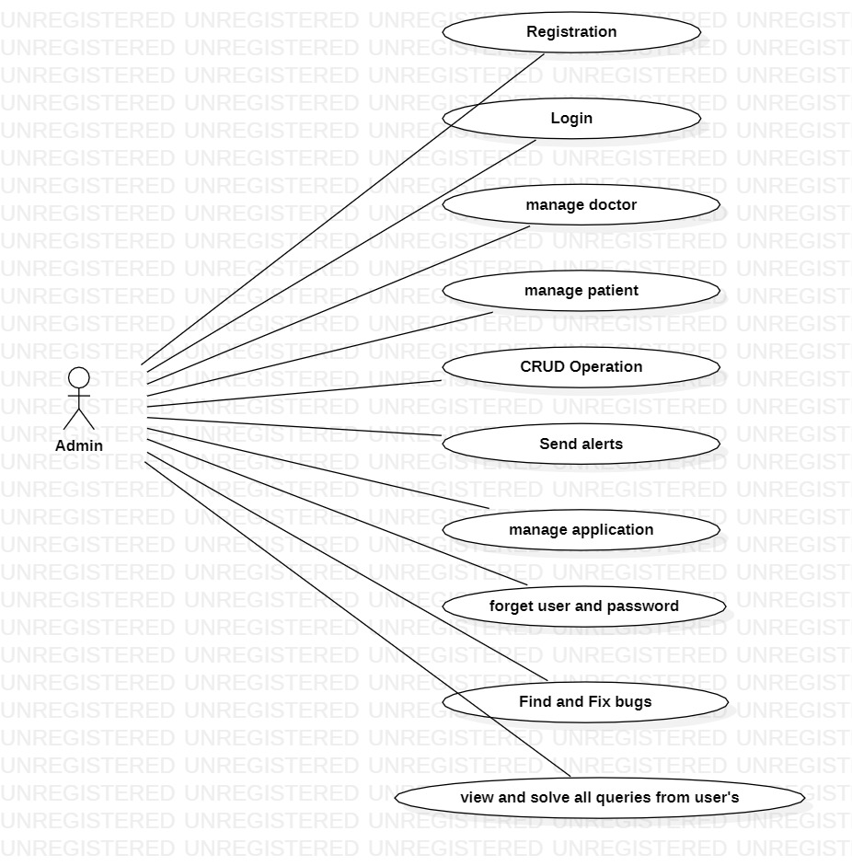

**Use Case Figure No.:- 2**

1. **Sequence Diagram:**

The Sequence diagram represents the go with the movement of messages within the device and is also called as a case diagram. It helps in imagining some dynamic possibilities. It represents the verbal exchange among any two helps as a time-ordered series of activities, such that those lifelines took module on the run time. In UML, the lifeline is represented by way of a vertical bar, while the message glide is represented through a perpendicular dotted line that spreads across the lowest of the page. It includes the iterations as well as branching.

* + **Representations of a Sequence Diagram:**

**Lifeline:**

A man or woman participant inside the series diagram is represented via a lifeline. it's far positioned at the pinnacle of the diagram.

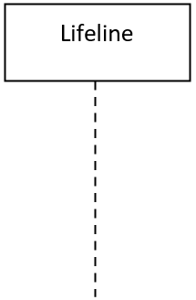

**Actor:**

A character played by means of an entity that relates with the situation is called as an actor.



**Activation:**

It a is represented by a thin rectangle on the lifeline structure. Defines the term in which the process is completed with the help of detail, so the top and lowest of the rectangle are related to the start and finish time.

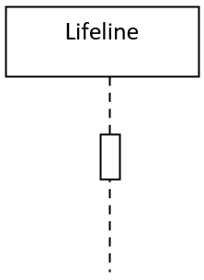

**Note:**

Notice is the possibility to attach many comments to a detail. It basically contains useful information for modellers.

* + **Sequence diagram for login:**

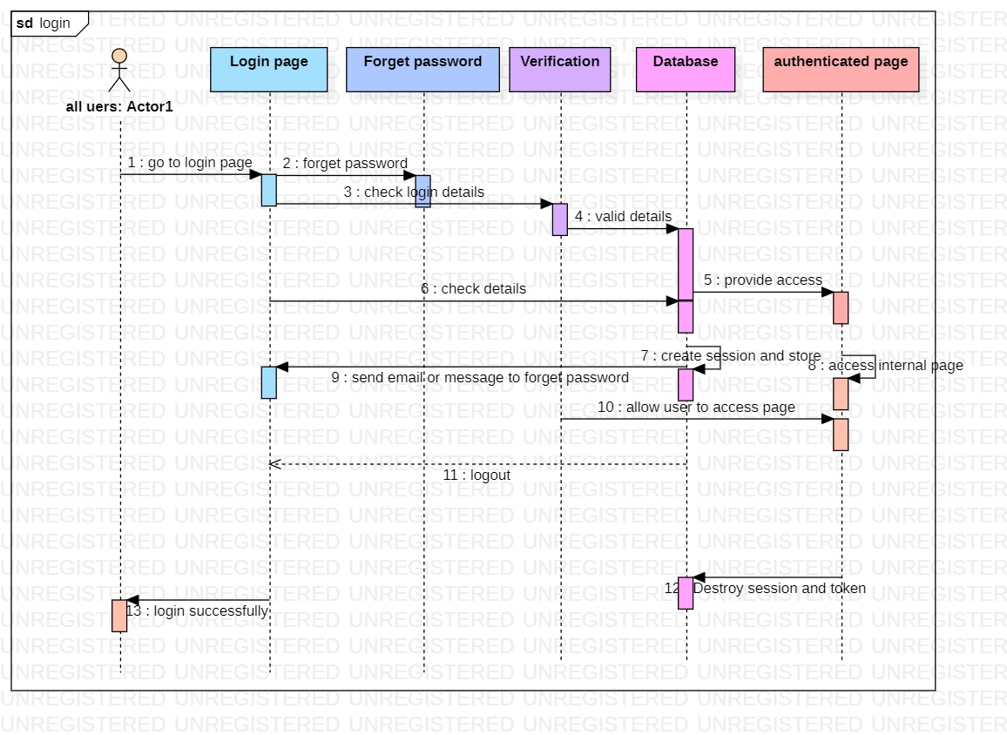

**Sequence Figure No.:- 1**

1. **Class diagram:**

When designing a system or software program, developers will frequently use class figures to plan out what the system will look like in static form. These diagrams allow them to figure out what classes they need, their functionality, and their relationships with other system elements - specifically other classes, processes, attributes, and objects.

**The benefit of class diagram:**

* Class diagrams are simple, fast to read, and gives a logic of orientation.
* They are the foundation for creating systems.
* They provide detailed vision into the structure of your project
* Create complete charts that highlight code required to be programmed and executed to the defined structure.
* Provide an implementation-independent explanation of type used in a project that is later passed on to its components.

**Class notation:**

* + - Class Name:
    - The name of the class is always shown in the first sector. It is the required information.
    - Class Attributes:
    - Attributes are shown in the after-class name sector.
    - The attributes types are show after the colon
    - Attributes are values that define a class.
    - Class Methods:
    - Operations are show in the third sector. They are facilities the class provides.
    - The return type of a method is show after the colon symbol at the end of the method name.
    - The return types of methods parameters are show after the colon.

**Class visibility:**

The symbol before an attributes and operations name in a class represent the visibility of the attributes and operations. Visibility signs are used to determine the availability of the information contained in classes

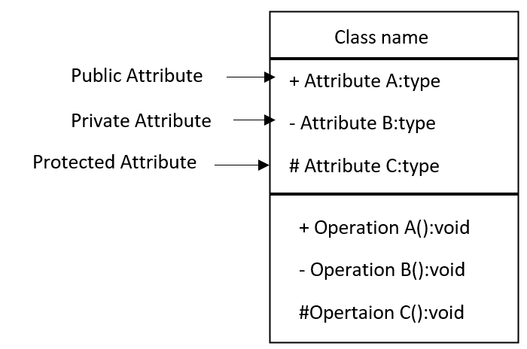

* **Class diagram of the Appointment system:**

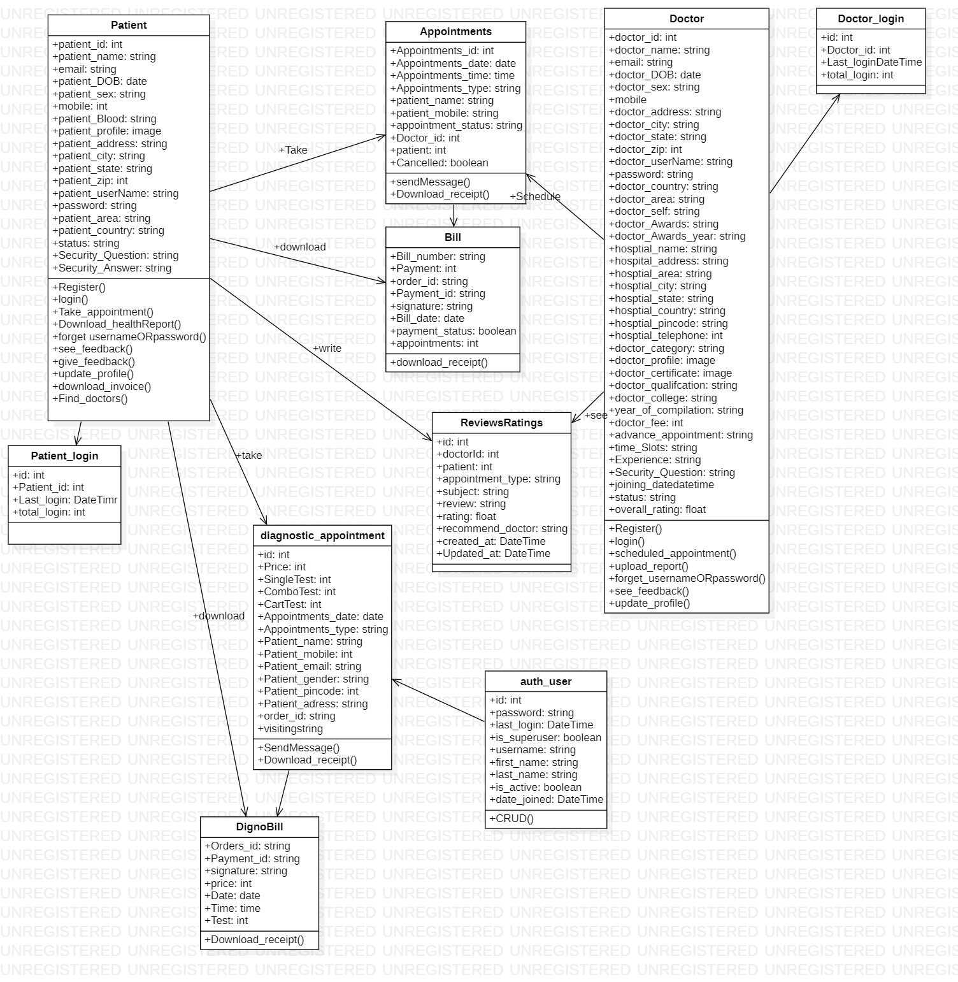

**Class Figure No.:- 1**

* **Class diagram of the order medicine system:**

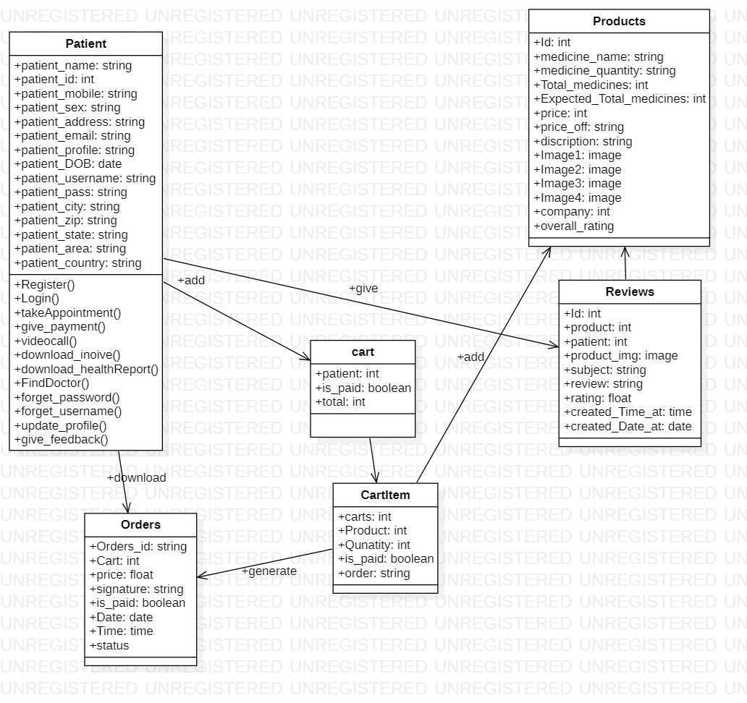

**Class Figure No.:- 2**

1. **List of tables with attributes and constraints:**

* **Patient table:**

|  |  |  |  |
| --- | --- | --- | --- |
| Serial number | Column name | Data types | Constraints |
| 1 | patient_id | int | Primary Key |
| 2 | patient_name | VarChar(50) | Not null |
| 3 | email | VarChar(50) | Not null |
| 4 | patient_sex | VarChar(10) | Not null |
| 5 | mobile | Int | Not null |
| 6 | patient_profile | Image | Not null |
| 7 | patient_address | VarChar(200) | Not null |
| 8 | patient_area | VarChar(50) | Not null |
| 9 | patient_city | VarChar(50) | Not null |
| 10 | patient_state | VarChar(50) | Not null |
| 11 | patient_country | VarChar(50) | Not null |
| 12 | patient_username | VarChar(50) | Not null |
| 13 | password | VarChar(100) | Not null |
| 14 | patient_zip | Int | Not null |
| 15 | patient_DOB | DATE | Not null |
| 16 | patient_Blood | VarChar(50) | Not null |
| 17 | status | VarChar(30) | Not null |
| 18 | Security_Question | VarChar(500) | Not null |
| 19 | Security_Answer | VarChar(500) | Not null |

* **Doctor Table:**

|  |  |  |  |
| --- | --- | --- | --- |
| Serial number | Column name | Data types | Constraints |
| 1 | doctor_id | Int | Primary Key |
| 2 | doctor_name | VarChar(50) | Not null |
| 3 | email | VarChar(50) | Not null |
| 4 | doctor_DOB | Date | Not null |
| 5 | doctor_sex | VarChar(10) | Not null |
| 6 | mobile | Int | Not null |
| 7 | doctor_address | VarChar(200) | Not null |
| 8 | doctor_city | VarChar(50) | Not null |
| 9 | doctor_state | VarChar(50) | Not null |
| 10 | doctor_zip | Int | Not null |
| 11 | doctor_username | VarChar(50) | Not null |
| 12 | password | VarChar(100) | Not null |
| 13 | doctor_country | VarChar(100) | Not null |
| 14 | doctor_area | VarChar(100) | Not null |
| 15 | doctor_self | VarChar(max) | Not null |
| 16 | hospital_address | VarChar(100) | Not null |
| 17 | hospital_area | VarChar(100) | Not null |
| 18 | hospital_pincode | VarChar(60) | Not null |
| 19 | hospital_city | VarChar(100) | Not null |
| 20 | hospital_telephone | Int | Not null |
| 21 | doctor_category | VarChar(50) | Not null |
| 22 | doctor_profile | Image | Not null |
| 23 | doctor_certificate | Image | Not null |
| 24 | doctor_qualification | VarChar(100) | Not null |
| 25 | doctor_fee | int | Not null |
| 26 | advanced_appointment | int | Not null |
| 27 | status | VarChar(50) | Not null |
| 28 | doctor_Awards | VarChar(100) | Not null |
| 29 | doctor_Awards_year | VarChar(100) | Not null |
| 30 | hosptial_name | VarChar(100) | Not null |
| 31 | hosptial_state | VarChar(100) | Not null |
| 32 | hosptial_country | VarChar(100) | Not null |
| 33 | doctor_college | VarChar(100) | Not null |
| 34 | year_of_compilation | VarChar(100) | Not null |
| 35 | time_Slots | VarChar(1000) | Not null |
| 36 | Experience | Int | Not null |
| 37 | Security_Answer | VarChar(500) | Not null |
| 38 | Security_Question | VarChar(500) | Not null |
| 39 | joining_date | Date | Not null |
| 40 | overall_rating | Float | Not null |
|  |  |  |  |

* **Doctor login table:**

|  |  |  |  |
| --- | --- | --- | --- |
| Serial number | Column name | Data type | Constraints |
| 1 | id | int | Primary Key |
| 3 | Doctor_id | Int | Florigen Key |
| 4 | total_login | Int | Not null |
| 5 | last_login | Date | Not null |

* **Patient login table:**

|  |  |  |  |
| --- | --- | --- | --- |
| Serial number | Column name | Data type | Constraints |
| 1 | id | int | Primary Key |
| 2 | Patient _id | Int | Foreign Key |
| 6 | total_login | Int | Not null |
| 7 | last_login | Date | Not null |

* **Appointment Table:**

|  |  |  |  |
| --- | --- | --- | --- |
| Serial number | Column name | Data types | Constraints |
| 1 | Appointments_id | int | Primary Key |
| 2 | Appointments_date | Date | Not null |
| 3 | Appointments_time | Time | Not null |
| 4 | Appointments_type | VarChar(60) | Not null |
| 5 | Doctor_id | int | Foreign Key |
| 6 | Doctor_name | VarChar(60) | Not null |
| 7 | Patient | int | Foreign Key |
| 8 | patient_name | VarChar(100) | Not null |
| 9 | order_id | VarChar(100) | Not null |
| 10 | appointment_status | VarChar(30) | Not null |
| 11 | patient_mobile | VarChar(100) | Not null |
| 12 | Cancelled | Boolean | Not null |

* **Auth_user table:**

|  |  |  |  |
| --- | --- | --- | --- |
| Serial number | Column name | Data types | Constraints |
| 1 | id | int | Primary Key |
| 2 | password | VarChar(60) | Not null |
| 3 | last_login | DateTime | Not null |
| 4 | is_superuser | Boolean | Not null |
| 5 | username | VarChar(60) | Not null |
| 6 | first_name | VarChar(60) | Not null |
| 7 | last_name | VarChar(60) | Not null |
| 8 | email | VarChar(60) | Not null |
| 9 | is_staff | Boolean | Not null |
| 10 | is_active | Boolean | Not null |
| 11 | date_joined | DateTime | Not null |

* **QNA Table:**

|  |  |  |  |
| --- | --- | --- | --- |
| Serial number | Column name | Data types | Constraints |
| 1 | id | int | Primary Key |
| 2 | Question | VarChar(500) | Not null |
| 3 | Answer | VarChar(500) | Not null |
| 4 | Email | Email | Not null |
| 5 | complete | Boolean | Not null |
| 6 | patient | Int | Foreign Key |

* **diagnostic_test_list**

|  |  |  |  |
| --- | --- | --- | --- |
| Serial number | Column name | Data types | Constraints |
| 1 | id | int | Primary Key |
| 2 | name | VarChar(100) | Not null |
| 3 | price | Int | Not null |
| 4 | Who_should_book_this_checkup | VarChar(max) | null |
| 5 | What_preparation_is_needed_for_this_Checkup | VarChar(max) | null |
| 6 | Age_Group | VarChar(100) | Not null |
| 7 | Gender | VarChar(200) | Not null |
| 8 | image | Image | Not null |
| 9 | Home_visit | Boolean | Not null |

* **diagnostic_test_list**

|  |  |  |  |
| --- | --- | --- | --- |
| Serial number | Column name | Data types | Constraints |
| 1 | id | int | Primary Key |
| 2 | name | VarChar(100) | Not null |
| 3 | price | Int | Not null |
| 4 | Who_should_book_this_checkup | VarChar(max) | null |
| 5 | What_preparation_is_needed_for_this_Checkup | VarChar(max) | null |
| 6 | Age_Group | VarChar(200) | Not null |
| 7 | Gender | VarChar(200) | Not null |
| 8 | image | Image | Not null |
| 9 | details | VarChar(max) | Not null |

* **dignostic_test_cart Table**

|  |  |  |  |
| --- | --- | --- | --- |
| Serial number | Column name | Data types | Constraints |
| 1 | id | Int | Primary Key |
| 2 | patient | Int | Foreign Key |

* **dignostic_test_cartItems Table**

|  |  |  |  |
| --- | --- | --- | --- |
| Serial number | Column name | Data types | Constraints |
| 1 | id | Int | Primary Key |
| 2 | carts | Int | Foreign Key |
| 3 | Tests | Int | Foreign Key |
| 4 | order | VarChar(500) | Not null |
| 5 | is_paid | Boolean | Not null |

* **diagnostic_appointment Table**

|  |  |  |  |
| --- | --- | --- | --- |
| Serial number | Column name | Data types | Constraints |
| 1 | id | int | Primary Key |
| 2 | patient | Int | Foreign Key |
| 3 | Price | Int | Not null |
| 4 | SingleTest | Int | Foreign Key |
| 5 | ComboTest | Int | Foreign Key |
| 6 | CartTest | Int | Foreign Key |
| 7 | Appointments_date | Date | Not null |
| 8 | Appointments_type | VarChar(100) | Not null |
| 9 | Patient_name | VarChar(100) | Not null |
| 10 | Patient_mobile | Int | Not null |
| 11 | Patient_email | Email | Not null |
| 12 | Patient_gender | VarChar(100) | Not null |
| 13 | Patient_pincode | Int | Not null |
| 14 | Patient_adress | VarChar(300) | Not null |
| 15 | order_id | VarChar(100) | Not null |
| 16 | visiting | VarChar(100) | Not null |
|  |  |  |  |

* **DignoBill Table**

|  |  |  |  |
| --- | --- | --- | --- |
| Serial number | Column name | Data types | Constraints |
| 1 | Orders_id | VarChar(500) | Primary Key |
| 2 | Payment_id | VarChar(100) | null |
| 3 | signature | VarChar(500) | null |
| 4 | price | float | Not null |
| 5 | Date | Date | Not null |
| 6 | Time | Time | Not null |
| 7 | Test | int | Foreign Key |
|  |  |  |  |

* **ReviewsRatings Table**

|  |  |  |  |
| --- | --- | --- | --- |
| Serial number | Column name | Data types | Constraints |
| 1 | id | Int | Primary Key |
| 2 | Payment_id | VarChar(100) | Not null |
| 3 | appointment_type | VarChar(100) | Not null |
| 4 | health_concern | VarChar(100) | Not null |
| 5 | subject | VarChar(100) | Not null |
| 6 | review | VarChar(max) | Not null |
| 7 | rating | Float | Not null |
| 8 | recommend_doctor | VarChar(50) | Not null |
| 9 | created_at | DateTime | Not null |
| 10 | Updated_at | DateTime | Not null |
| 11 | doctorId | Int | Foreign Key |
| 12 | patient | int | Foreign Key |

* **Products Table**

|  |  |  |  |
| --- | --- | --- | --- |
| Serial number | Column name | Data types | Constraints |
| 1 | Id | Int | Primary Key |
| 2 | medicine_name | VarChar(200) | Not null |
| 3 | medicine_quantity | VarChar(200) | Not null |
| 4 | Total_medicines | Int | Not null |
| 5 | Expected_Total_medicines | Int | Not null |
| 6 | price_off | VarChar(200) | Not null |
| 7 | discription | VarChar(1000) | Not null |
| 8 | price | Float | Not null |
| 9 | uses | VarChar(500) | Not null |
| 10 | Image1 | Image | Not null |
| 11 | Image2 | Image | Not null |
| 12 | Image3 | Image | Not null |
| 13 | Image4 | Image | Not null |
| 14 | category | int | Foreign Key |
| 15 | company | Int | Foreign Key |
| 16 | overall_rating | Float | Not null |

* **Category Table:**

|  |  |  |  |
| --- | --- | --- | --- |
| Serial number | Column name | Data types | Constraints |
| 1 | id | Int | Primary Key |
| 2 | Category | VarChar(200) | Not null |

* **Brand Table**

|  |  |  |  |
| --- | --- | --- | --- |
| Serial number | Column name | Data types | Constraints |
| 1 | Id | Int | Primary Key |
| 2 | Brand_name | VarChar(200) | Not null |
| 3 | Quantity | Int | Not null |

* **Cart Table**

|  |  |  |  |
| --- | --- | --- | --- |
| Serial number | Column name | Data types | Constraints |
| 1 | id | Int | Primary Key |
| 2 | patient | Int | Foreign Key |
| 3 | is_paid | Boolean | Not null |
| 4 | total | Int | Not null |

* **CartItem Table**

|  |  |  |  |
| --- | --- | --- | --- |
| Serial number | Column name | Data types | Constraints |
| 1 | id | Int | Primary Key |
| 2 | carts | Int | Foreign Key |
| 3 | Product | Int | Foreign Key |
| 4 | Qunatity | Int | Not null |
| 5 | is_paid | Boolean | Not null |
| 6 | order | VarChar(500) | Not null |

* **Orders Table**

|  |  |  |  |
| --- | --- | --- | --- |
| Serial number | Column name | Data types | Constraints |
| 1 | Orders_id | VarChar(500) | Primary Key |
| 2 | carts | Int | Foreign Key |
| 3 | price | Int | Not null |
| 4 | signature | Int | Not null |
| 5 | is_paid | Boolean | Not null |
| 6 | Date | Date | Not null |
| 7 | Time | Time | Not null |
| 8 | status | VarChar(50) | Not null |

* **Wishlist Table**

|  |  |  |  |
| --- | --- | --- | --- |
| Serial number | Column name | Data types | Constraints |
| 1 | id | Int | Primary Key |
| 2 | patient | Int | Foreign Key |
| 3 | total | Int | Not null |

* **wishlistItem Table**

|  |  |  |  |
| --- | --- | --- | --- |
| Serial number | Column name | Data types | Constraints |
| 1 | id | Int | Primary Key |
| 2 | WishlistProduct | Int | Foreign Key |
| 3 | Product | Int | Foreign Key |

* **Bill Table:**

|  |  |  |  |
| --- | --- | --- | --- |
| Serial number | Column name | Data types | Constraints |
| 1 | Bill_number | VarChar(60) | Primary Key |
| 2 | Payment | Int | Not null |
| 3 | order_id | VarChar(60) | Not null |
| 4 | Payment_id | VarChar(60) | Not null |
| 5 | signature | VarChar(60) | Not null |
| 6 | Bill_date | DateTime | Not null |
| 7 | appointments | Int | Foreign Key |

1. **Test Cases:**

|  |  |  |  |
| --- | --- | --- | --- |
| System Name: - | Drmedizone | | |
| Module code: - | **Dr_001** | | |
| Pass | 0 | **Pending:-** | 7 |
| Fail | 0 | **Number of test case:-** | 7 |

|  |  |  |  |  |
| --- | --- | --- | --- | --- |
| Test case Id | Test case | Expected Output | Actual Output | Result |
| Dr_001L1 | Correct Username and password | Redirect on profile page |  |  |
| Dr_001L2 | Correct Username and Invalid password | Show error message:-  Password is invalid. |  |  |
| Dr_001L3 | Invalid Username and  Correct password | Show error message:-  Username is invalid. |  |  |
| Dr_001L4 | Invalid Username and  Invalid password | Show error message:-  Username and password are invalid. | . |  |
| Dr_001L5 | Username input box is empty and  Correct password | Show error message:-  Please enter username |  |  |
| Dr_001L6 | Correct Username and password input box is empty | Show error message:-  Please enter password |  |  |
| Dr_001L7 | Username and password input boxes both are empty | Show error message:-  Please enter username and password |  |  |
| Dr_001L8 | Input boxes are empty | Show error message:- Enter all necessary details are required |  |  |
| Dr_001L9 | Click submit button | Submit the form and show message:-  Submitted successfully |  |  |
| Dr_001L10 | If doctor schedule is busy | Show message:-  Doctor is not available |  |  |
| Dr_001L11 | Search doctor by name | Show list of all related name of doctors |  |  |
| Dr_001L12 | Search doctor by categories | Show list of all related category of doctors |  |  |
| Dr_001L13 | Search doctor by fees | Show list of all related doctors |  |  |
| Dr_001L14 | Upload health report | Show message:-Upload successfully |  |  |
| Dr_001L15 | Download health report | Show message:-download successfully |  |  |
| Dr_001L16 | Doctor is not found | Show message:- Doctor is not found |  |  |
| Dr_001L17 | Click get appointment button | Open appointment form |  |  |
| Dr_001L18 | Click doctor button | Show list of all doctors |  |  |
| Dr_001L19 | Click get appointment button but patient is not login | Open login form |  |  |
| Dr_001L20 | Click on doctor profile | Show all doctor details |  |  |

**Chapter 5 – Implementation And Testing**

1. **Model used**

* **Incremental Model**

The incremental model is used when the requirements for the basic product are understood.

Several deliverables are defined independently and the workflow is linear. repeat again

in nature and increasingly focus on practical products.

1. **Details of tools and technologies used:**
2. **Details of tools:**
   * **VS Code:**

It is a free and open source application. VS Code has many features, including support for multiple programming languages, code debugging, debugging, and Git integration. There is also a robust extension market where users can download and install extensions to enhance the editor's functionality. It has a user friendly UI with customizable themes and settings. It has supports integrated terminal functionality that allows users to run commands and execute code in the editor. It also has a live support feature that allows you to edit in real time. Overall, It is a versatile and powerful code editor suitable for a wide range of programming problems.

* + **MySQL Workbench:**

It is a UI for database design and management tool. It provides a graphical interface for creating and modifying database structures, as well as managing data and queries. MySQL Workbench supports several database management systems, including MySQL, MariaDB, and other RDBMS systems. It also has a built in editor with syntax and autocompletion features. MySQL Workbench offers database backup and allows users to easily backup and restore databases. It has a user-friendly UI with customizable themes and settings. Overall, MySQL Workbench is a powerful database design and management tool suitable for both new and experienced database administrators.

1. **Details of technologies:**

* **HTML/CSS:**

HTML is a markup language used to create the structure and content of web pages. CSS is a styling language used to control the presentation and layout of web pages. HTML uses tags to define different types of content, such as headers, paragraphs, and images. HTML and CSS work together to create attractive and functional Web application s. HTML, CSS are used for the presentation of the Web application .

* **Bootstrap:**

Bootstrap is a frontend development framework for building responsive Web application s. Bootstrap includes pre-built HTML and CSS templates as well as JavaScript plugins to speed up development. Bootstrap uses a mesh framework to easily create flexible and responsive layouts for Web application s. Bootstrap includes many UI components such as buttons, views, tables, and navigation menus to help create a Web application . Bootstrap is free to use.

* **Python:**

It's simple to read, develop, and maintain python. it's a high level anguage. Data analysis, Python, web development, artificial intelligence, etc. Because Python is platform unaffected and is compatible with a wide range of operating systems, including Windows, macOS, and Linux, it is utilised for a wide variety of applications. Since it is an interpreted language, no coding is required for its operation. Python emphasizes programmed readability with simple syntax. Functional and object oriented programming is available.

* **Django Framework:**

To create web applications with Python, use the high-level web framework Django. Django uses the MVC architectural model to break down tasks in small portions. For common web application development tasks like authentication, routing, and database admin, Django comes with a tonne of built-in tools. The ORM framework is used by Django to make working with databases simpler.

* **MySQL:**

Data may be stored, managed, and retrieved using MySQL, an open source RDBMS. Many programming languages are compatible with MySQL, which is commonly used for online applications. MySQL performs CRUD processes and data interaction via Structured Query Language. Windows, macOS, and Linux are just a few of the various operating systems on which MySQL may be used. With features like encryption, access control, MySQL is quite safe.

1. **Details for hardware used:**

|  |  |
| --- | --- |
| Components | Hardware Used |
| Processor | Intel(R) Core(TM) i5-10300H CPU @ 2.50GHz 2.50 GHz |
| RAM | 8.00 GB |
| System type | 64-bit operating system, x64-based processor |

1. **Source Code:**

**Snippets of Import statements of codes**

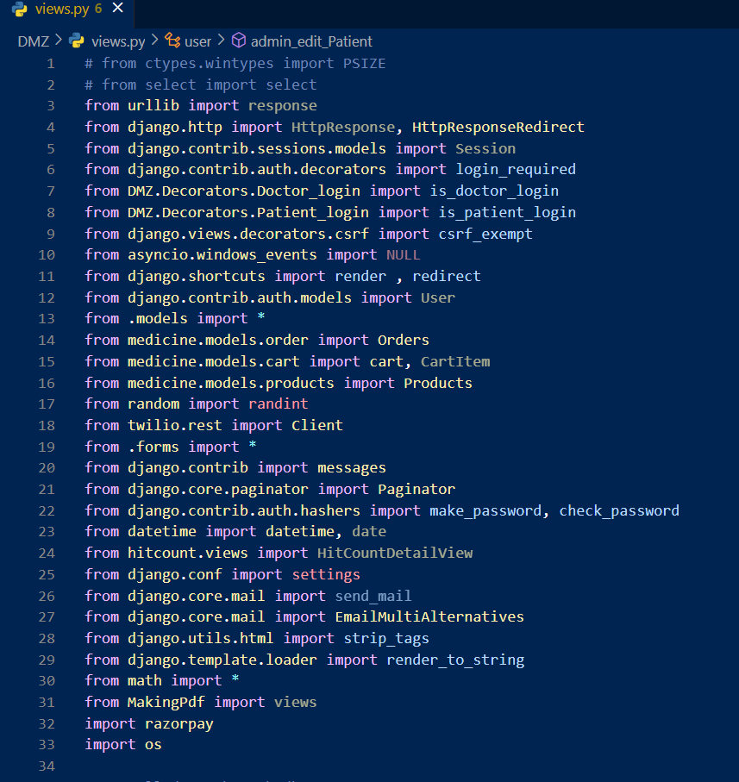

**Snippets code of send email messages and otp:**

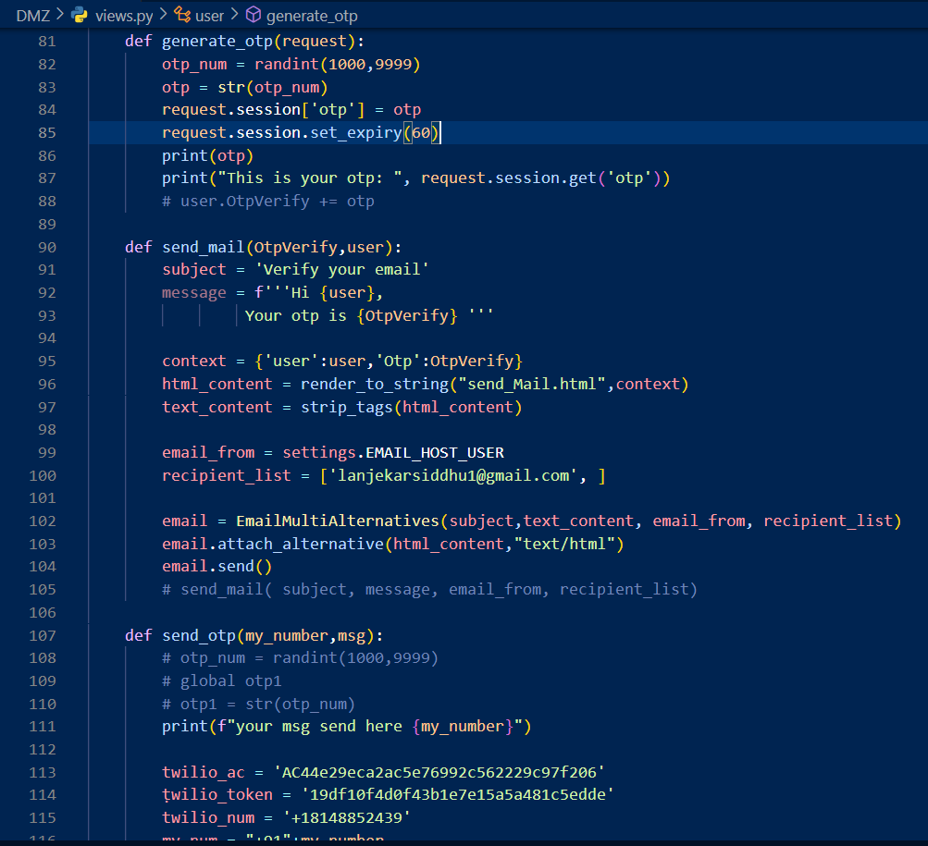

**Snippets of view.py file:**

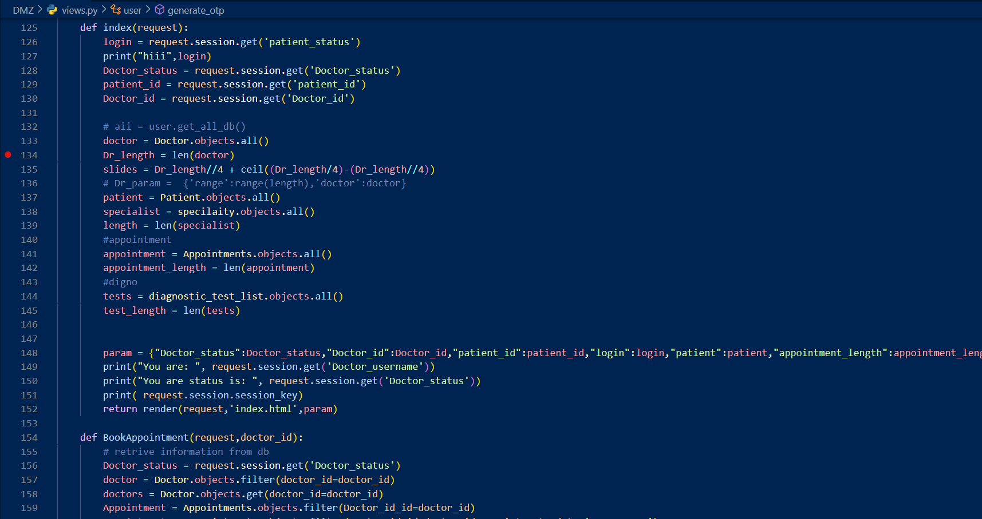

**Snippets code of Doctor Dashboard:**

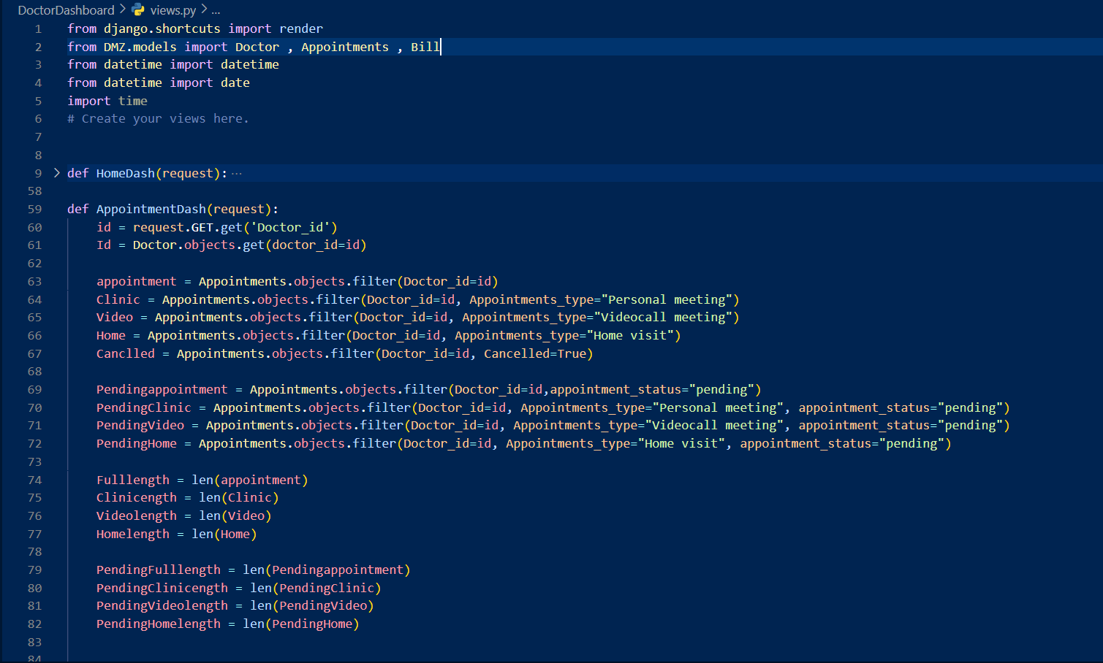

**Snippets code of patient dashboard:**

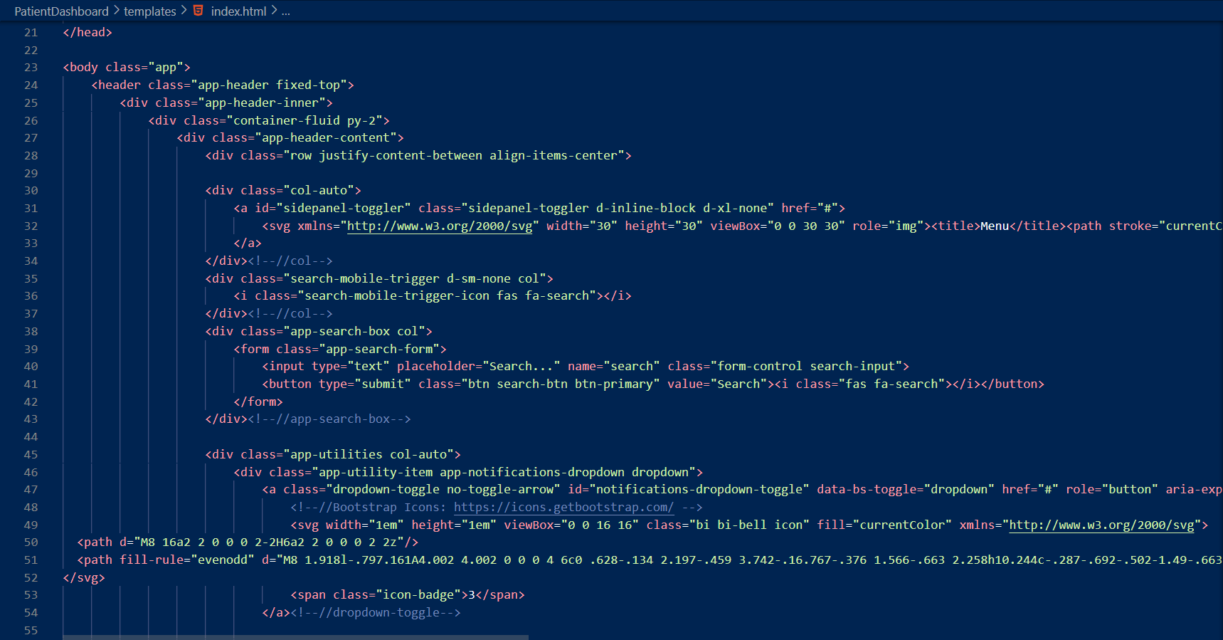

**Snippets code of admin dashboard:**

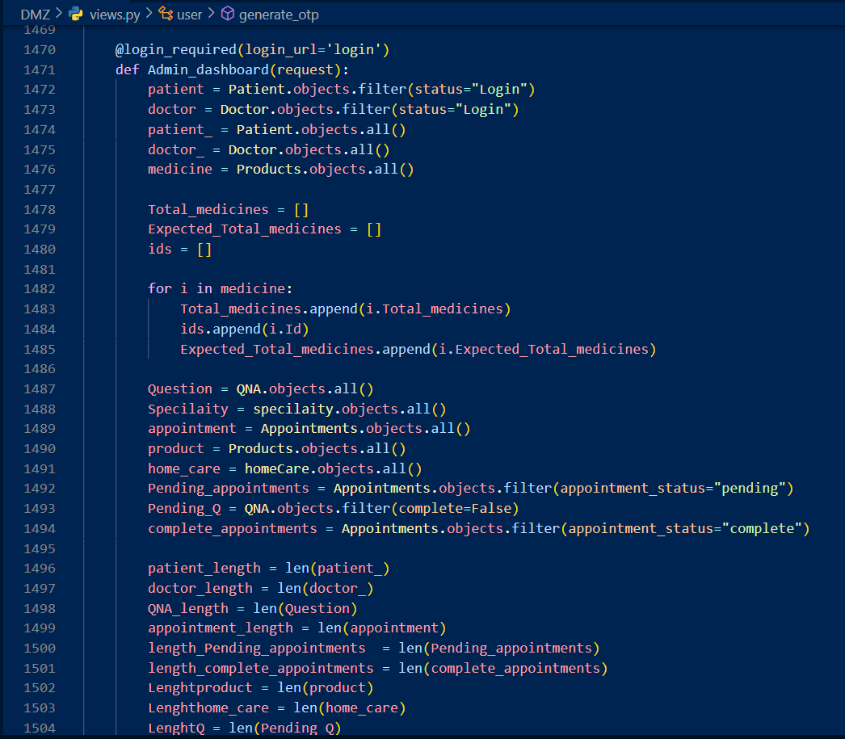

**Snippets code of generator and download code:**

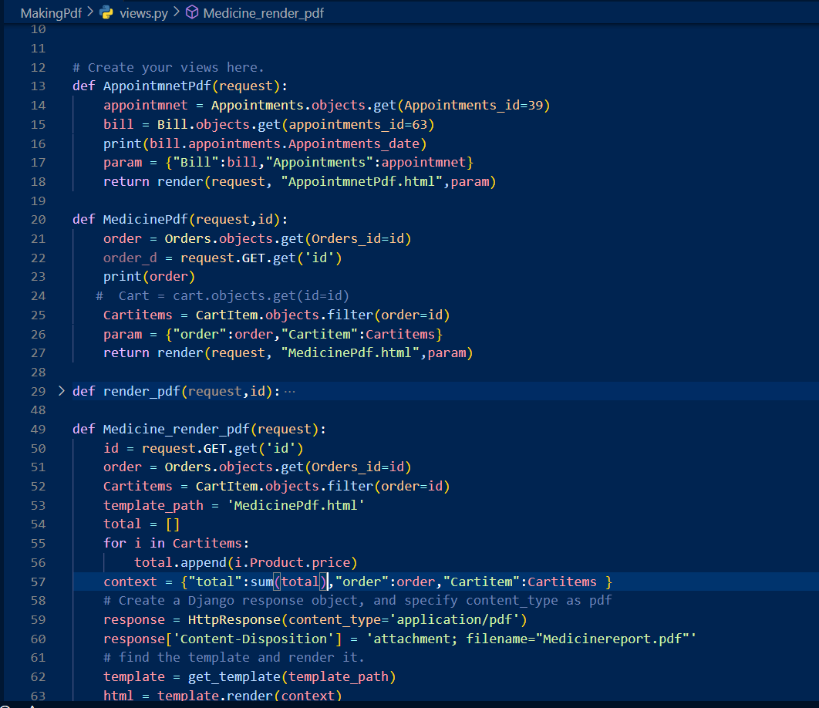

**Snippets of medicine part of code:**

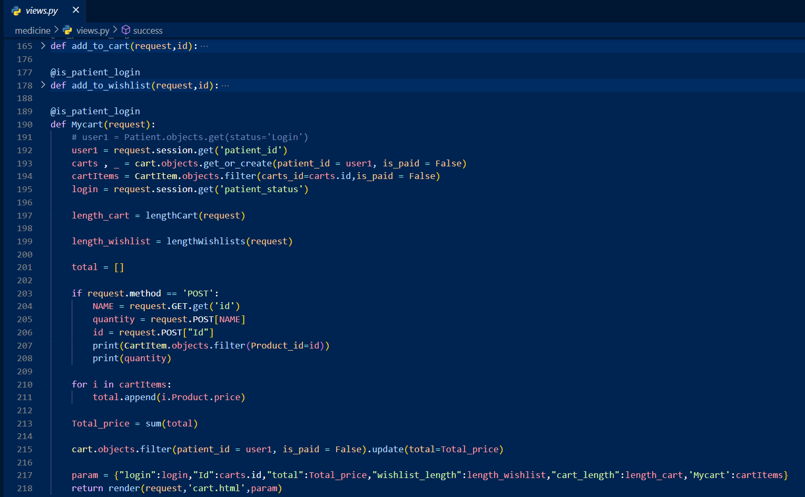

**Snippets of Routing code:**

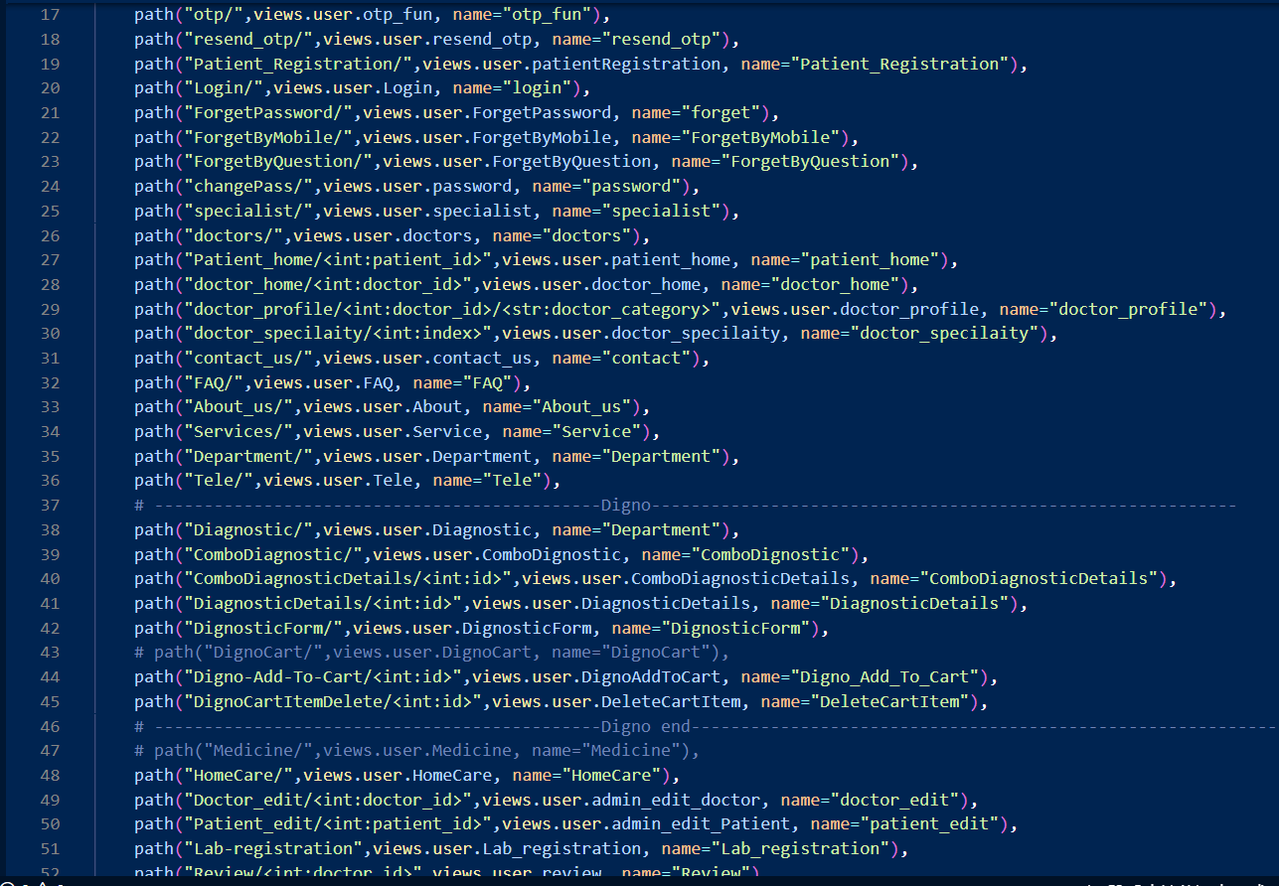

**Snippets of Database model code:-**

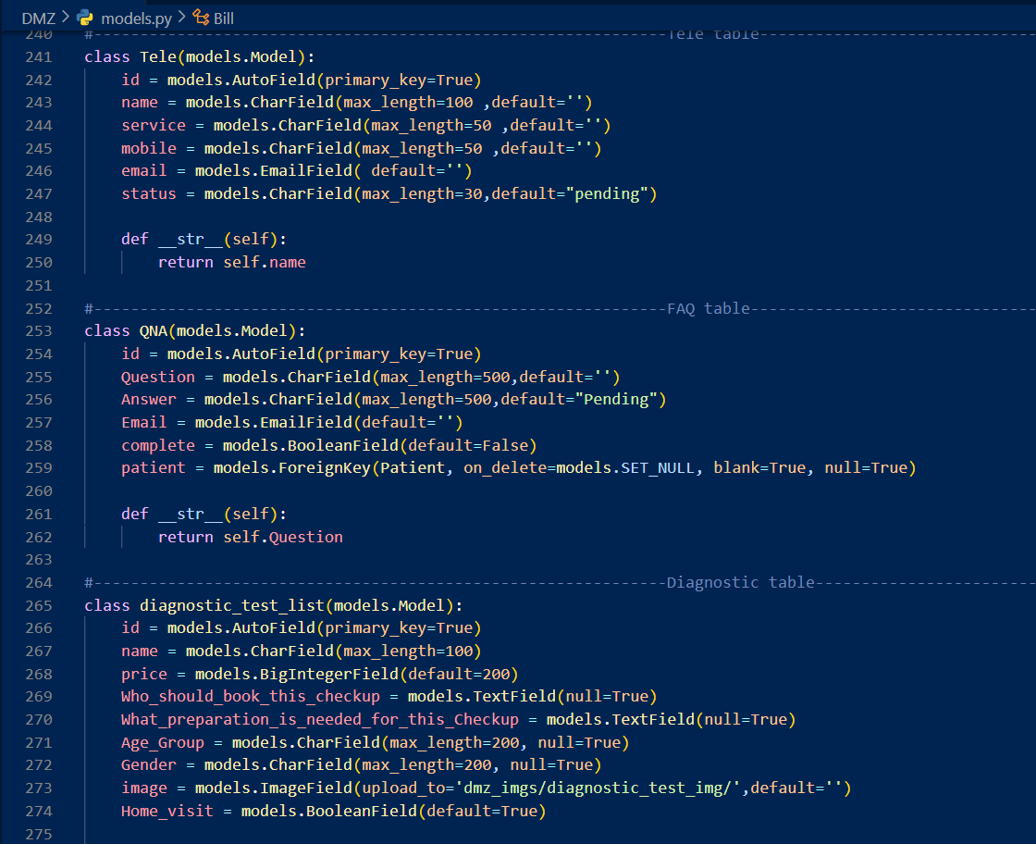

1. **Code Efficiency:**

It describes non-functional requirements such as code efficiency, reliability, speed, and the process used to generate code for an application or Web application . It is related to the effectiveness of the code and the speed of the processing time. It is important to ensure high performance for the. The aim is to reduce resource usage and time to completion while minimizing business and workplace risk. Evaluate the quality of product using the code function. It plays an important part in applications organized in high speed area where performance and scalability are critical. It is important that rules govern the complex process.

I have used the following procedure for maintain code efficiency for my project:

* The code that was redundant was removed.
* Will be using caching to load components faster and only when necessary.
* Unnecessary packages were removed.
* Used reusable components. Have proper exception handling blocks.

**Chapter 6 – Testing**

1. **Testing Approach**

A new test form was written to evaluate the features and functionality of the Web application . Different features and functions have different characteristics. We need to generate test data to make the system reliable, safe, useful, effective and efficient. Software testing is used for assessing a software item to find the discrepancies between the specified input and the expected output. It assesses the quality of the product made. The system needs to be tested to see if it is working properly. The testing is done through all the stages of the development life cycle. It is a verification and validation approach (V&V Model).

* **Verification:**

Verification includes checking that the product or process meets requirements and specifications. Validation is usually done during development to catch bugs or issues early. Validation can be performed using a variety of techniques, including experimentation, statistical analysis, and analysis. Validation ensures that the product or process is reliable, safe, and meets the customer's needs. The acknowledgment can help identify defects or issues that may cause problems in the future. Validation helps improve the quality of the product and decrease the risk of failure.

* **Validation:**

The product is made as per customer requirements. Testing goes hand in hand with the execution to ensure that the system works accurately and efficiently. The most common type of testing is done by the user who executed the program. The application that is developed should be valid. It is in this phase, all the bugs and errors made in the previous step of the software development life cycle are solved. System testing helps in uncovering the weaknesses that were not detected in the earlier stages of the development cycle. The program is executed to find errors intentionally. This includes stress testing, boundary value analysis etc. For the purpose of testing, various test cases are generated.

Testing ensures that the product or process meets user needs and is fit for purpose. Various methods can be used such as testing, user testing, usability testing and visual inspection. Testing ensures that a product or process is user-friendly, effective, and efficient. Testing is essential to ensure that a product or process meets the needs and wants of the customer

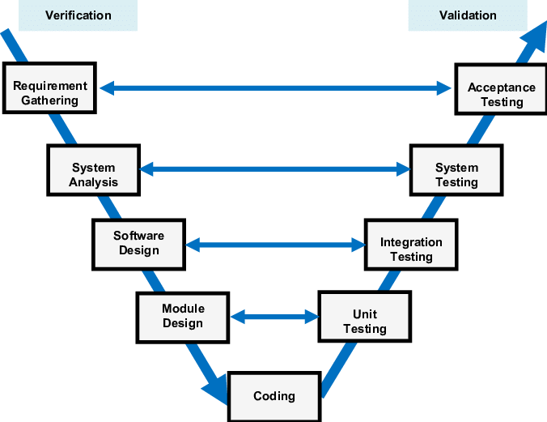

1. **Unit Testing:**

Unit testing is a software testing process in which separate or section parts of a software application are tested separately from the rest of the system to confirm they are work properly. Unit testing usually involves writing tests for a unit of code that covers all inputs and outputs, and then executing those tests to make sure the rules behave as predictable. Unit testing is an vital part of current software development because it helps confirm the overall quality and reliability of the final product. Unit testing is a method of testing separate or chunks of a software application to confirm they are work correctly. This is done by collecting test data that examines how the code behaves in different contexts. By doing this, developers can find and fix bugs early in the development cycle, resultant in improved and improved products.

**Types of unit testing:**

* **Black box testing:**

Black box testing is a software testing technique. It attentions on the exterior behaviour of the system and tests it against input and output. Testers are troubled with the work seen by end users, not with the inner workings of the system. This approach helps identify inconsistencies between system behaviour and user requirements or expectations.

* **White box testing:**

Black box testing is a software testing technique. It attentions on the exterior behaviour of the system and tests it against input and output. Testers are troubled with the work seen by end users, not with the inner workings of the system. This approach helps identify inconsistencies between system behaviour and user requirements or expectations.

* **Grey box testing:**

Gray box testing is a software testing technique. It involves testing the system with some knowledge of its inner workings. Testers have limited access to the inner parts of the system and use this info to produce more well-organized and actual test data. This approach will help identify problems that may arise due to the impact of different parts of the system, such as integration problems. Gray box testing is beneficial for systems that are too complex to be completely tested using a stand alone black box but do not have access to all the functionality exclusive, such as checking the white box.

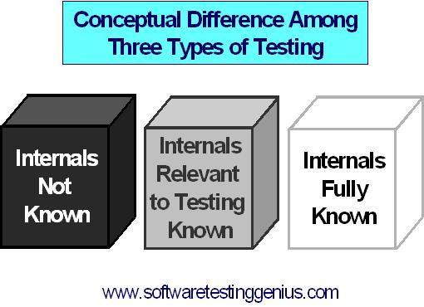

1. **Integration Testing:**

It is a type of testing where separate software program components are mutual and tested as a whole to confirm they work well together. It involves testing how the different components of the system work to perform their intended function**.** In other words, integration testing is a method of confirming that different types of the software application work composed as likely and that the system meets specified requirements and specific instructions. It's usually done after unit testing because it helps to catch matters initial in the development procedure.

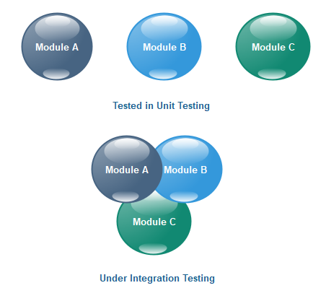

* **Test Plan:**

A test plan is a document that defines the test strategy, purpose, resources mandatory for testing test time, appraisal and delivery. Prepared software test situation is carefully evaluated according to the defined process and evaluated by the administrator. Test preparation is known as the most important task in the test implementation process.

There are following steps for testing:

* Analyse the product
* Develop test strategy
* Define test strategy
* Define test criteria
* Resource planning
* Plan test environment
* Test Deliverables
* **Test Cases:**

A test case is a set of actions or steps used to test whether a software application, system, or functionality is at work as expected. It is intended to switch the right behaviour of the software under certain conditions.

|  |  |  |  |
| --- | --- | --- | --- |
| System Name: - | Drmedizone | | |
| Module code: - | **Dr_001** | | |
| Pass | 7 | **Pending:-** | 0 |
| Fail | 0 | **Number of test case:-** | 7 |

|  |  |  |  |  |
| --- | --- | --- | --- | --- |
| Test case Id | Test case | Expected Output | Actual Output | Result |
| Dr_001L1 | Correct Username and password | Redirect on profile page | Redirect on profile page | pass |
| Dr_001L2 | Correct Username and Invalid password | Show error message:-  Password is invalid. | Show error message:-  Password is invalid. | pass |
| Dr_001L3 | Invalid Username and  Correct password | Show error message:-  Username is invalid. | Show error message:-  Username is invalid. | pass |
| Dr_001L4 | Invalid Username and  Invalid password | Show error message:-  Username and password are invalid. | Show error message:-  Username and password are invalid  . | pass |
| Dr_001L5 | Username input box is empty and  Correct password | Show error message:-  Please enter username | Show error message:-  Please enter username | pass |
| Dr_001L6 | Correct Username and password input box is empty | Show error message:-  Please enter password | Show error message:-  Please enter password | pass |
| Dr_001L7 | Username and password input boxes both are empty | Show error message:-  Please enter username and password | Show error message:-  Please enter username and password | pass |
| Dr_001L8 | Input boxes are empty | Show error message:- Enter all necessary details are required | Show error message:- Enter all necessary details are required | pass |
| Dr_001L9 | Click submit button | Submit the form and show message:-  Submitted successfully | Submit the form and show message:-  Submitted successfully | pass |
| Dr_001L10 | If doctor schedule is busy | Show message:-  Doctor is not available | Show message:-  Doctor is not available | pass |
| Dr_001L11 | Search doctor by name | Show list of all related name of doctors | Show list of all related name of doctors | pass |
| Dr_001L12 | Search doctor by categories | Show list of all related category of doctors | Show list of all related category of doctors | pass |
| Dr_001L13 | Search doctor by fees | Show list of all related doctors | Show list of all related doctors | pass |
| Dr_001L14 | Upload health report | Show message:-Upload successfully | Show message:-Upload successfully | pass |
| Dr_001L15 | Download health report | Show message:-download successfully | Show message:-download successfully | pass |
| Dr_001L16 | Doctor is not found | Show message:- Doctor is not found | Show message:- Doctor is not found | pass |
| Dr_001L17 | Click get appointment button | Open appointment form | Open appointment form | pass |
| Dr_001L18 | Click doctor button | Show list of all doctors | Show list of all doctors | pass |
| Dr_001L19 | Click get appointment button but patient is not login | Open login form | Open login form | pass |
| Dr_001L20 | Click on doctor profile | Show all doctor details | Show all doctor details | pass |

**Chapter 7 – User Interface**

**Home Page User Interface**

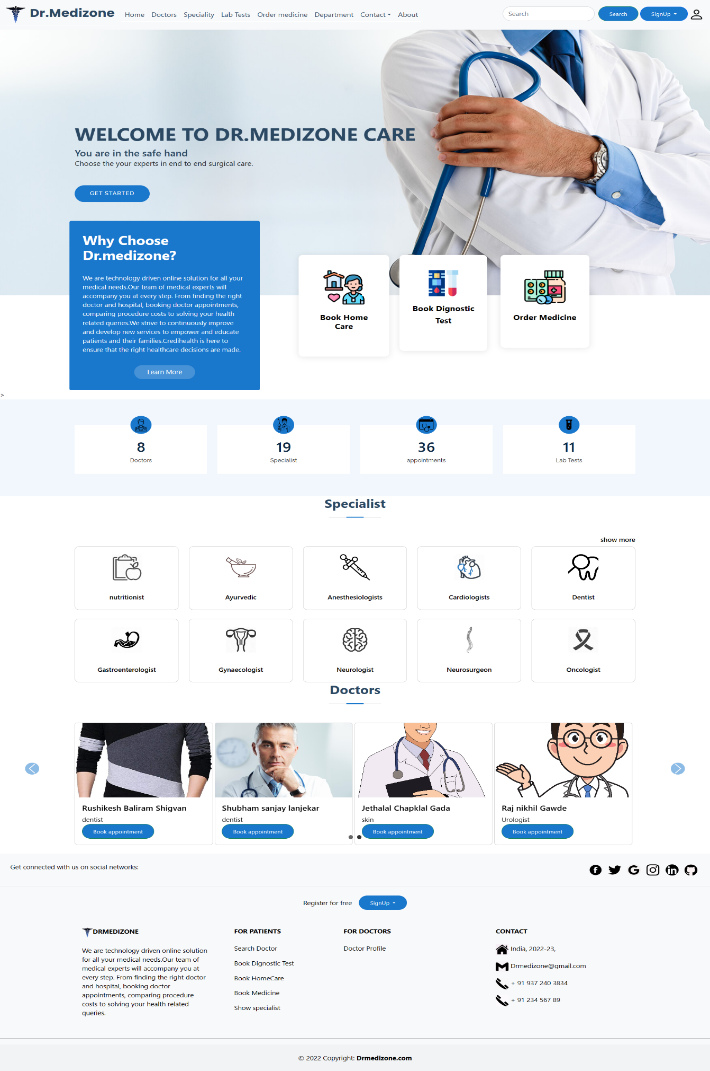

**Specialist Page User Interface**

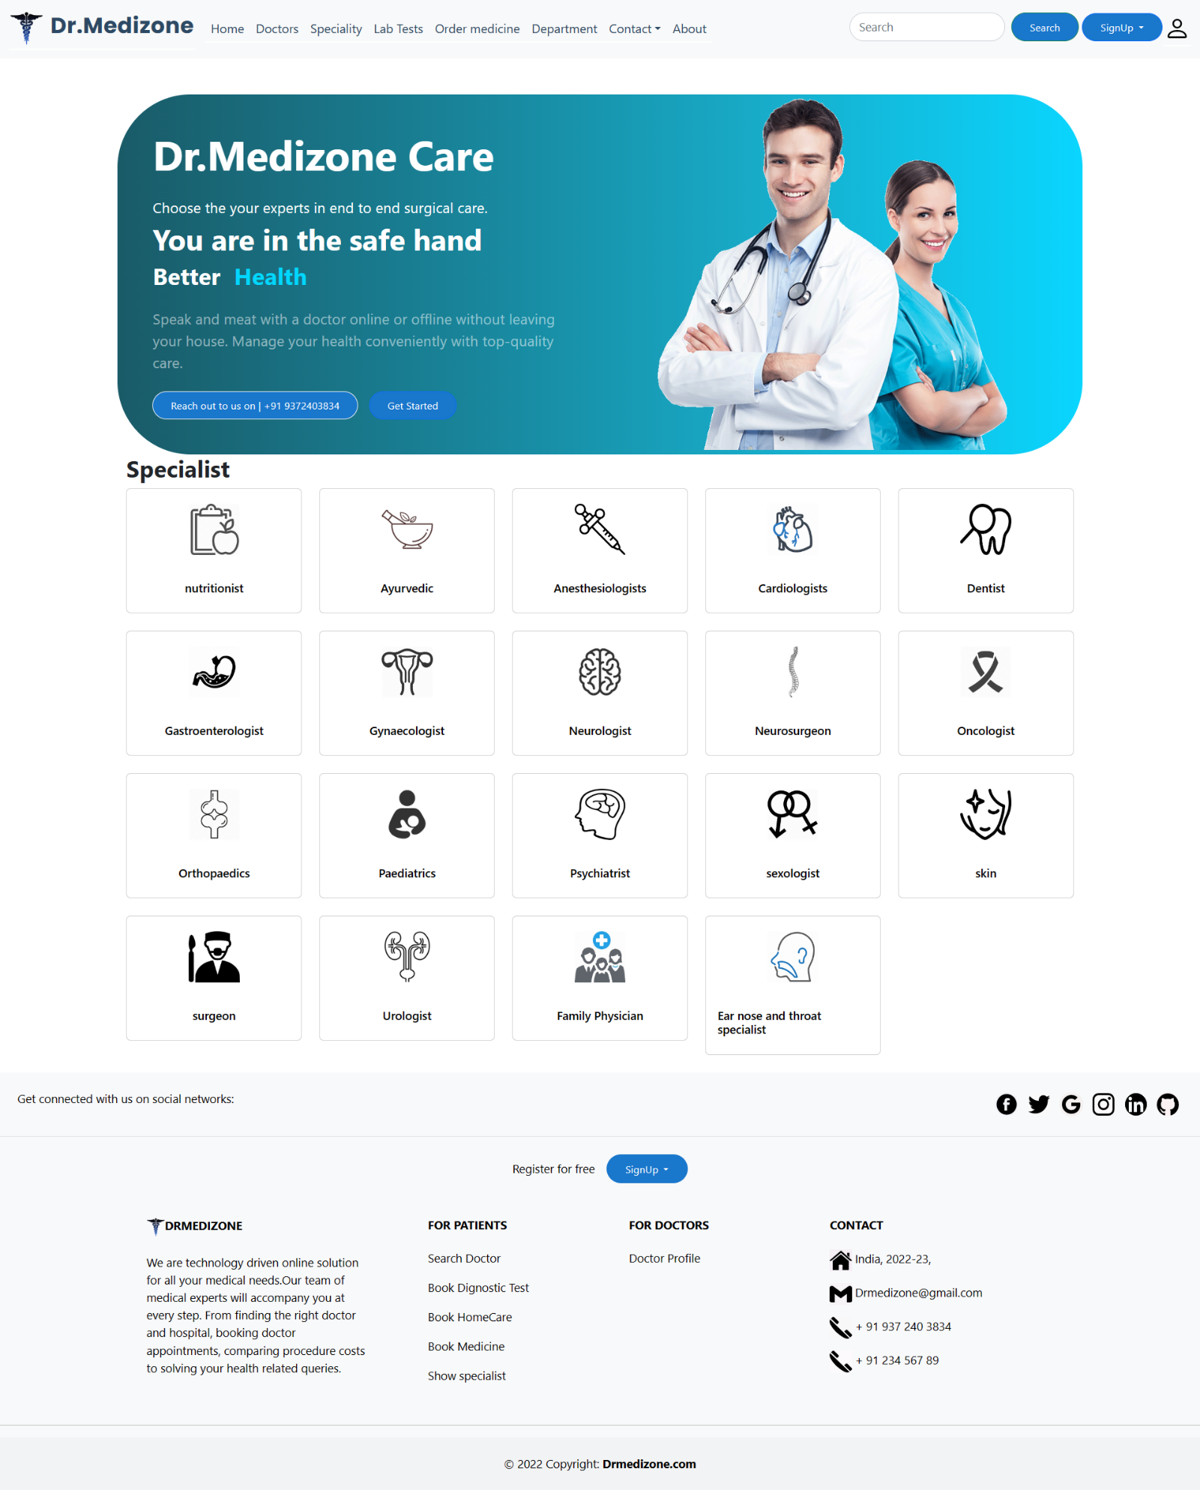

**Doctor Detail Page User Interface**

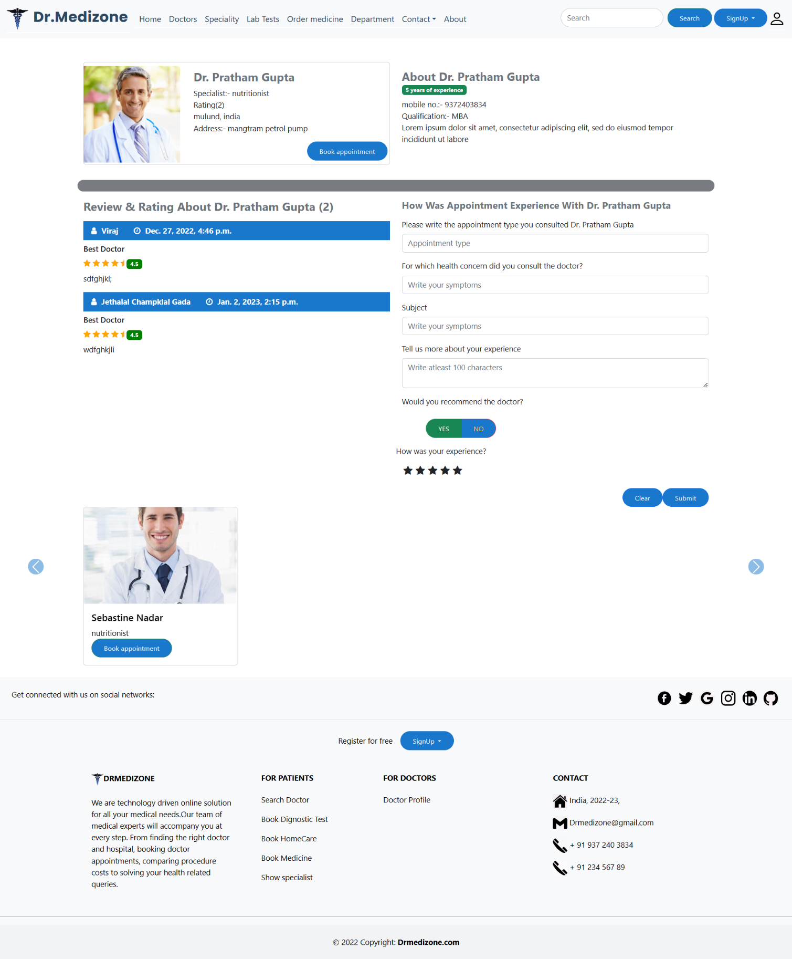

**Doctor’s Page User Interface**

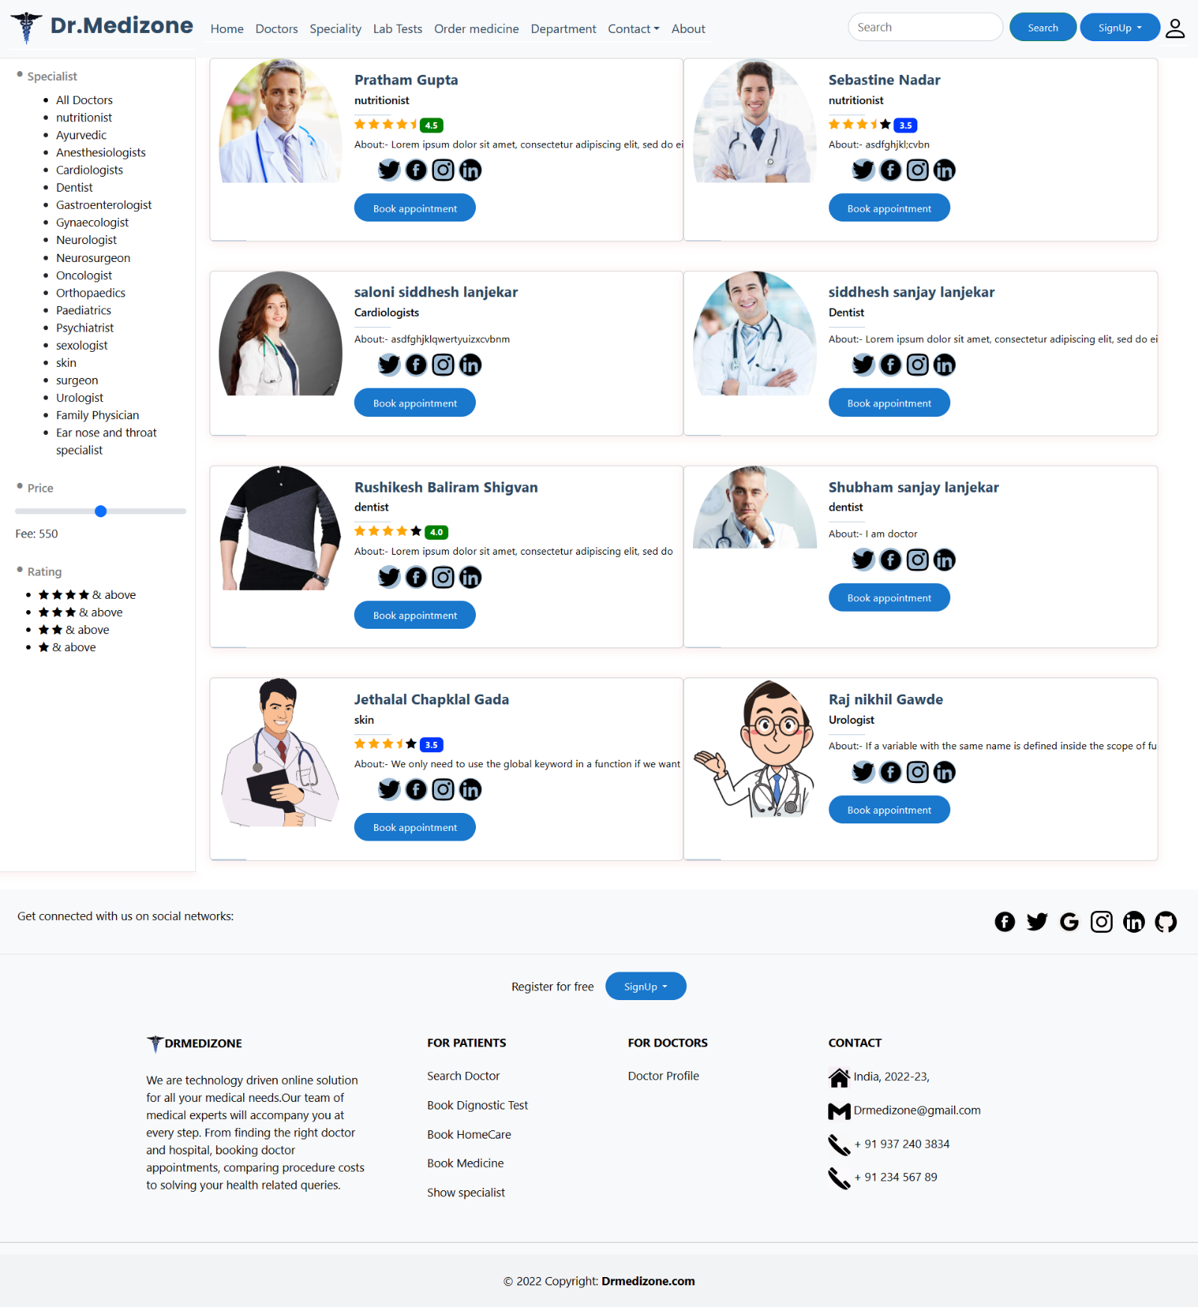

**Filter Page On Doctor’s Page User Interface**

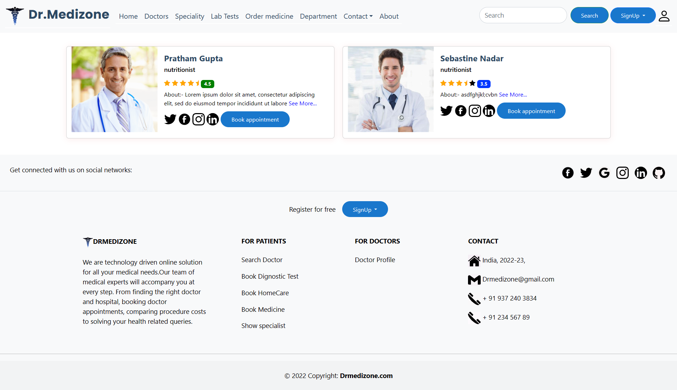

**Filter Page On Doctor’s Page If Doctor Not Found User Interface**

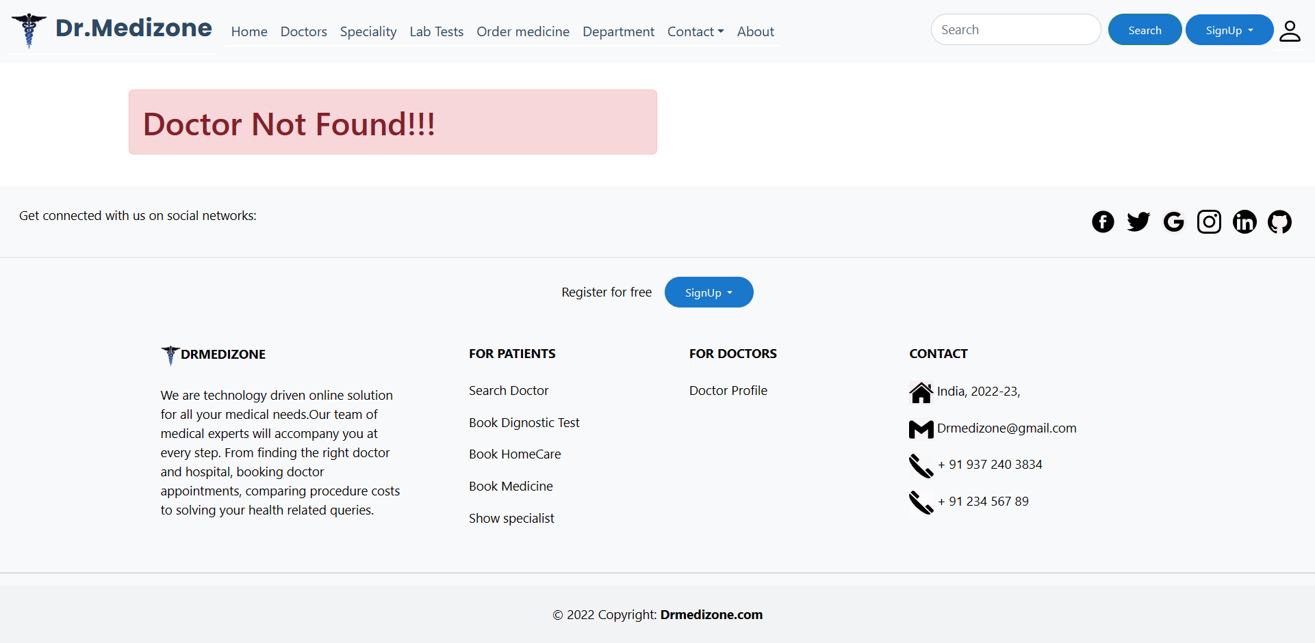

**HomeCare Page User Interface**

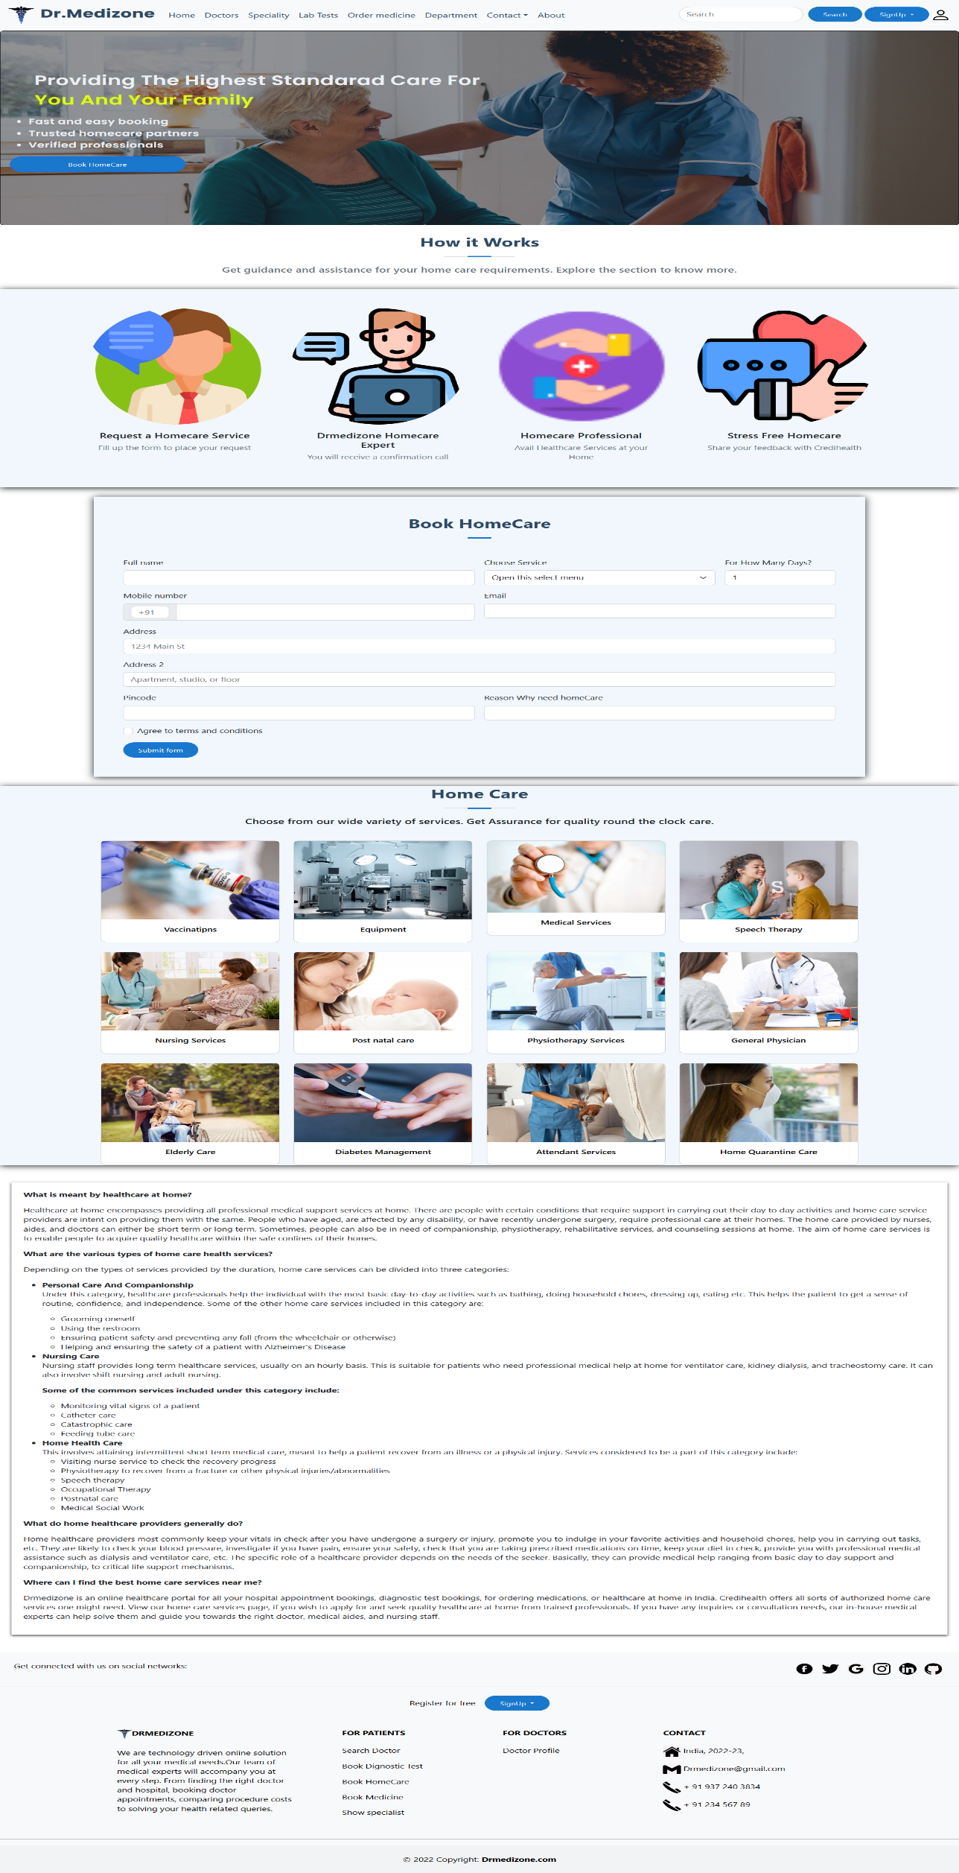

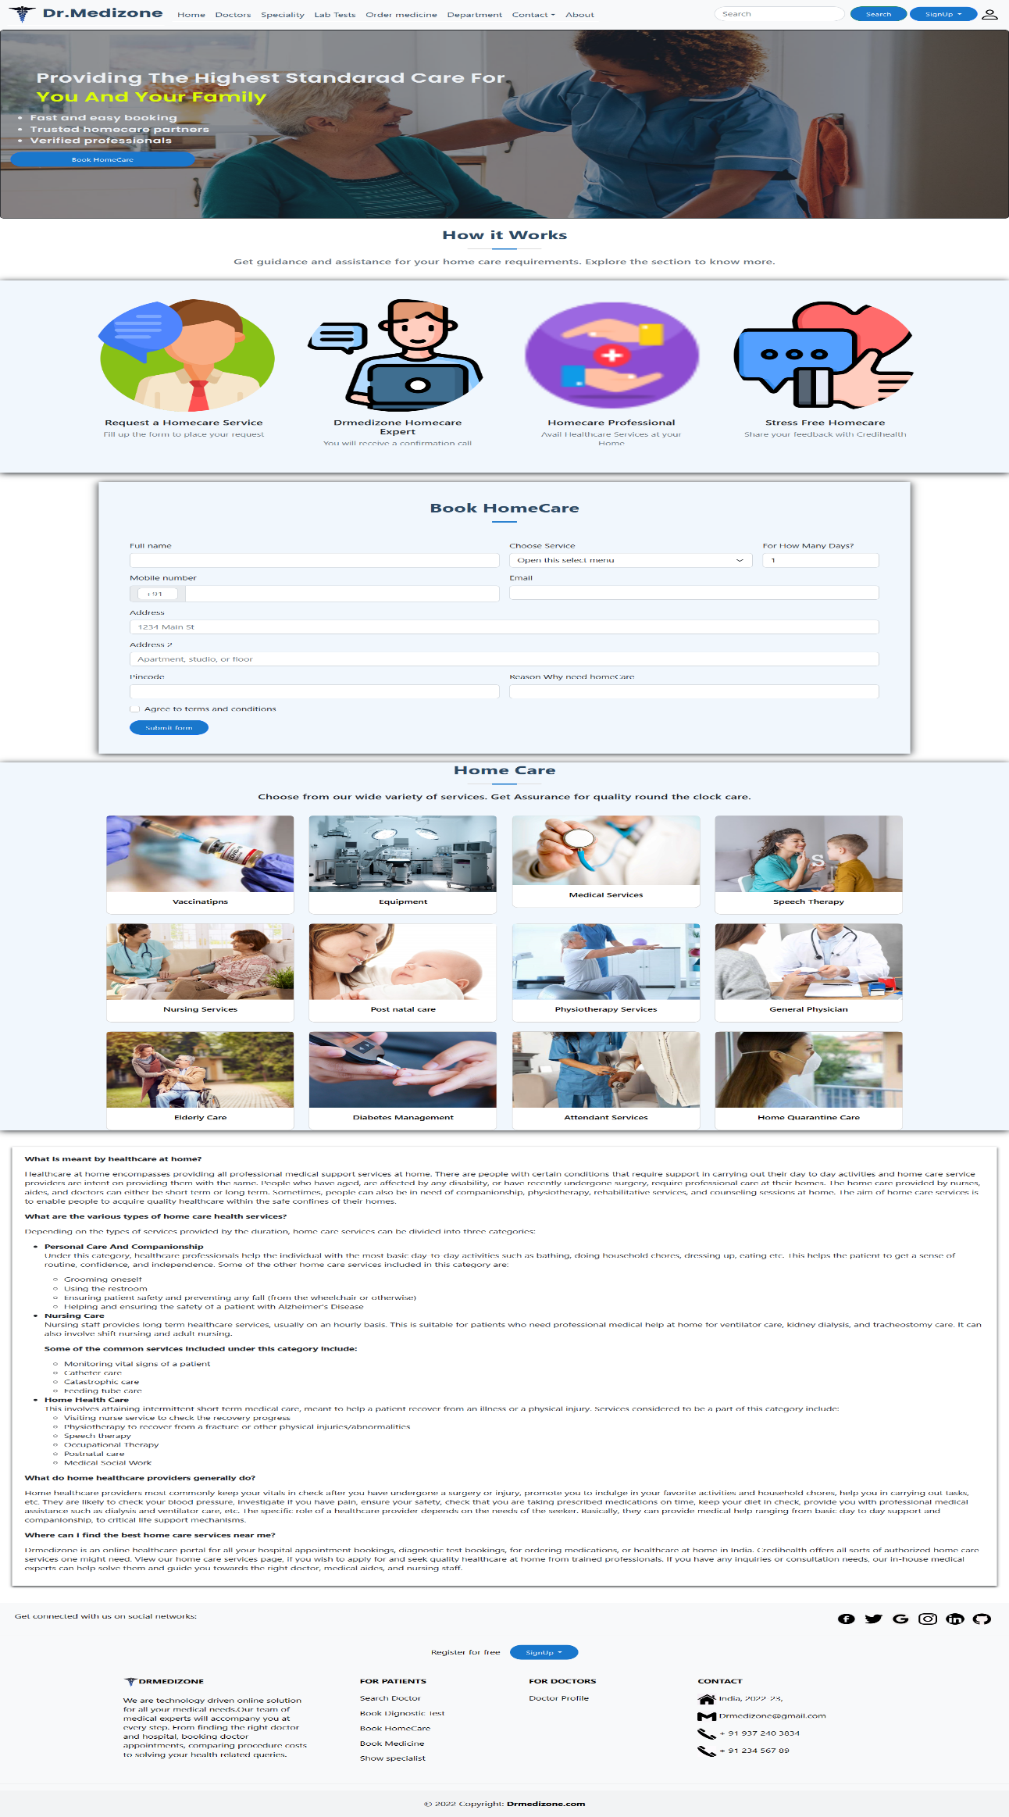

**Lab Test Page User Interface**

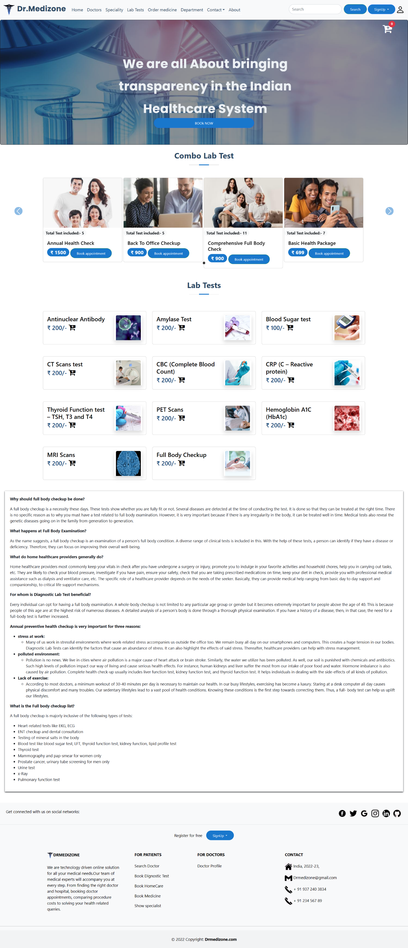

**Combo Package Detail Lab Test Page User Interface**

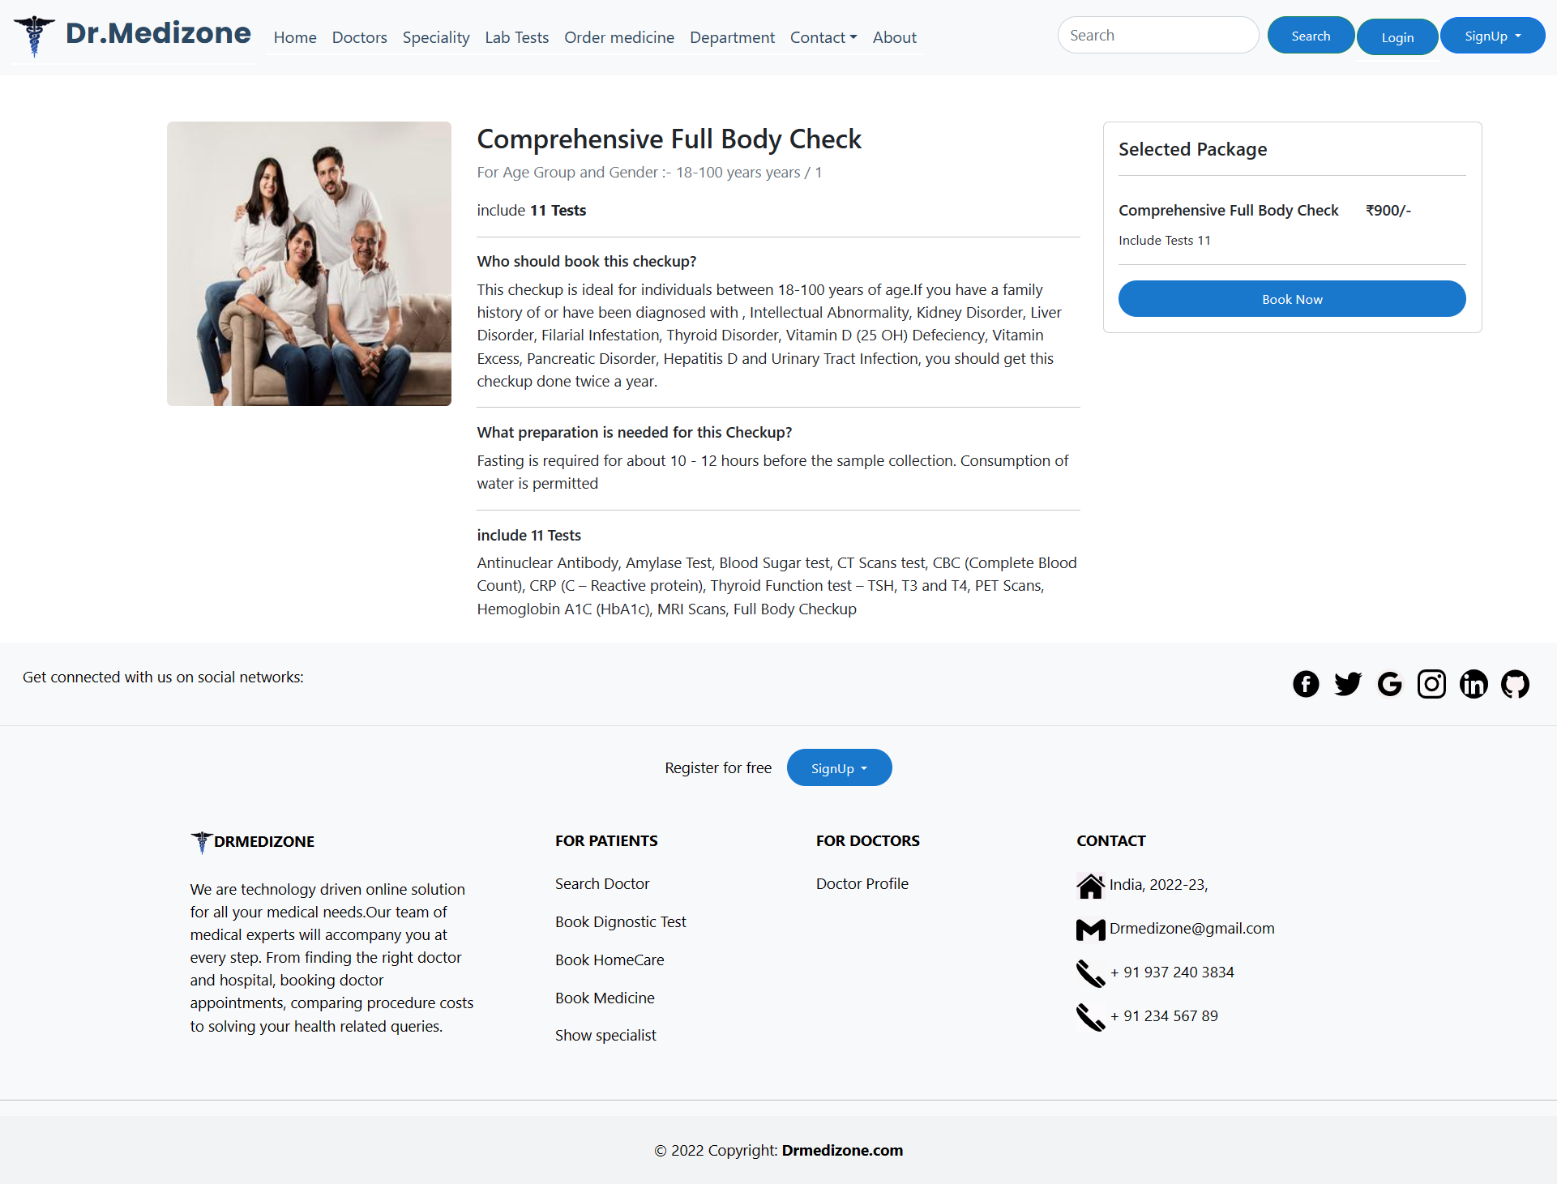

**Single Lab Test Detail Page User Interface**

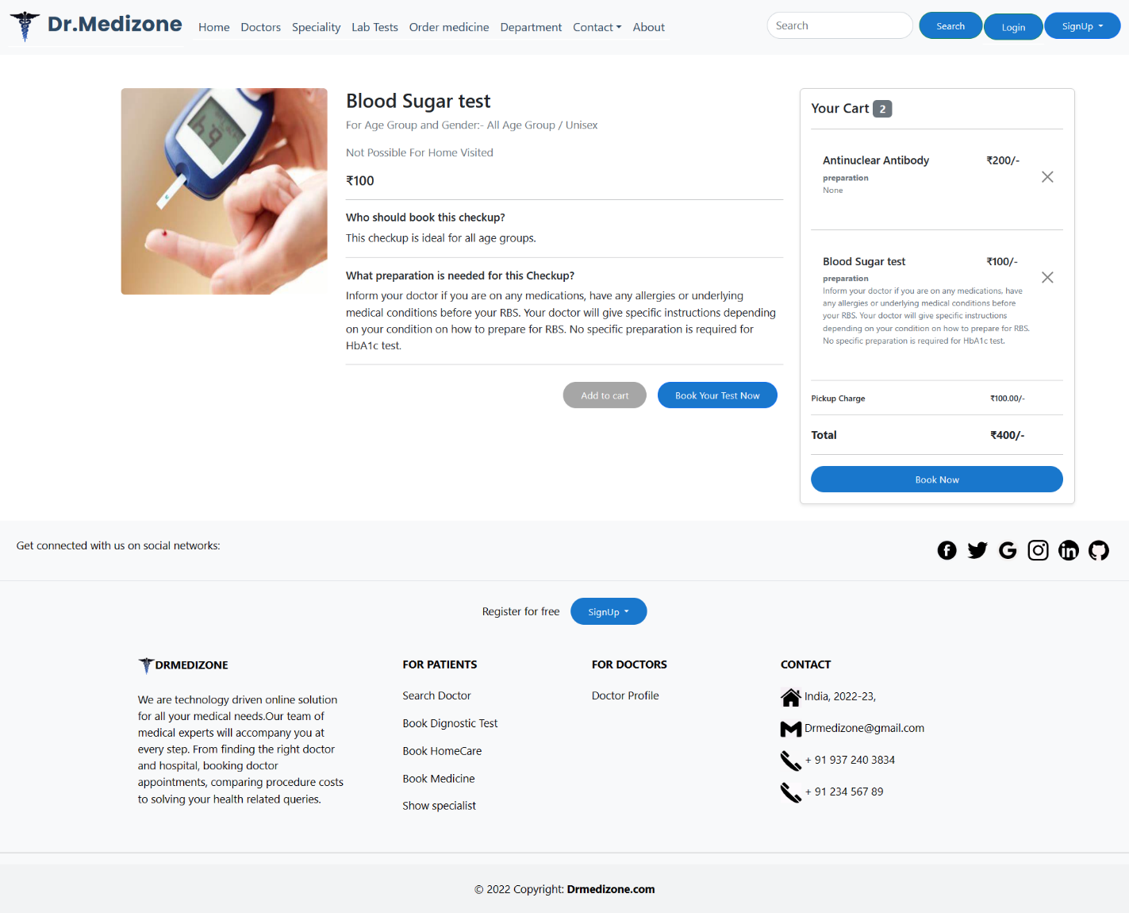

**Contact Page User Interface**

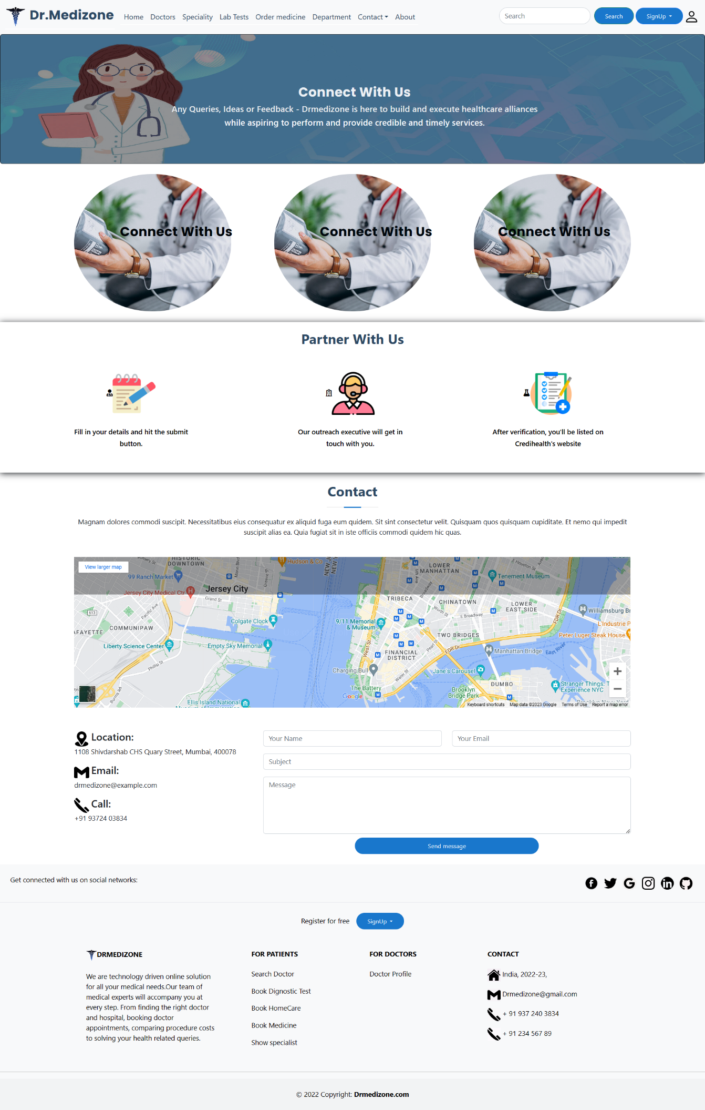

**FAQ Page User Interface**

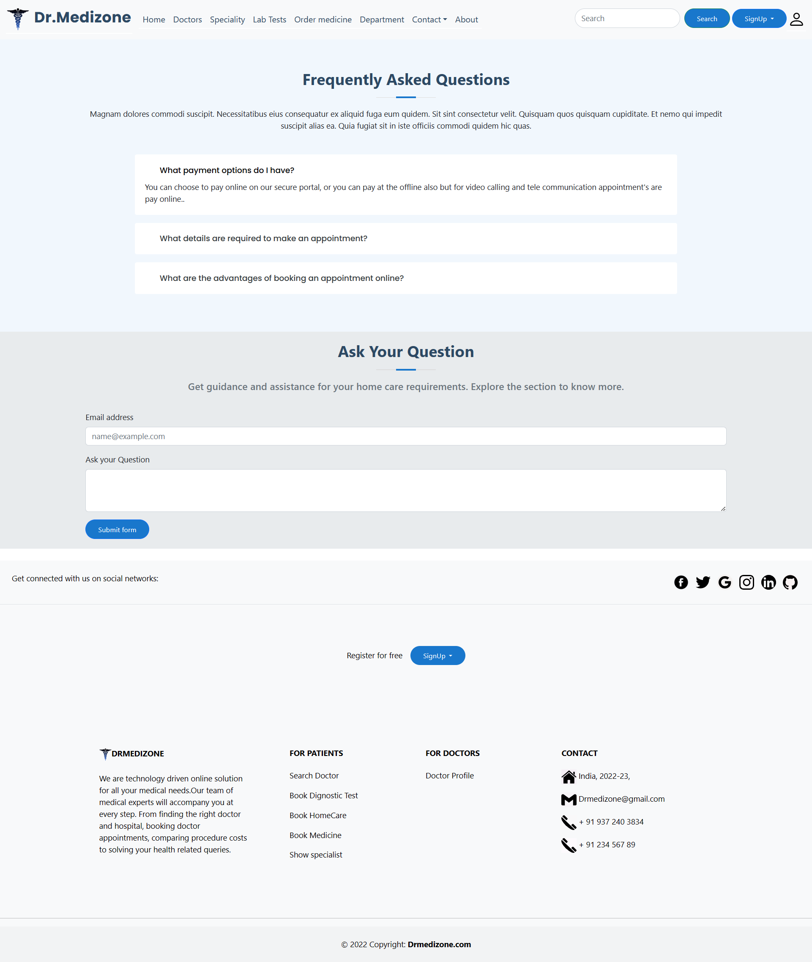

**Lab Test Form Page User Interface**

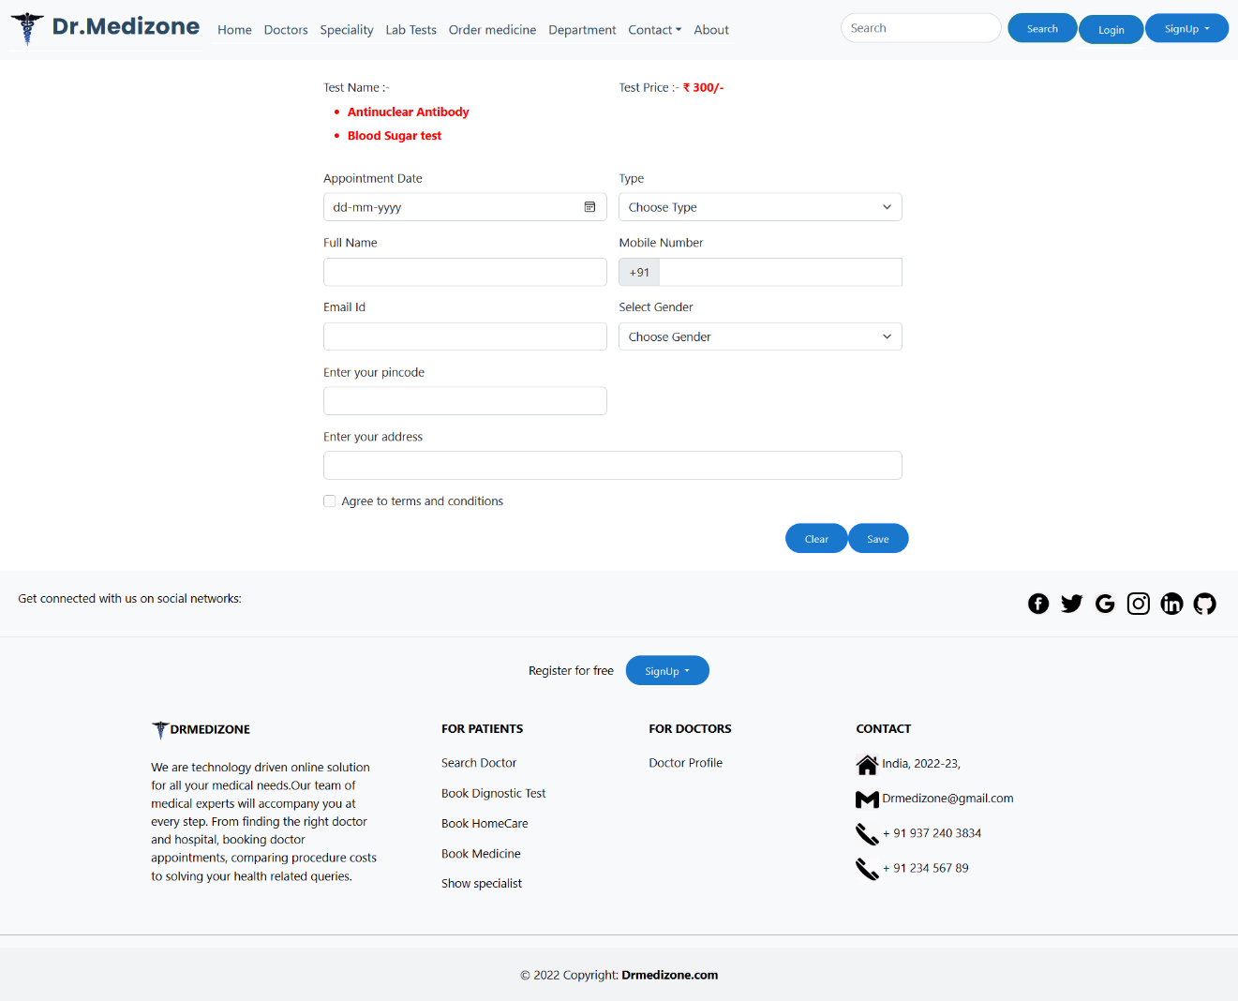

**Payment Welcome Page User Interface**



**Payment Popup User Interface**

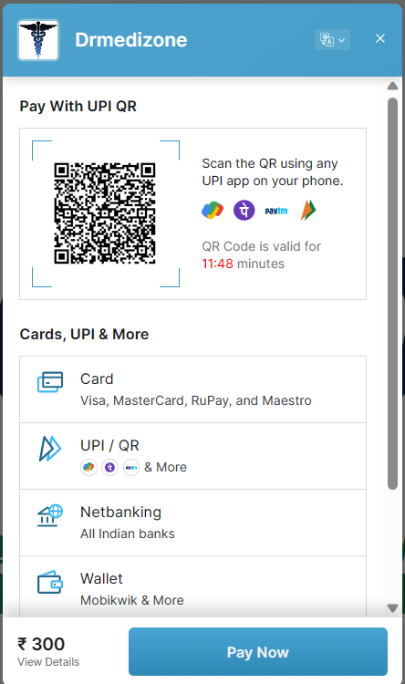

**Thanks Page User Interface**

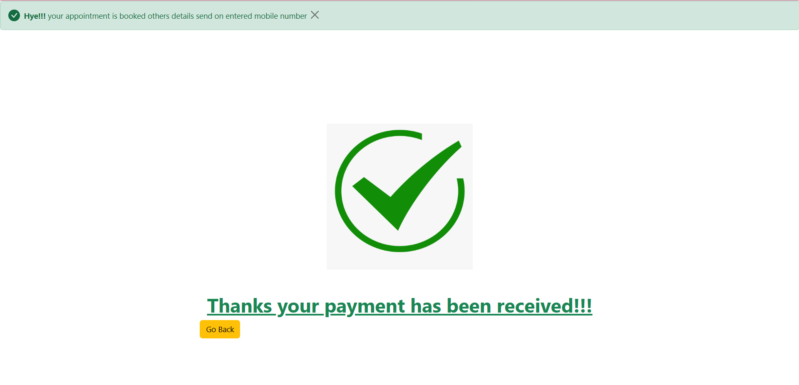

**About Page User Interface**

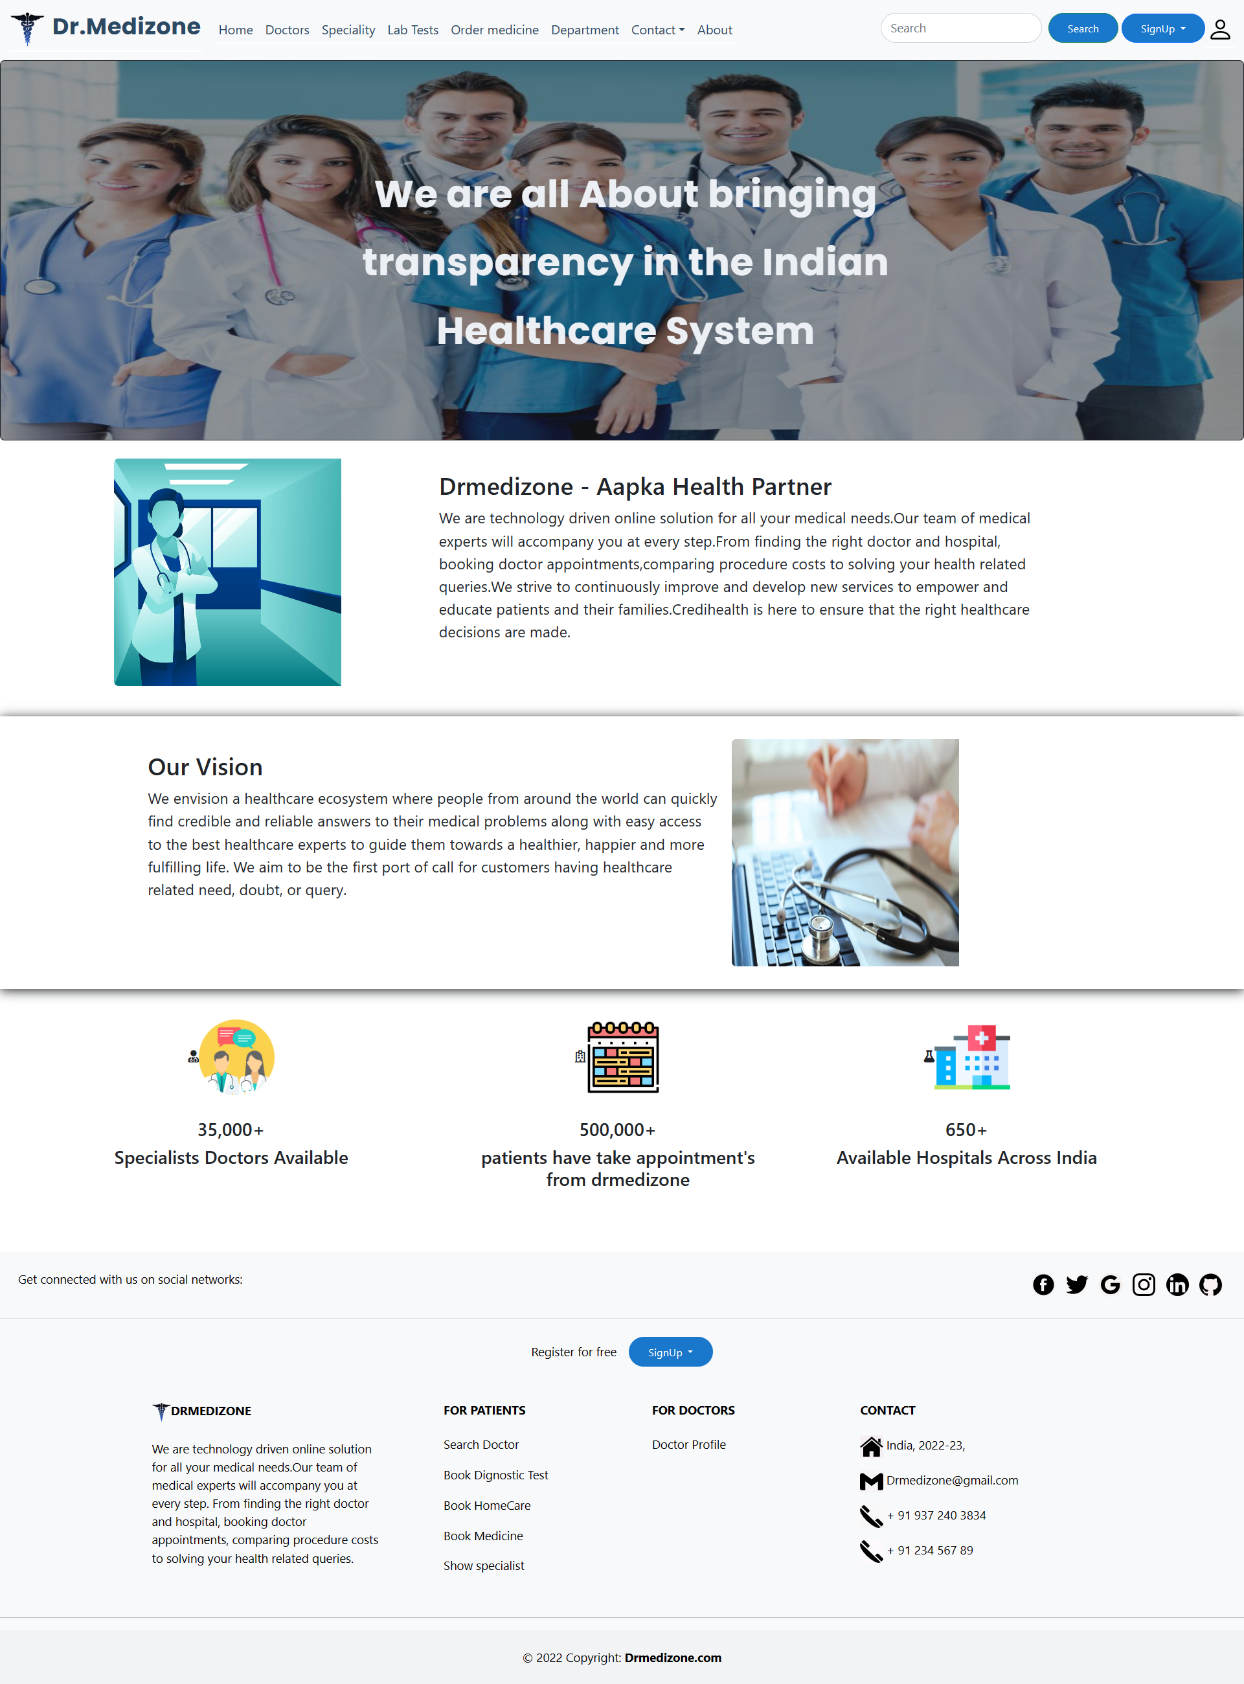

**Doctor Appointment Page User Interface**

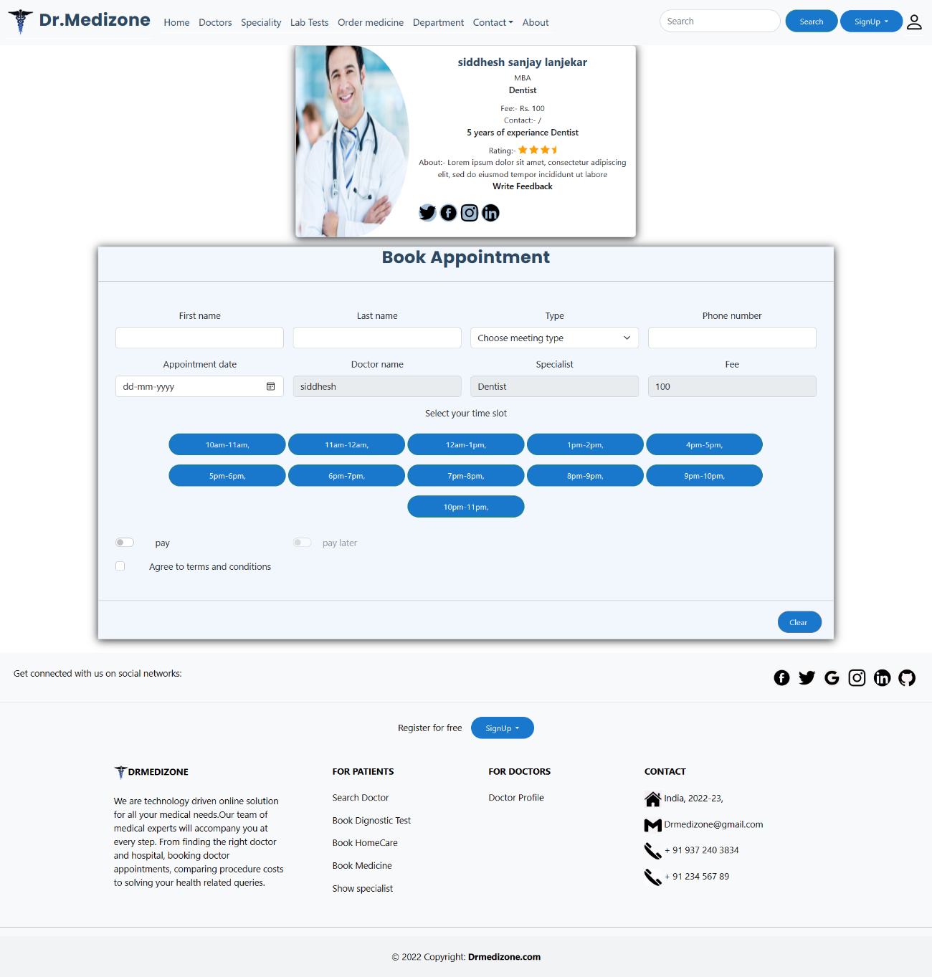

**Appointment Receipt User Interface**

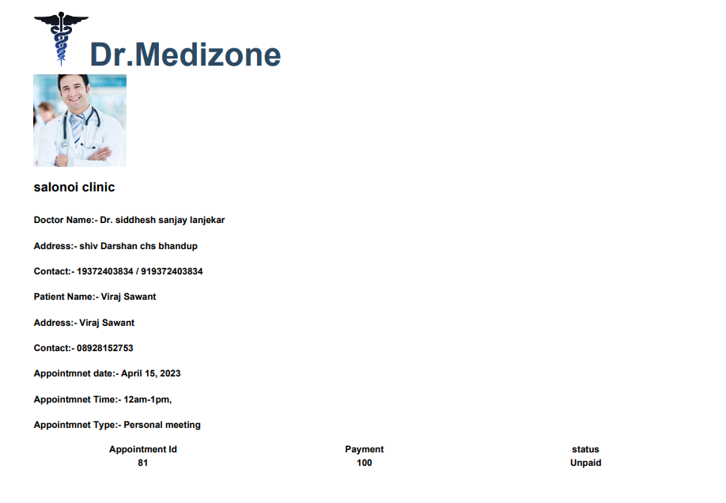

**Admin Home Page User Interface**

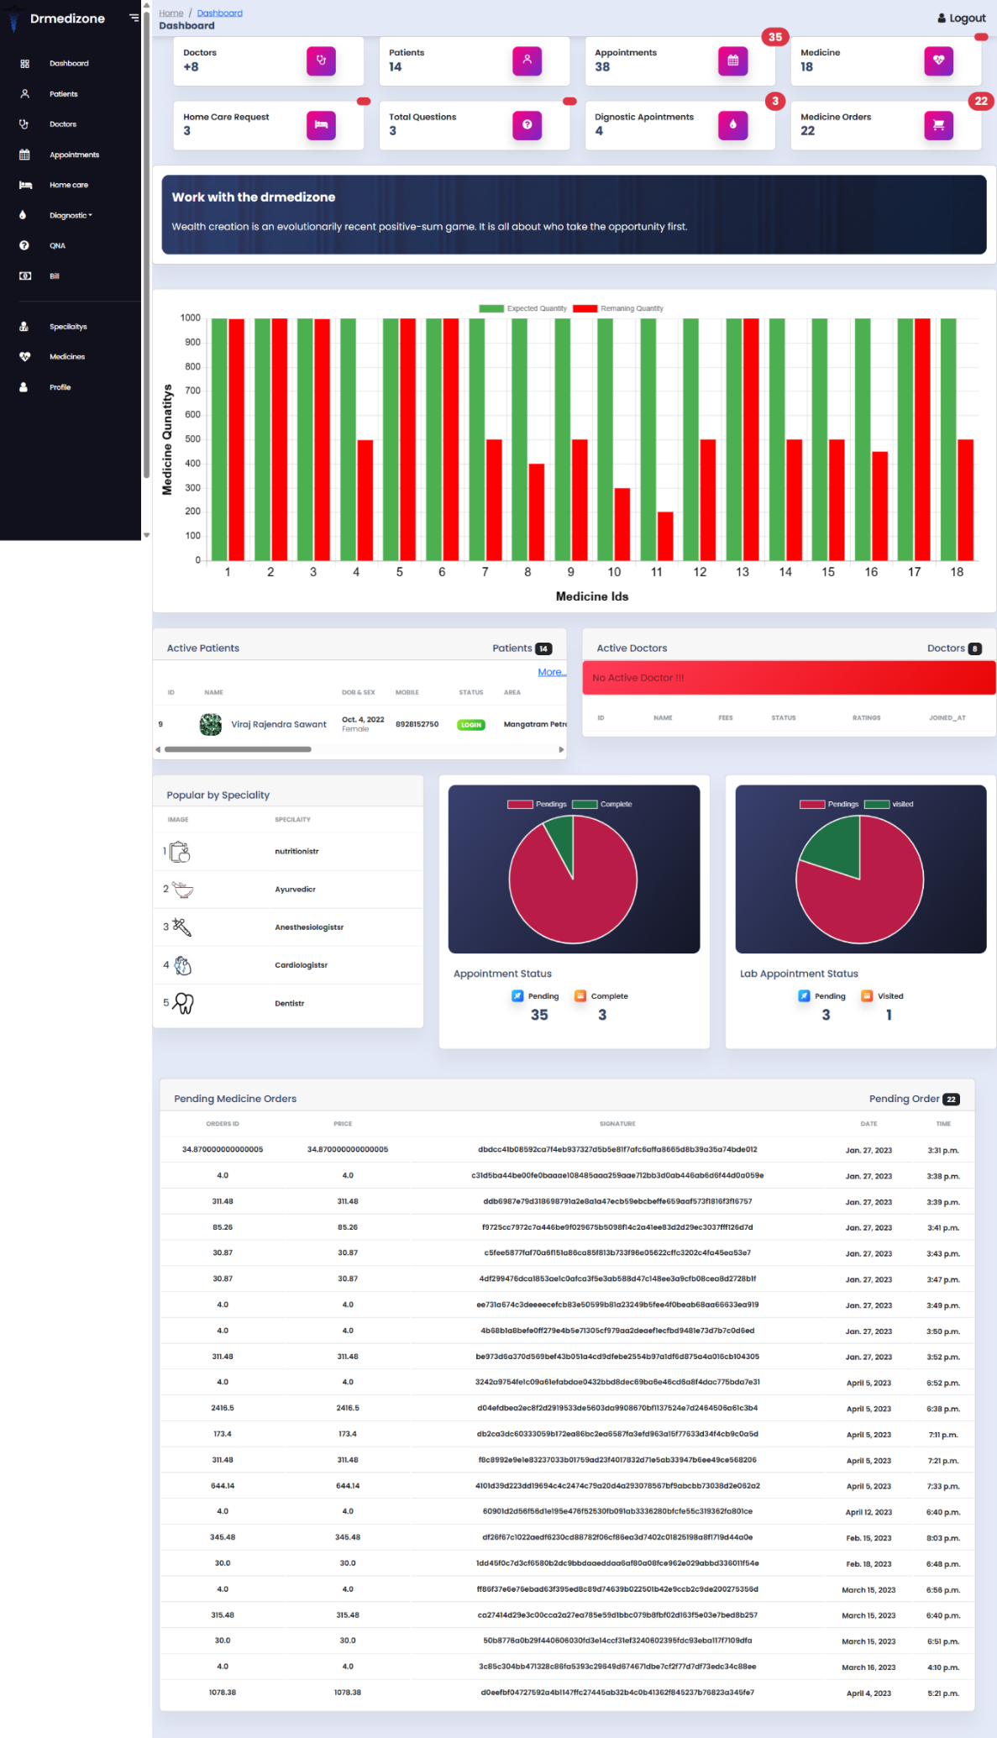

**Admin Patient Table User Interface**

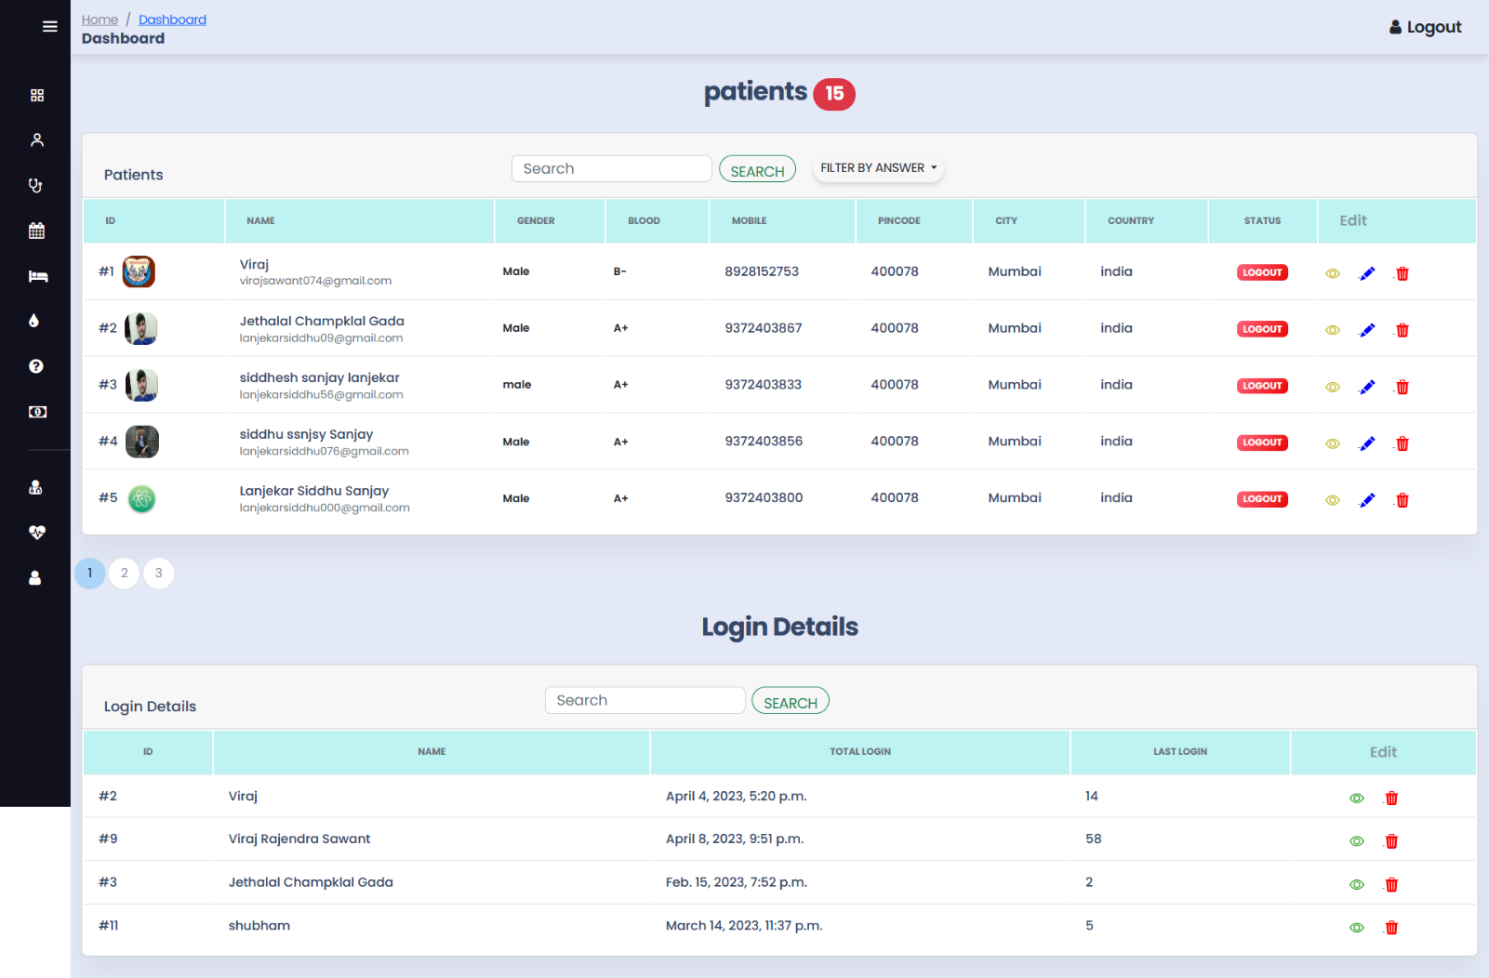

**Admin Doctor Part User Interface**

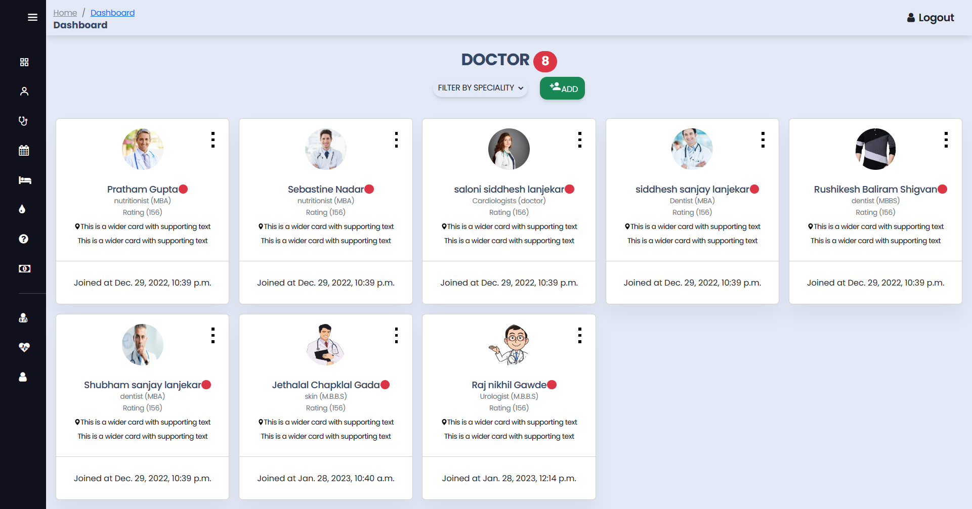

**Admin Doctor Appointment User Interface**

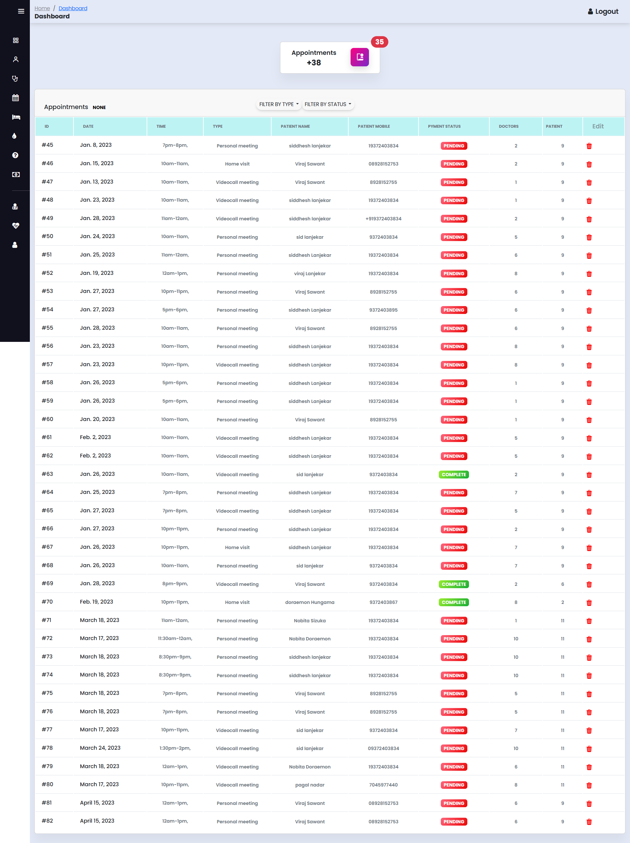

**Admin QNA User Interface**

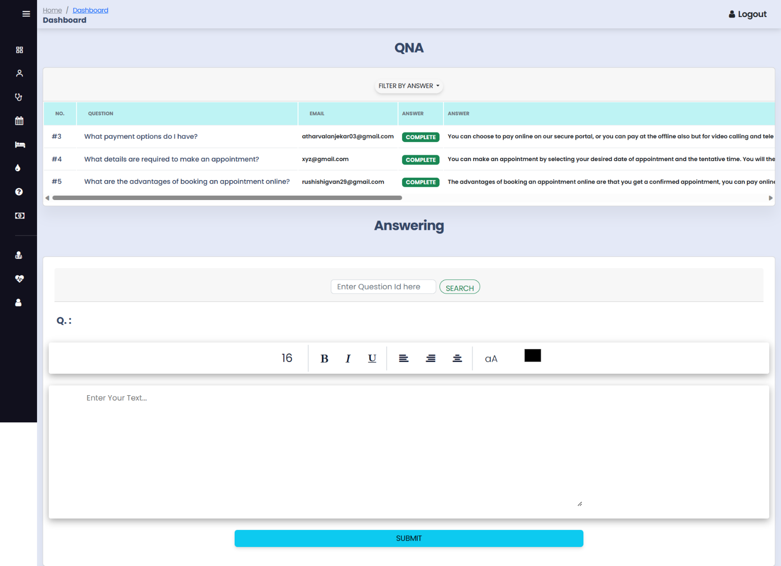

**Admin Medicine User Interface**

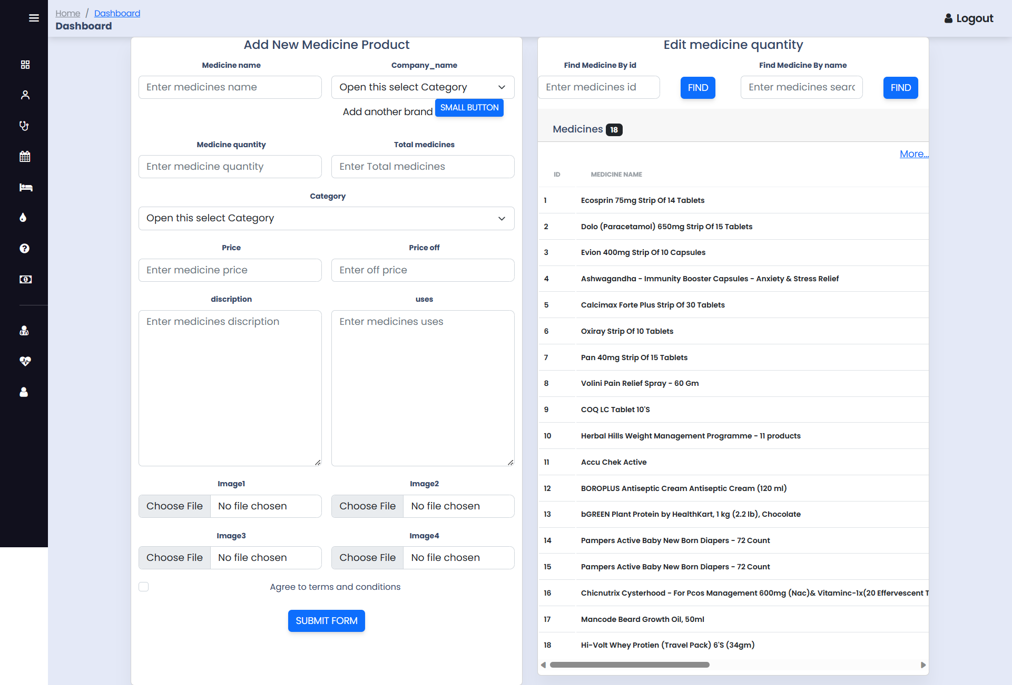

**Admin Lab Appointment User Interface**

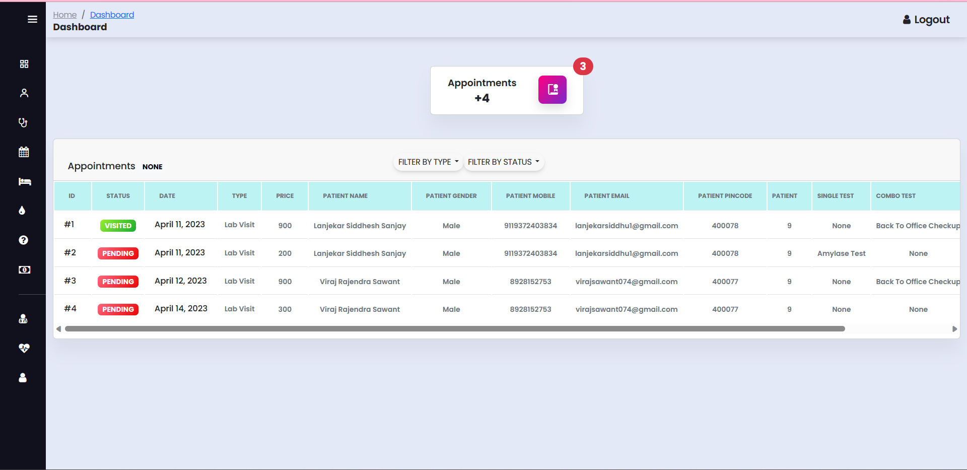

**Admin Lab Test User Interface**

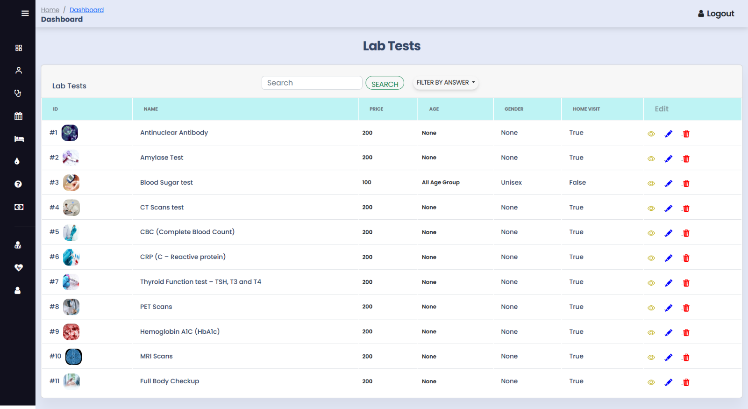

**Admin Combo Lab Test Form User Interface**

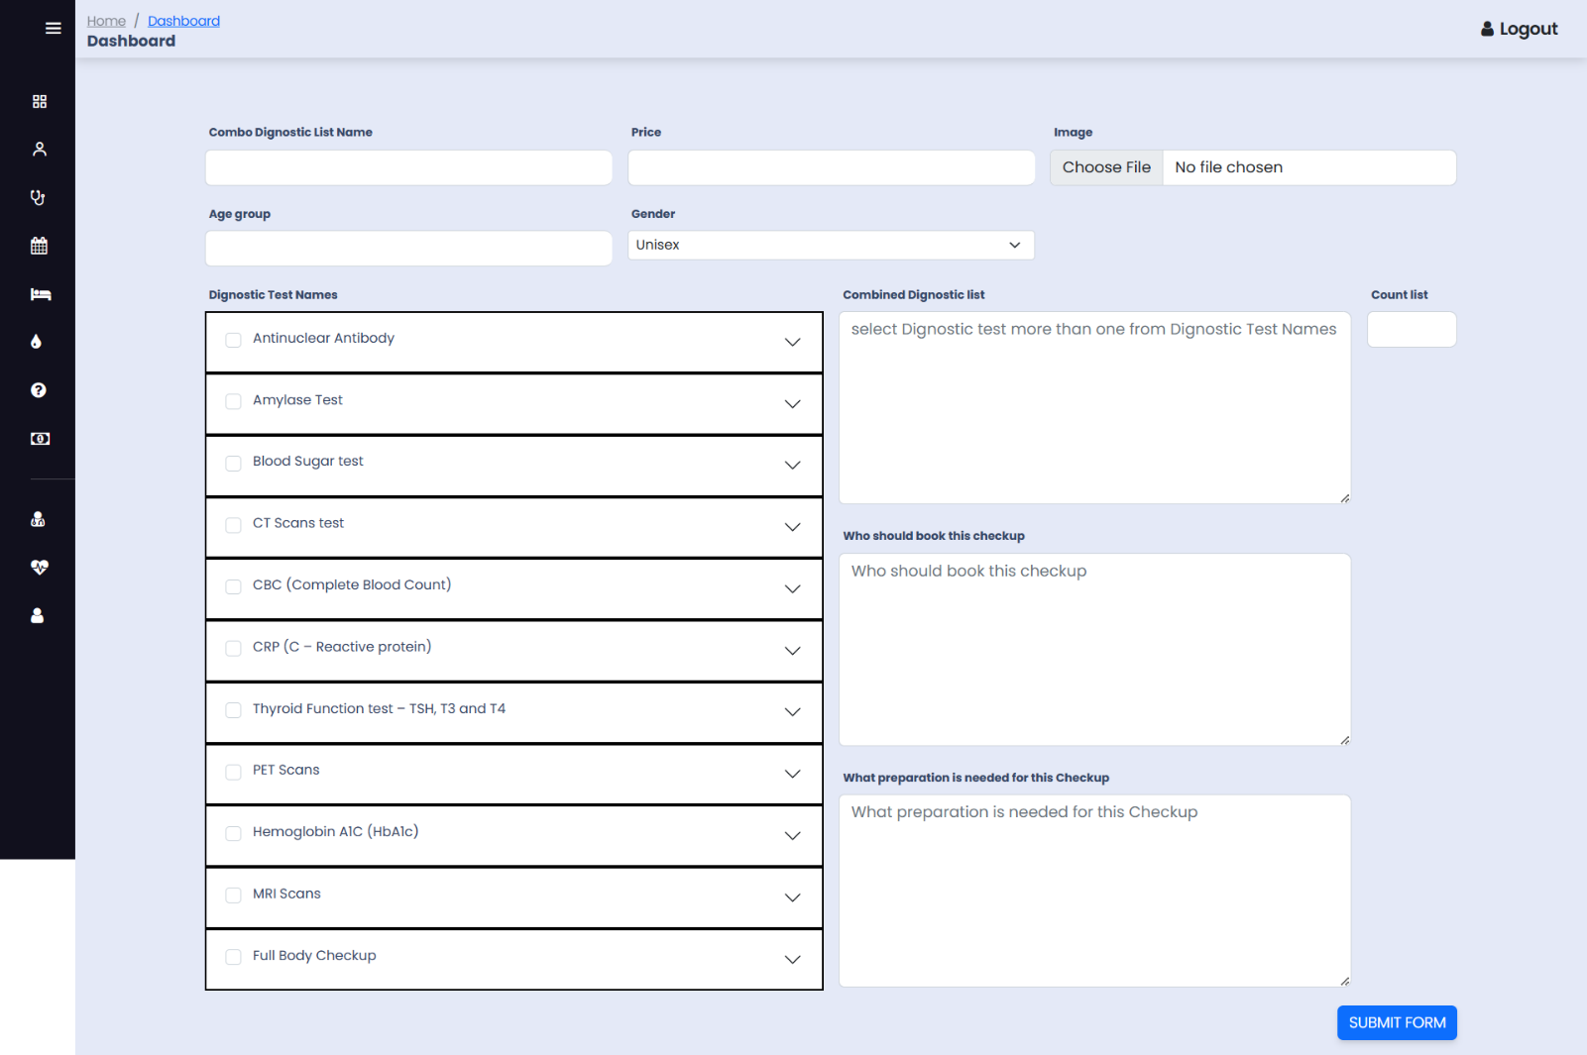

**Doctor Dashboard Home Page User Interface**

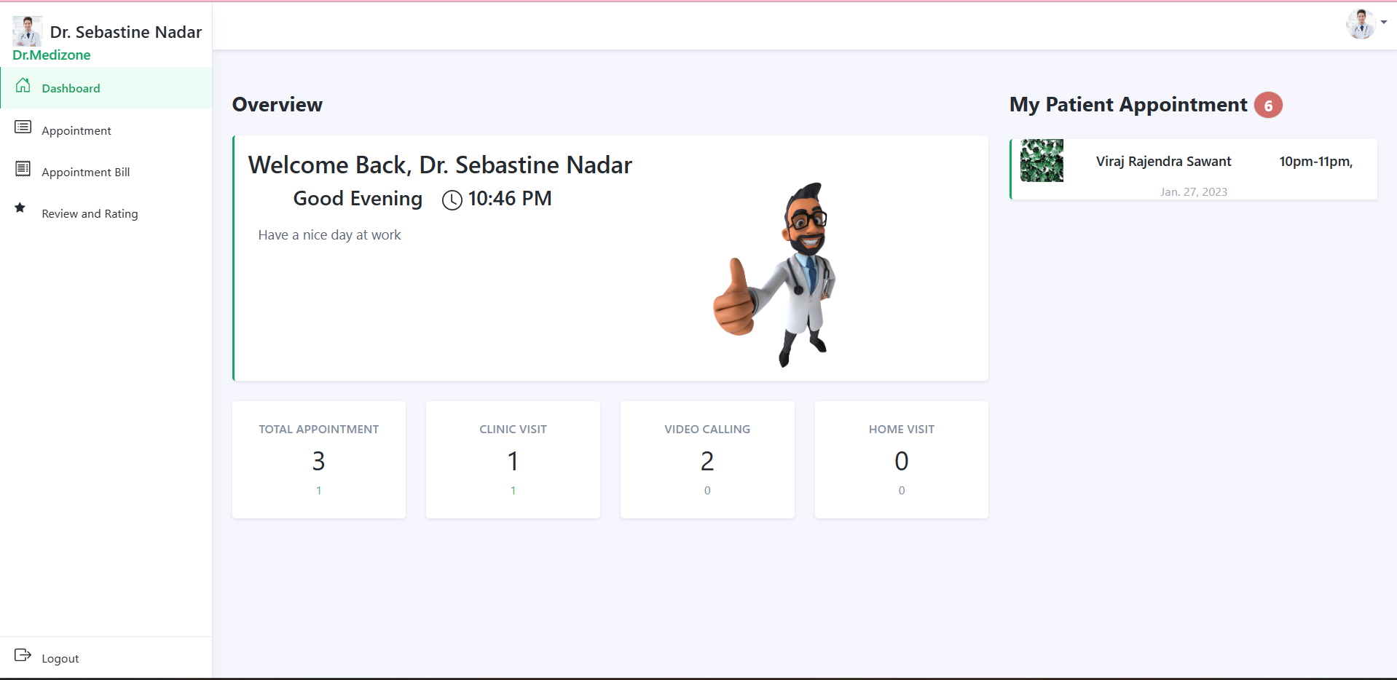

**Doctor Dashboard Appointments Page User Interface**

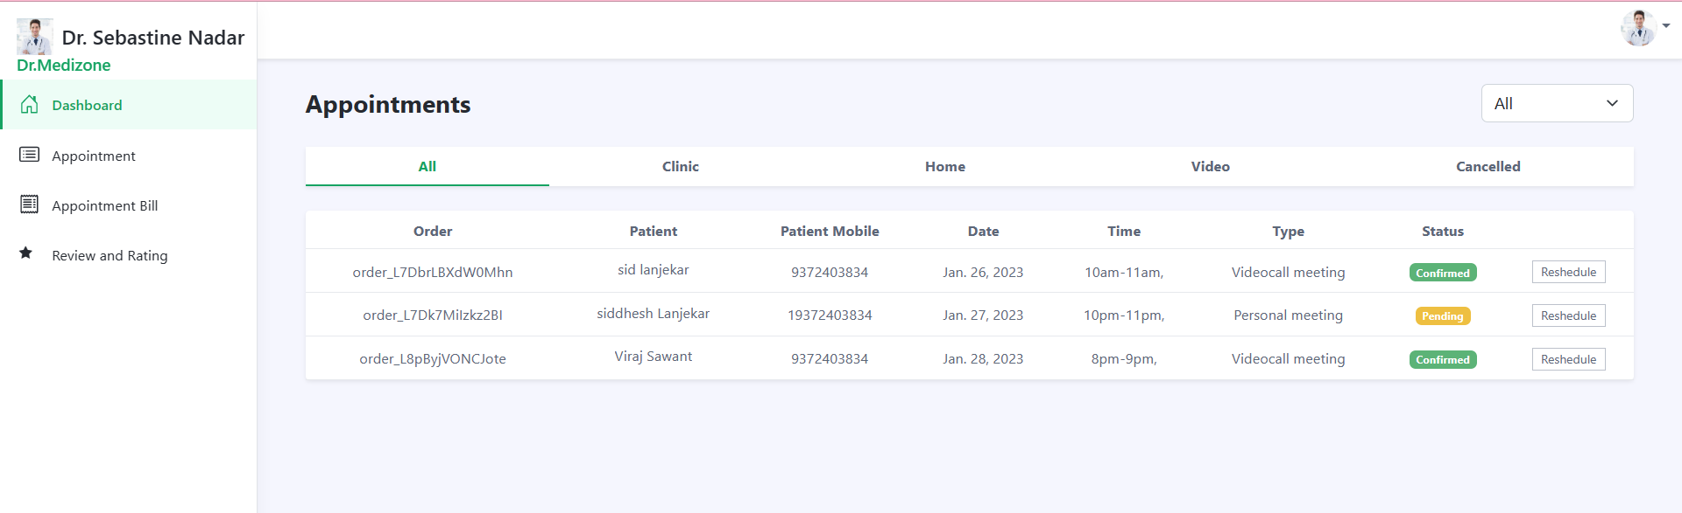

**Doctor Dashboard Appointments Bill Page User Interface**

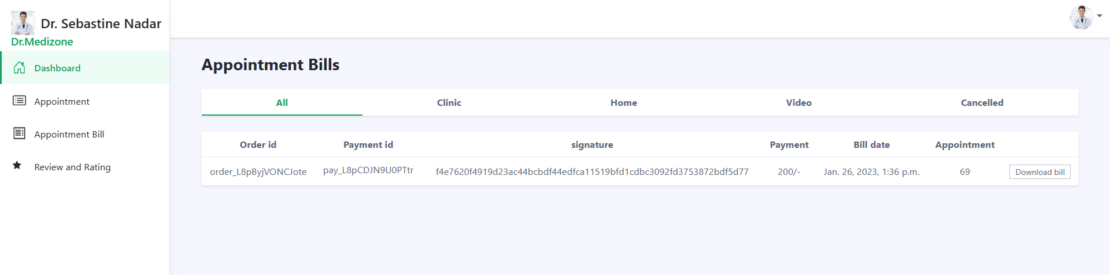

**Doctor Dashboard Review And Rating Page User Interface**

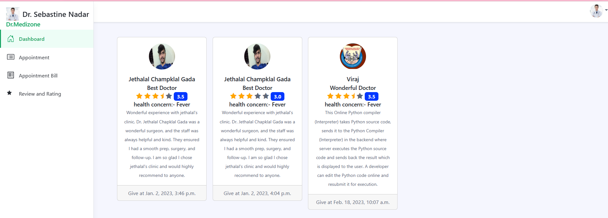

**Patient Dashboard Doctor Appointment Page User Interface**

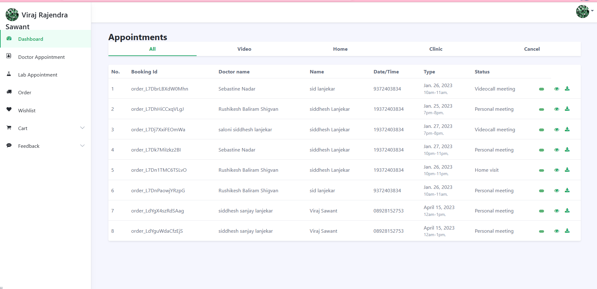

**Patient Dashboard Lab Appointment Page User Interface**

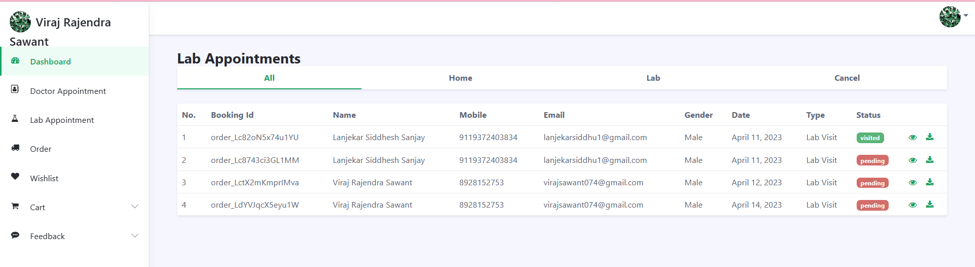

**Patient Dashboard Orders Page User Interface**

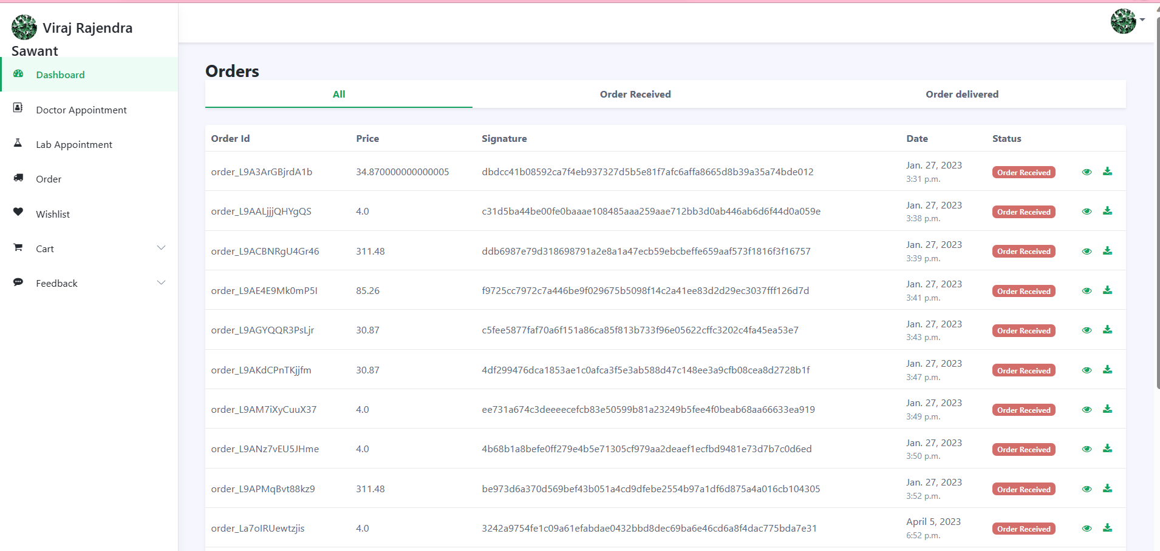

**Patient Dashboard Wishlist Page User Interface**

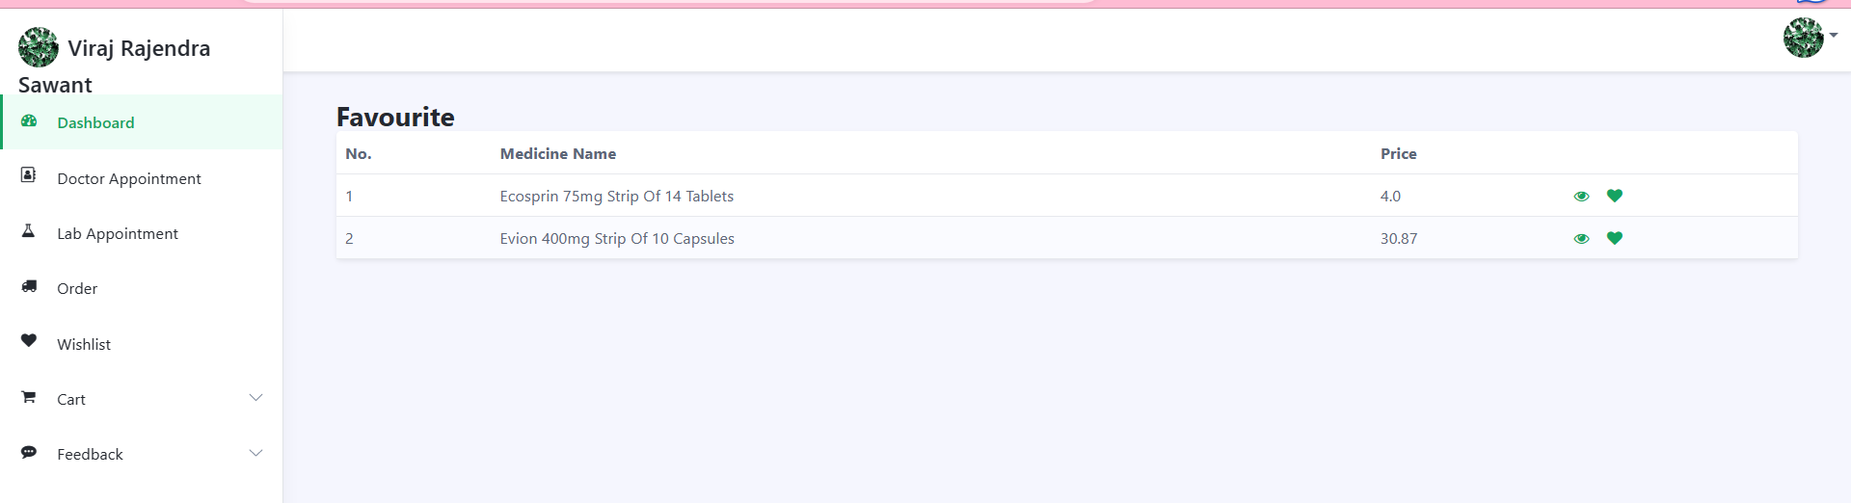

**Medicine Page User Interface**

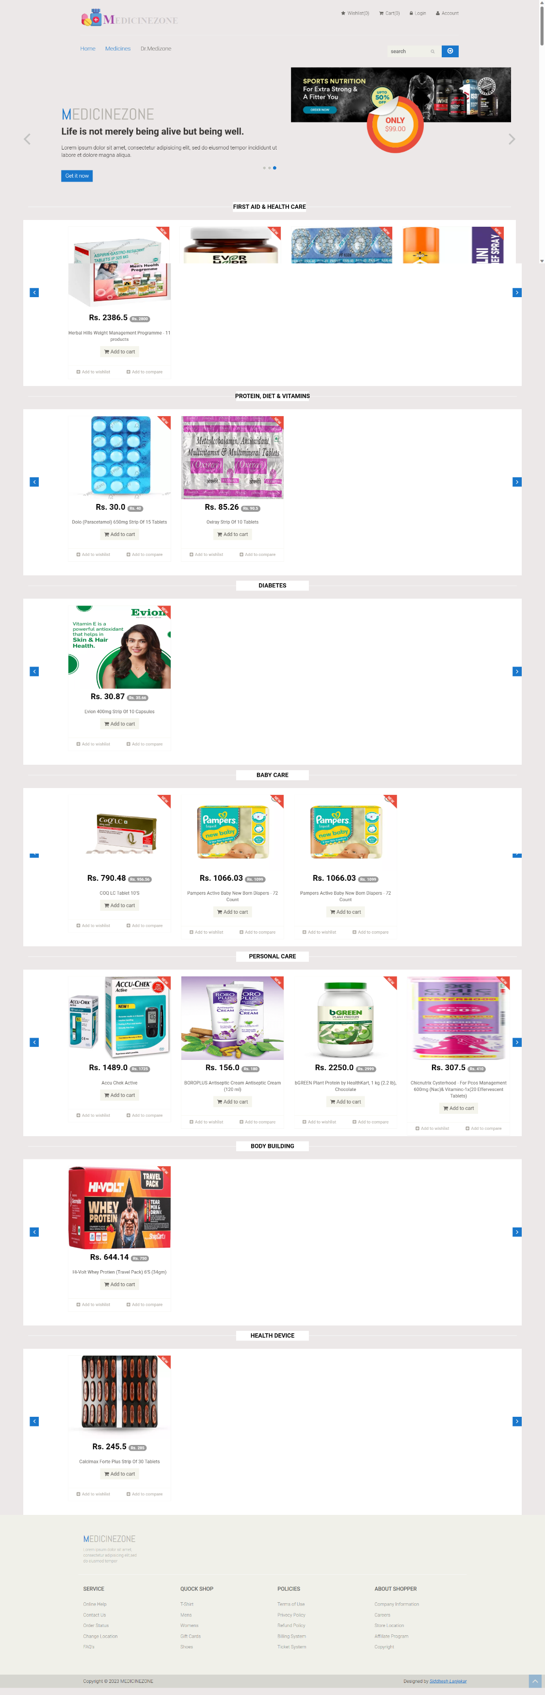

**Medicine Product Page User Interface**

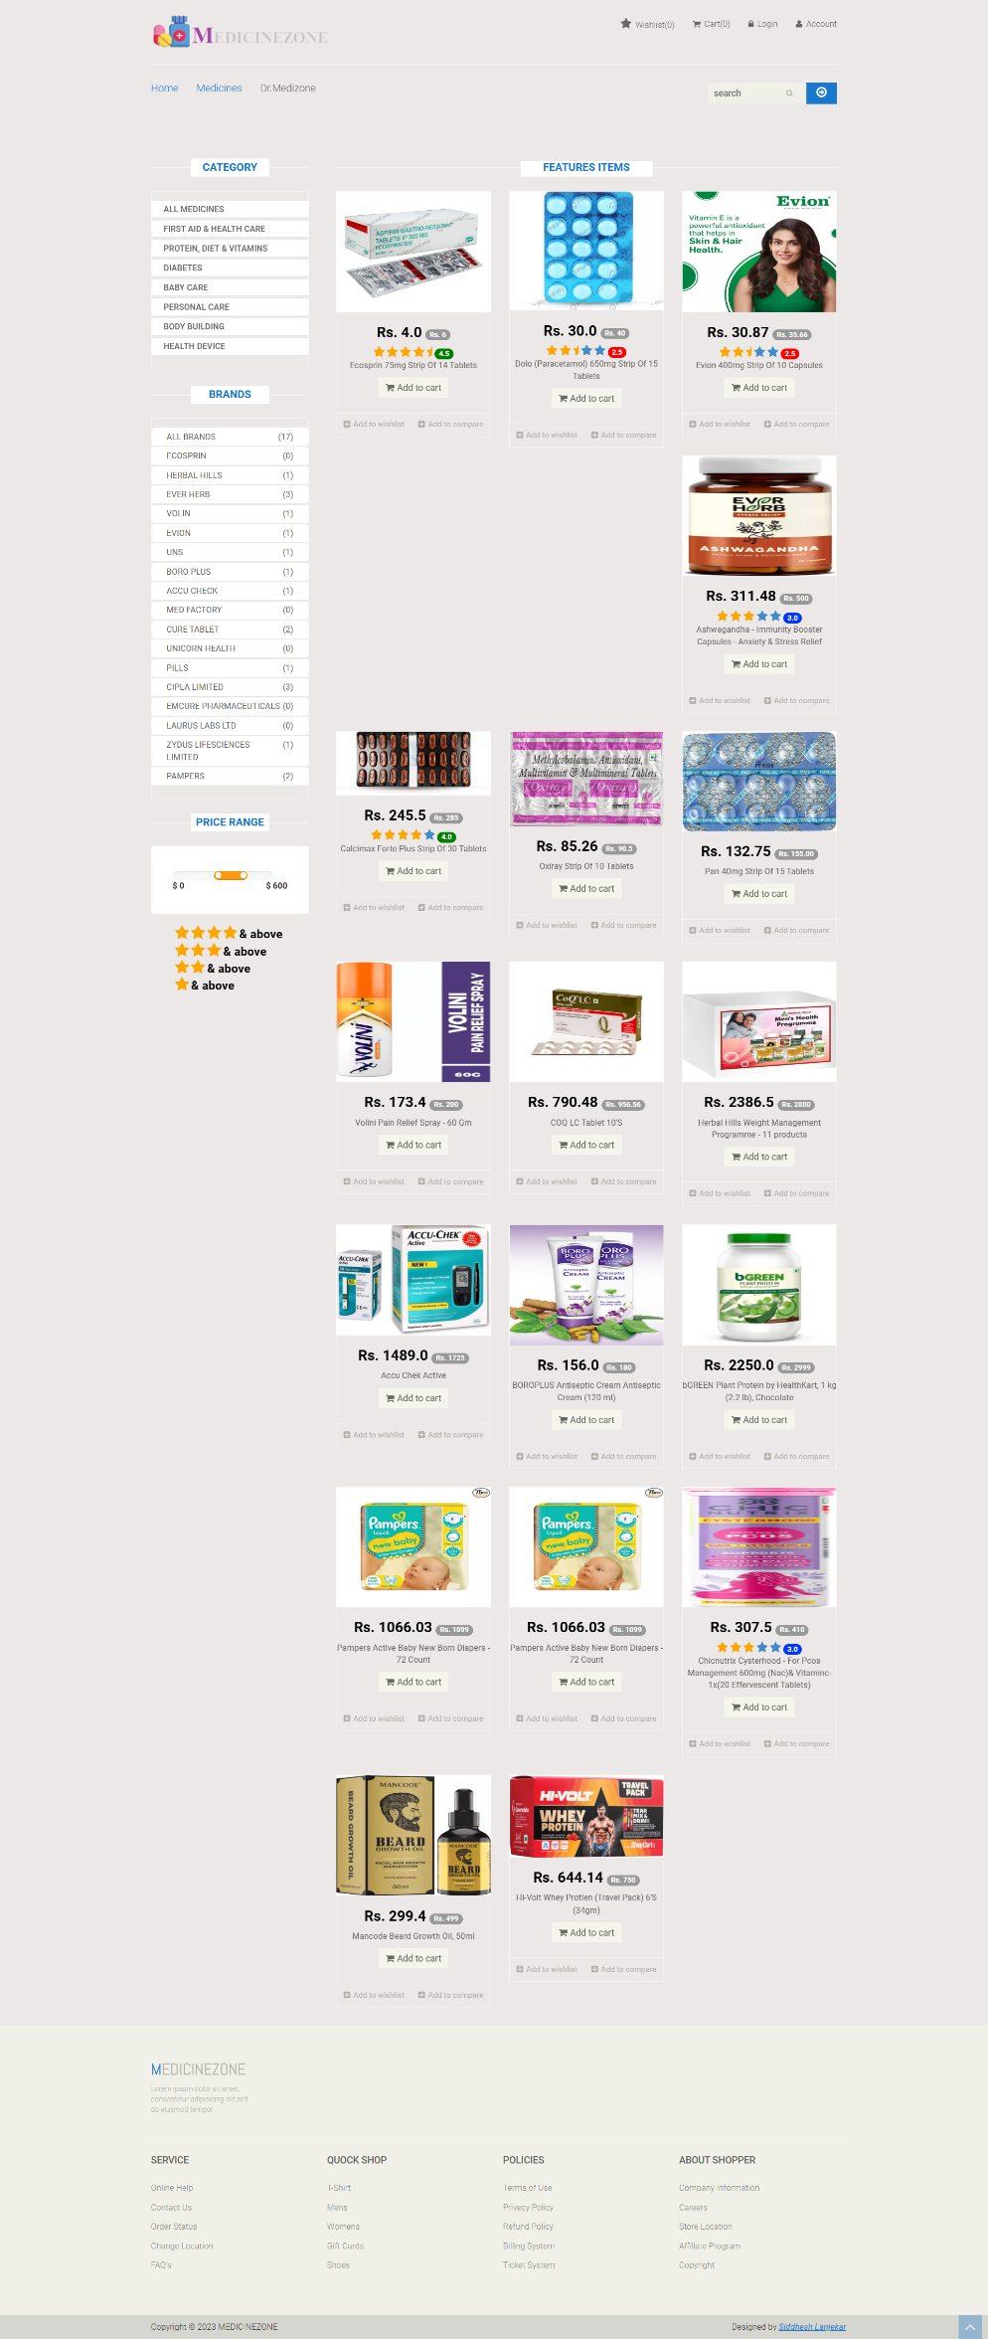

**Medicine Product Detail Page User Interface**

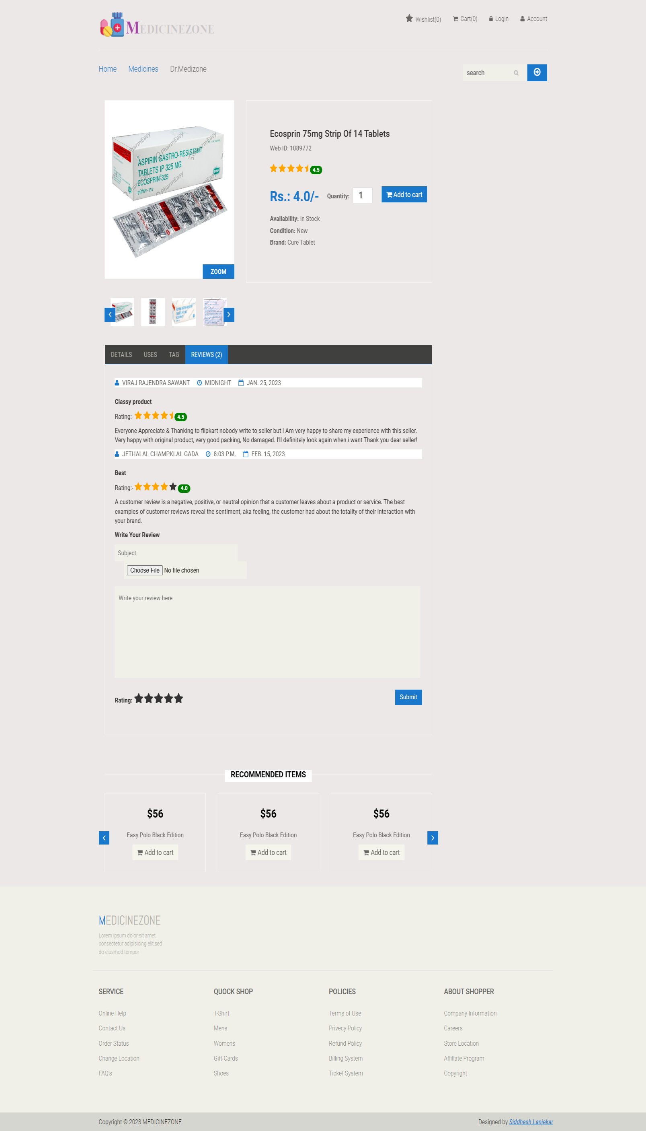

**Medicine Cart Page User Interface**

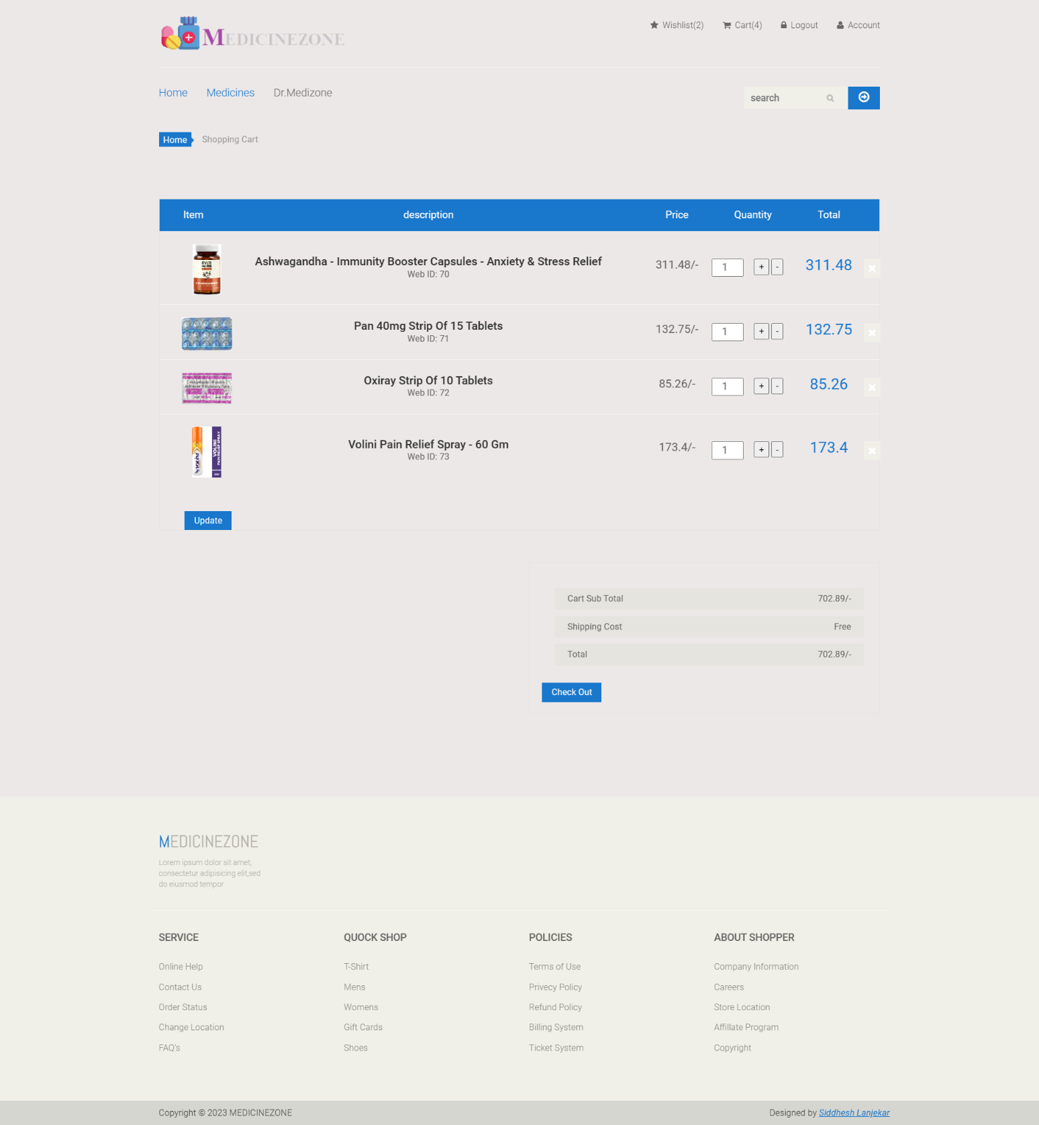

**Login Page User Interface**

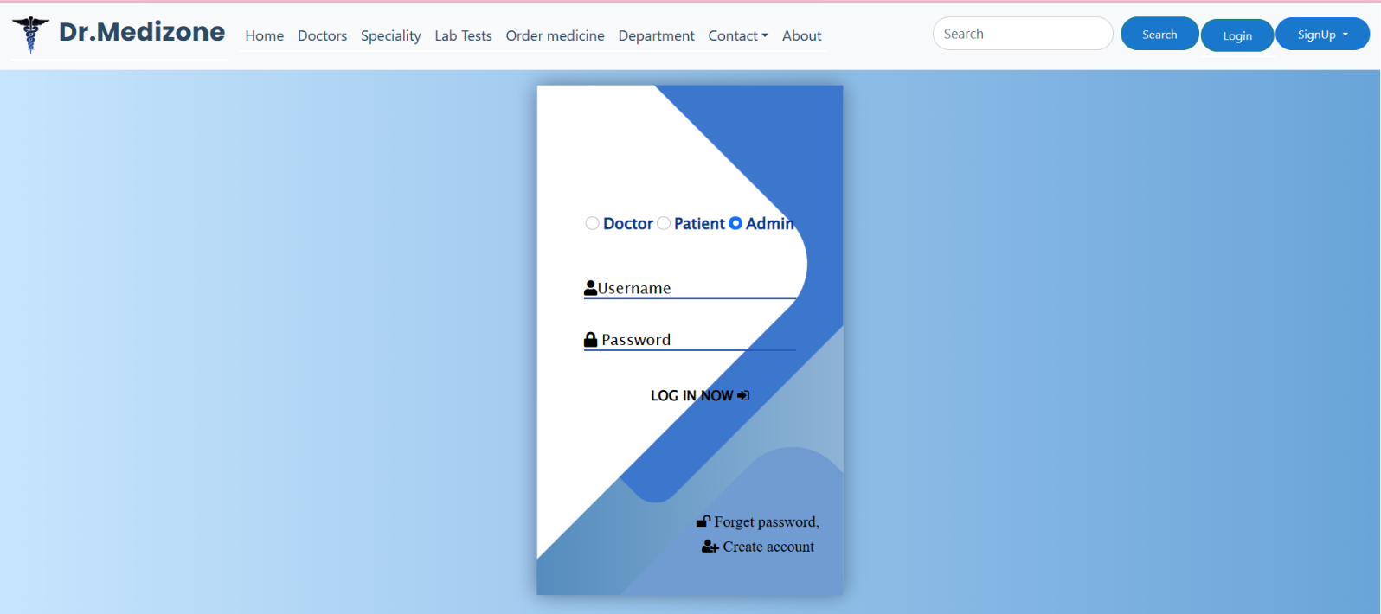

**Doctor Registration Page User Interface**

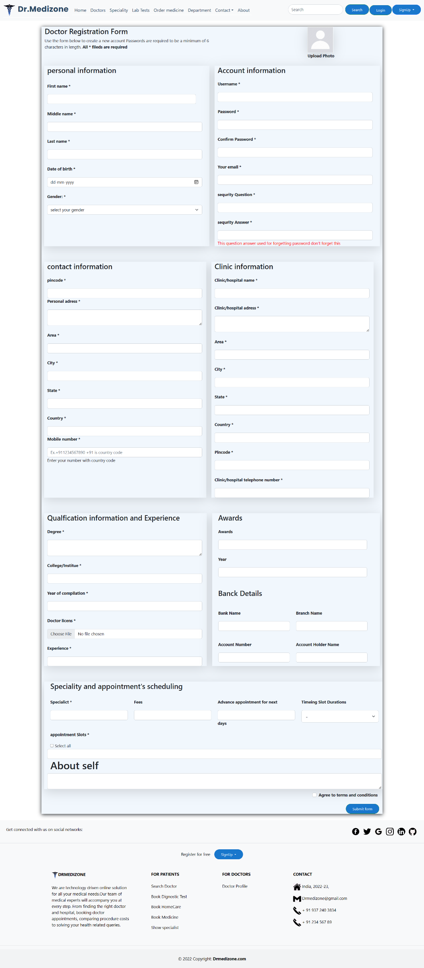

**Patient Registration Page User Interface**

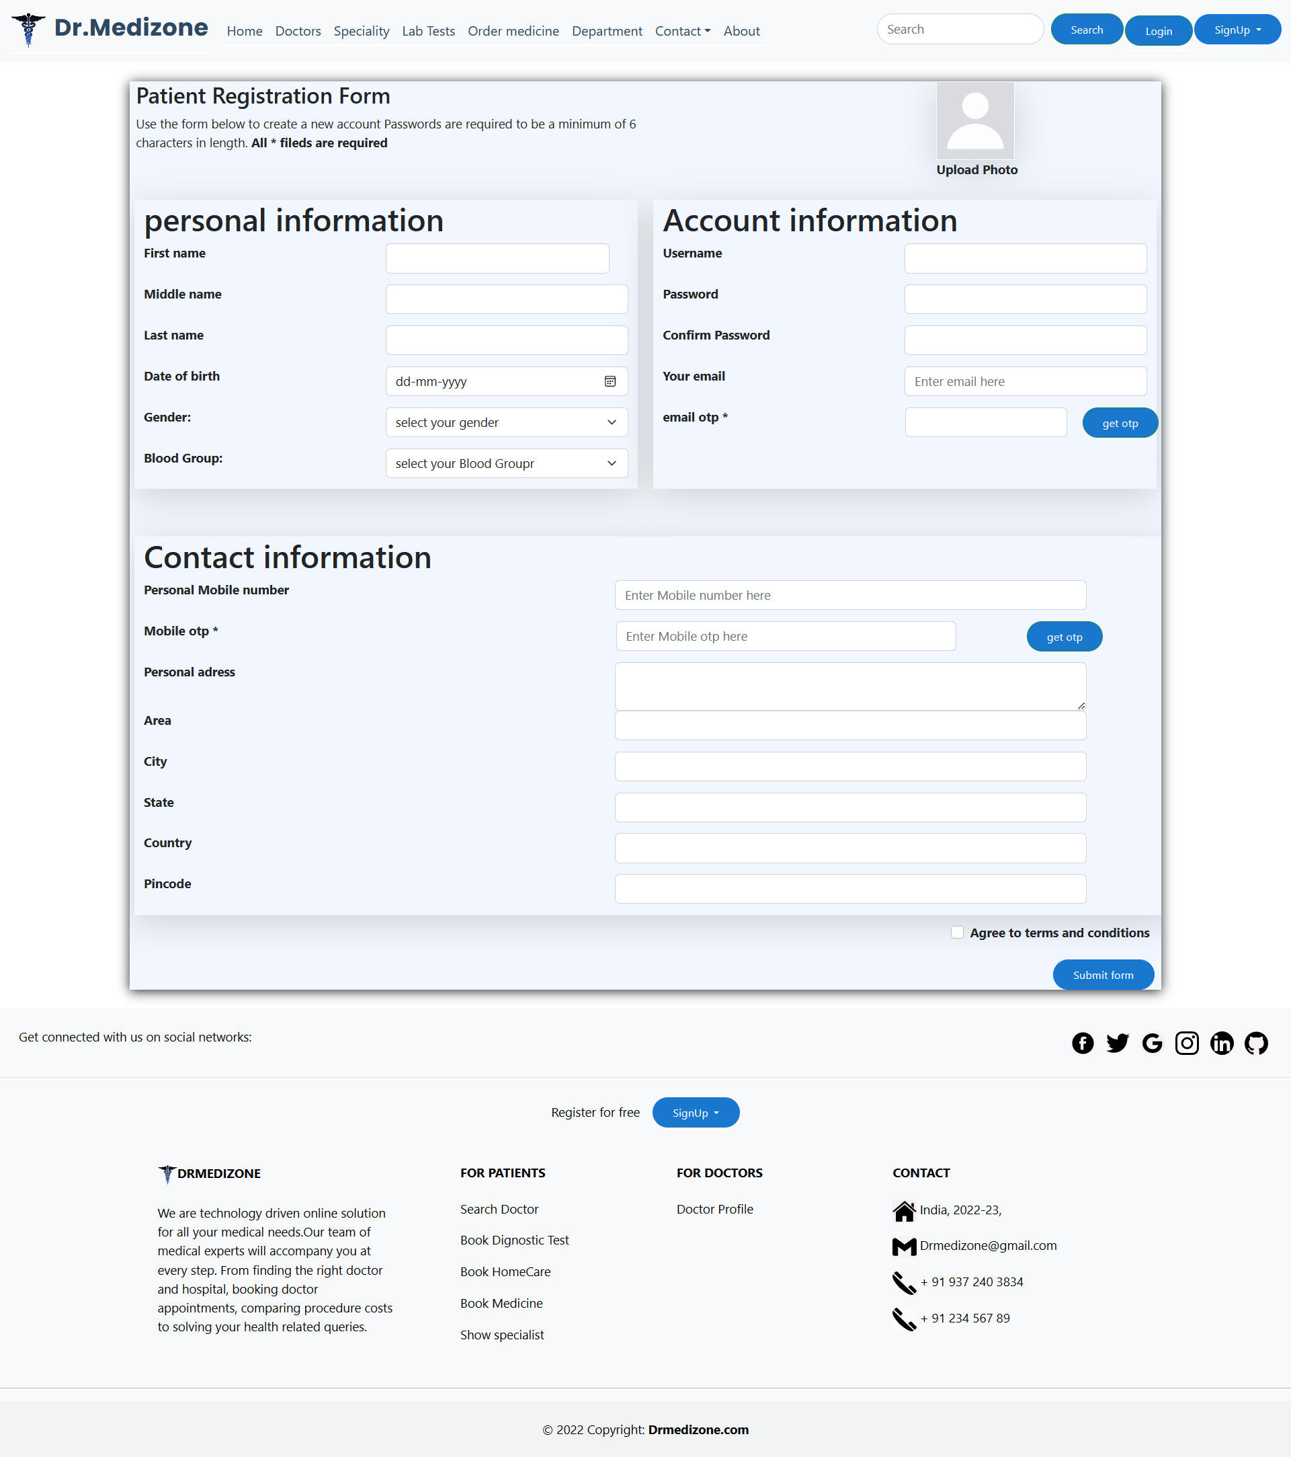

**OTP verification Page User Interface**

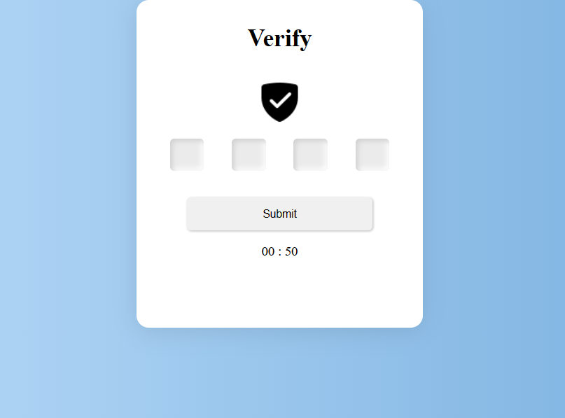

**Chapter 8 – Result and Discussion**

1. **Test report**

The process of developing test cases can help you uncover problems in the application's requirements or design. Case is a set of conditions where the tester can regulate whether the system happens the requirements. There are possible bugs or holes in the system, test cases will help identify those bugs and can be solved using test cases. Therefore, proper testing is required to expect minimal errors. Although 100% testing is impossible, we must provide as much as possible. So, we need to choose the right test.

**Test report should be:**

* + - **Detailed :** It should provide a detailed description of the testing activity, which showcases the testing performed on the product. No abstract information is included in this document.
    - **Clear :** The information in the test report should have clarity.
    - **Standard :** It must follow a standard template.
    - **Specific :** Summarize the document in clear and concise points.

1. **Project Information:**

|  |  |
| --- | --- |
| **Project Overview** | |
| Project | Appointment System |
| Name of the product | Drmedizone |
| Product description | A platform for patient can book appointments and buy medicines; doctor scheduled appointments. |

|  |  |
| --- | --- |
| **Project Duration** | |
| Start date | 12/09/2022 |
| End date | 10/04/2023 |

**Chapter 9 – Conclusion**

Drmedizone is web-based system that overcome the issue of booking appointments according to user’s choice and demands. Drmedizone is a very exciting topic to work. The project offers an actual solution where users can view many booking slots available and select the chosen date and time. With this system doctor can set his/her own schedule. Hospital can easily manage their appointment process and monitor the flow of patients to the doctor. With this system the time can be saved to both doctor and patients. Patient can book diagnostic appointments as select the preferred time. Patient can also buy medicine with exclusive offers. By above document anyone will be able to understand the project at a glance. In this project –

A doctor can.

* Get and rescheduled appointments
* Get patient information
* Set his own schedule
* Send reports

A patient can.

* Easy to get doctor and diagnostic appointment
* See doctors and medicines
* Get report and receipts
* Able to connect doctor any time
* Buy medicines
* Pay online

Day by day healthcare system become an important part of our society. So we have decided to build this system. We research so many system showed us the direction how to develop our system. We interact with the people that what type of problem they facing. They were very happy to take this system as it gives them some reliefs in modern age. Our analysis reveals that Drmedizone in some cases can help to reduce the total cost of the healthcare system as well as the patient’s waiting time. Despite everything we achieved, we faced many challenges to finish this project. After all it’s an online web-based system so in real life both doctor and patient need to follow the using rules otherwise it’s goal will be failed.

1. **Future Scope:**

In Future we are very keen to update our Web application . As we have plan to add new features as we want more user friendly system. Such as online emergency treatment system to implement in our Web application . Our main goal is to set a good online treatment Web application for a hospital management tool as both doctors & patients get a good environment of their health treatment. We are in search of new features & ideas in general to implement new things. Hopefully we done that in next couple of months.

Also We are very keen to promote this as a telemedicine treatment as we are planning to implement video call service in drmedizone as patient can take doctors advice from long distance. Hopefully we can do this within couple of months. As the major goal of technology in the area of medicine is to enhance the quality of care to the patients, it is absolutely essential to move towards better technology. Future enhancements will help in refining the systems and also make the healthcare system more powerful and far-reaching. With the increase in the disease burden of the society, it will be worthwhile to have measures in place that do to ensure that even people living in relatively less privileged areas can get access to doctors and hospitals in a short span of time, without the need of travelling to far off cities.

**Chapter 10 – Bibliography**

Title of the project: Drmedizone

Project type: Web Application

Project Developed by: Siddhesh Sanjay Lanjekar

**References**

* https://www.djangoproject.com/
* https://getbootstrap.com/
* https://www.youtube.com/
* https://www.w3schools.com/
* https://stackoverflow.com/
* https://www.python.org/
* https://fontawesome.com/